
554 Old Spanish Trail
Slidell, LA 70458
Phone: 985-649-5832
Fax: 985-641-5950
dammonengineering.com
info@dammonengineering.com

December 7, 2015

Mr. Dixon Greenwood
Ball Realty & Auction, Inc.
P.O. Box 237, 1894 Hwy 25 E
Tazewell, TN 37879
(865) 525-2307

Re: Verizon, 1330 Gause Blvd. Slidell, LA
Civil Site Work and MEPs

Mr. Greenwood,

It was a pleasure to talk with you about your plans to construct a new building at the referenced location. Dammon Engineering, Inc. is pleased to propose our Engineering services to provide you with plans to construct the proposed facility.
We propose a fee of 4% of the site construction cost for site development. You had discussed the possibility of needing help with the MEPs. We would charge a fee of 7% of the individual construction costs for each of these disciplines.
Our fee(s) does not include the cost of permitting, any county/parish or other government required studies or tests, nor the cost of traffic, or other engineering studies, which may be required. Our fee also does not include sprinkler or alarm system design which may be required, nor design of the landscaping. However, we do have a Landscape Architect whom we work with regularly. We can contract all of these services at a "cost plus 10%" fee.
Our design fee does not include construction management or site visits; However, these services can be arranged & billed at our standard hourly rate.
We look forward to working with you on this project. Please indicate your acceptance of the above by signing below. By signing below you acknowledge that you are duly authorized to enter into and execute contracts/agreements on behalf of Verizon.
If you have any questions, or require any additional information, please feel free to call.

Thank You,
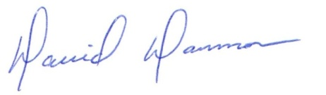
David Dammon
President

Accepted: _________________________________ Date:___________________
Dixon Greenwood

