
554 Old Spanish Trail
Slidell, LA 70458
Phone: 985-649-5832
Fax: 985-641-5950
dammonengineering.com
info@dammonengineering.com

June 4, 2015

James Cochran
Cochran & Gill Specialty Contracting, LLC
P.O. Box 2388 Mandeville, LA 70470
(985) 893-4688 (O)
(985) 893-4699 (F)
(985) 966-4759 (C)
jcochran@cochran-gill.com

RE: Christwood Kitchen Renovation
Covington, Louisiana

Dear Mr. Cochran,

It was a pleasure to speak with you to discuss plans for renovations to the kitchen at Christwood in Covington. Dammon Engineering, Inc. is pleased to propose our Engineering services to design the Electrical portion of this renovation.

We propose a fee of 7.5% of the construction cost for the Electrical portion of the work.

We look forward to working with you on this project. Please indicate your acceptance of the above by signing below. If you have any questions, or require any further information, please feel free to call.

Sincerely,
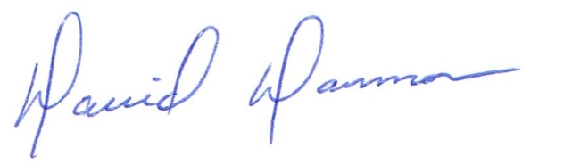

David Dammon, VP

Accepted: ____________________________ Date:__________________ James Cochran

