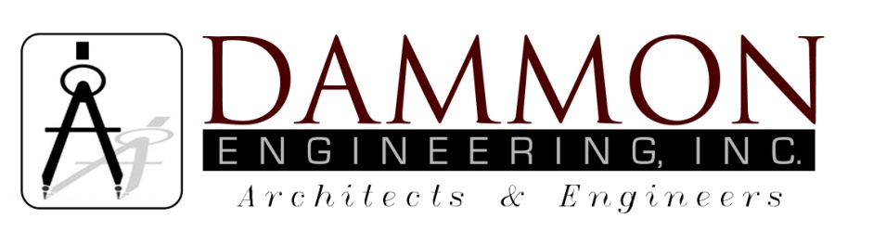
554 Old Spanish Trail
Slidell, LA 70458
Phone: 985-649-5832
Fax: 985-641-5950
dammonengineering.com
info@dammonengineering.com

June 4, 2015

Bert Thiess
Area Wide LLC
3433 U.S. 190 #321
Mandeville, LA 70471
Office: (985) 966-2355
Fax: (985) 892-0288
Cell: (504) 382-2360

RE: Christwood Kitchen Renovation
Covington, Louisiana

Dear Mr. Thiess,

It was a pleasure to speak with you to discuss plans for renovations to the kitchen at Christwood in Covington. Dammon Engineering, Inc. is pleased to propose our Engineering services to design the Plumbing portion of this renovation.

We propose a fee of 7.5% of the construction cost for the Plumbing portion of the work.

We look forward to working with you on this project. Please indicate your acceptance of the above by signing below. If you have any questions, or require any further information, please feel free to call.

Sincerely,
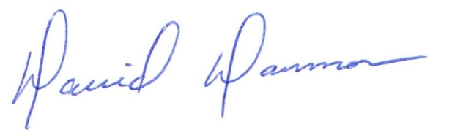

David Dammon, VP

Accepted: ____________________________ Date:__________________ Bert Thiess

