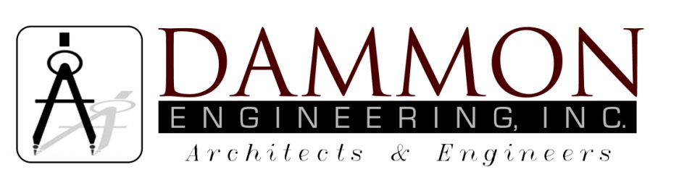
554 Old Spanish Trail
Slidell, LA 70458
Phone: 985-649-5832
Fax: 985-641-5950
dammonengineering.com
info@dammonengineering.com

July 2, 2015

Mr. Don McMath
McMath Construction
1125 N Causeway Blvd.
Mandeville, LA 70471

RE: Renovation of Existing Office/Warehouse
NATCO Building
2450 Destrehan Av.
Harvey, Louisiana

Dear Mr. McMath,

It was a pleasure to speak with you to discuss plans for construction of the renovation of the Office Warehouse in Harvey. Dammon Engineering, Inc. is pleased to propose our Architectural & Engineering services to design this renovation.

We propose a renovation fee of 7.5% of the construction cost for the project.

Dammon Engineering is not responsible for the existing foundation.

We look forward to working with you on this project. Please indicate your acceptance of the above by signing below. If you have any questions, or require any further information, please feel free to call.

Sincerely,
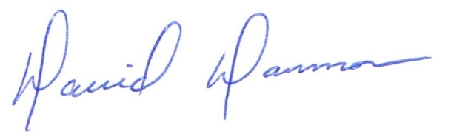

David Dammon, VP

Accepted: ____________________________ Date:__________________ Don McMath

