DIVISION 33
UTILITIES

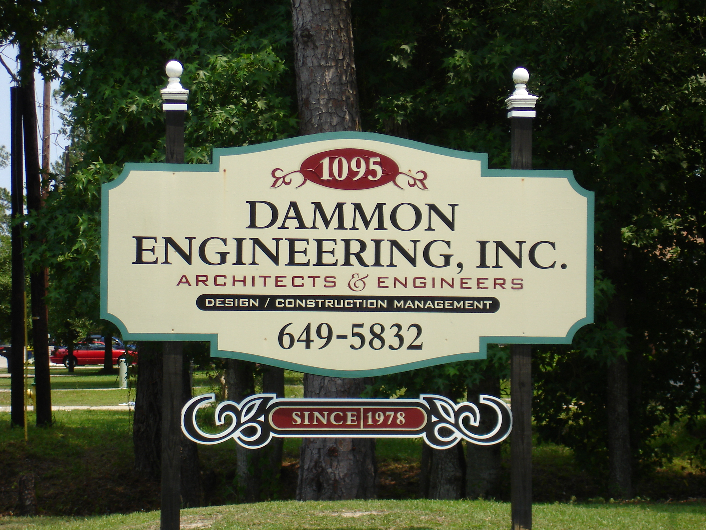
DAMMON ENGINEERING, INC.
554 OLD SPANISH TRAIL
SLIDELL, LOUISIANA 70458
Phone: 985-649-5832
Email: info@dammonengineering.com
Website: www.dammonengineering.com

