March 31, 2026 Meeting date/time : March 31th @ 1pm

Pre-Construction Meeting Minutes

STPSB Project No. 1919
Gymnasium HVAC and Roof Replacement
at Covington Elementary School
The meeting was held on site at Covington Elementary School inside the gymnasium.

ECO was represented by Elwin Ordoyne, IBOS roofing was also in attendance.

The agenda was discussed; the site access as well as staging area were discussed.

ECO was reminded to have all workers to wear the same color shirts for their company while on the jobsite.

The anticipated NTP for Phase II (Construction) is after Memorial Day.
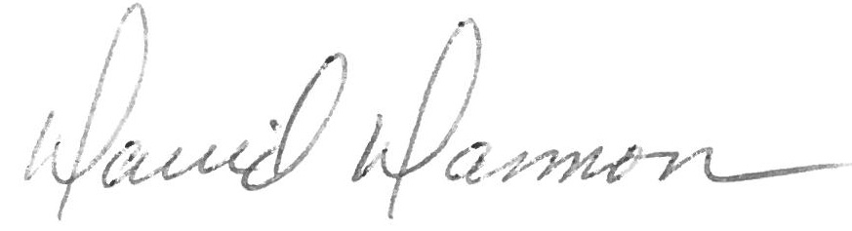

David Dammon
Dammon Engineering, Inc.

cc: Cameron Tipton, STPSB
Sammy Mannino, STPSB

