April 1, 2026

Elwin C Ordoyne III
ECO Builders Inc
2990 Gause E BLVD
Slidell, La 70461

RE: STPSB Project #1919
Covington Elementary School, Gymnasium HVAC and Roof Replacement
Instruction No: EI-001

Dear Mr. Ordoyne,

In accordance with the provisions of the contract’s general conditions, you are hereby notified to re-install the existing Novo HVAC control system currently in use at subject location. Advise your HVAC technician to take specific notes of the existing connections to the existing units prior to removal of the old system. Re-Install the connections for the Novo HVAC control system in the same manner as it currently is installed.
Site maintenance personnel should be consulted for the controls of the Novo system.

Sincerely,
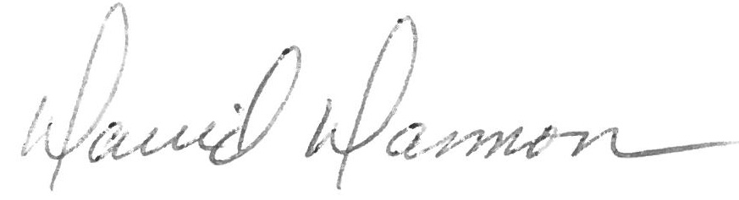

David Dammon
Dammon Engineering, Inc.

Contractor Acknowledgement

I/we acknowledge receipt of this instruction.

Signed: _______________________

Date: _________________________

cc: Cameron Tipton, STPSB
Sammy Mannino, STPSB

