
554 Old Spanish Trail
Slidell, LA 70458
Phone: 985-649-5832

dammonengineering.com
info@dammonengineering.com

October 16, 2025

Daniel Latournerie
Director of Operations
M.S. Rau Antiques
630 Royal St.
New Orleans, LA 70130

Ref: Warehouse Storage Calculations at 2223 Perdido St

Dear Mr. Latournerie

We have concluded our assessment of the elevated areas at your warehouse at the reference address. We found 3 things that should be brought to your attention.

1. The elevated storage area above the entrance corridor, SouthEast side of the building has a limited storage capacity due to the manner which the floor/ceiling joist were attached to the exterior CMU block wall. We propose 2 different options to bring this storage area up to 90 lbs/s.f. See attached. Also, the end of the corridor that opens to warehouse widens from 10.5 ft to 12.5 ft would increase the allowable load up to 40 lbs/s.f. See attached.

2. The elevated storage area next to the delivery truck parking area, NorthWest, the first section nearest to the truck parking area has a very long beam between column/posts. If you install a new column/post half the distance between existing column/post, you can store items up to 90 lbs/s.f. Use a Simpson Strongtie for installing post.

3. The elevated storage area in the middle of the open warehouse has a limiting factor of the central beam. There appears to be 3 bays under this storage area where both end bays have a distance of approximately 14 ft between supports but the center bay has only 9.75 ft between supports. If these bays on both ends would have a column installed in the middle of the beam(s) this would increase the capacity to 40 lbs/s.f. Install new column using the same base plate used through out this platform.

If you have any questions please contact me.

Sincerely,
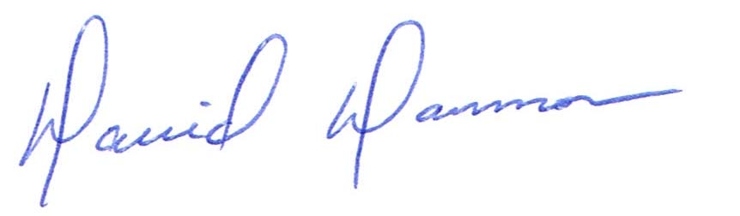

David Dammon, President

