
554 Old Spanish Trail
Slidell, LA 70458
Phone: 985-649-5832

dammonengineering.com
info@dammonengineering.com

Structural Inspection
May 21, 2025

Richard Farmer
Re/Max Alliance
625 N Causeway Blvd
Suite C
Mandeville, La. 70448

RE:
105 W Pear Dr.
Slidell, La. 70461

Construction:
Single-story raised house, wood frame, wood veneer, wood flooring.

Scope:
This inspection is limited to a visual inspection of the shell of the home, including the exterior foundation of the home. No Inspection of the mechanical or electrical systems was performed. This report is as outlined by the National Academy of Building Inspection Engineers and is not an explanation of cause, effect, or engineering.

History:
Dammon Engineering was contacted to request a structural inspection of the referenced raised home.

Findings:
Upon inspection, the house has been raised and supported by Concrete Masonry Units (CMU). These CMU supports date back to around the 1980’s. Some of the CMU’s have sustained stresses causing cracks. Apparently during one or more hurricanes trees fell on the house near the locations of the damaged CMU’s.

It was also noted that in the garage area the center of the house was supported using creosote beams, some of these beams are starting to show cracks along the beams.

Another area that was inspected is the decking on the rear of the house. This decking was apparently installed then altered to stop water from entering the sliding glass door at the deck. The method used to alter the support for the decking was not attached properly to the structure. Also, some of the flooring boards on the deck have started to decay on the outside edges.

Conclusion:
Exhibits 1 – 4 shows different levels of stress cracks in the CMU, see attached exhibits and recommendations to repair them.

Exhibits 5 & 6 shows the cracks in the creosote beams, see attached exhibits and recommendations to repair them.

Exhibit 7 shows the supports for the rear decking, see attached exhibit and recommendations to repair the deck supports.

See attachments;

Sincerely,

Brian Mistich, P.E.

Exhibit #1

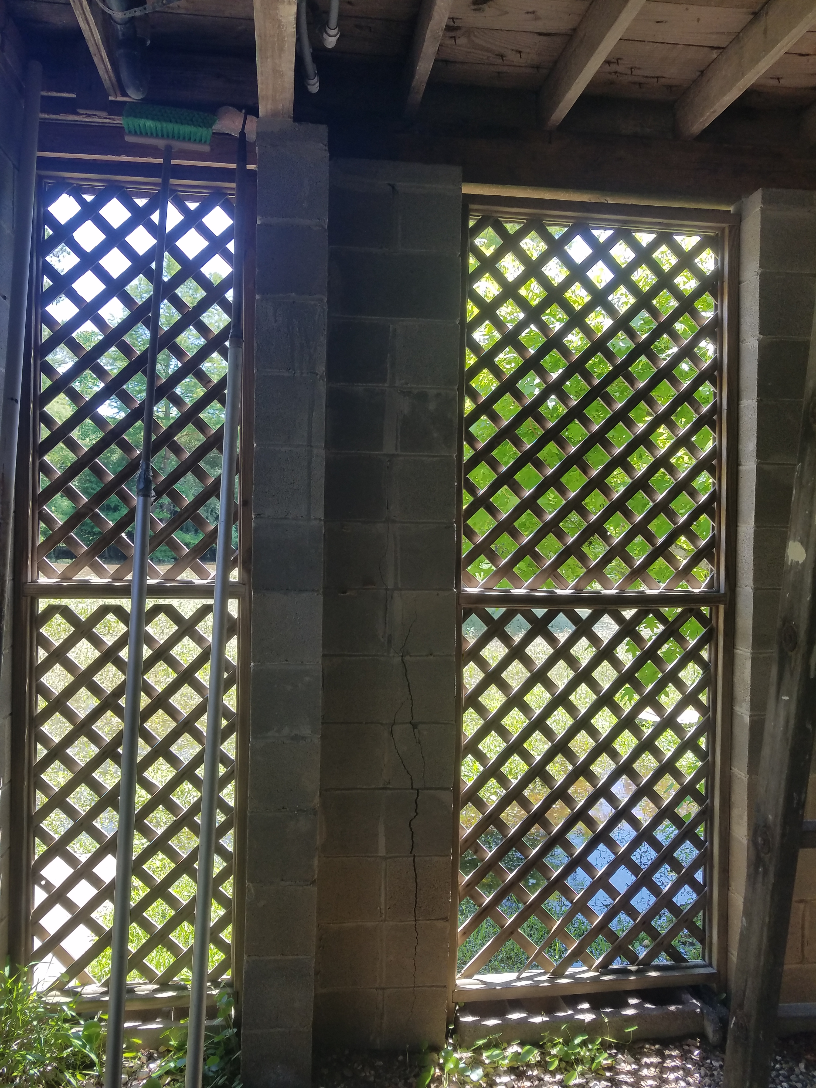
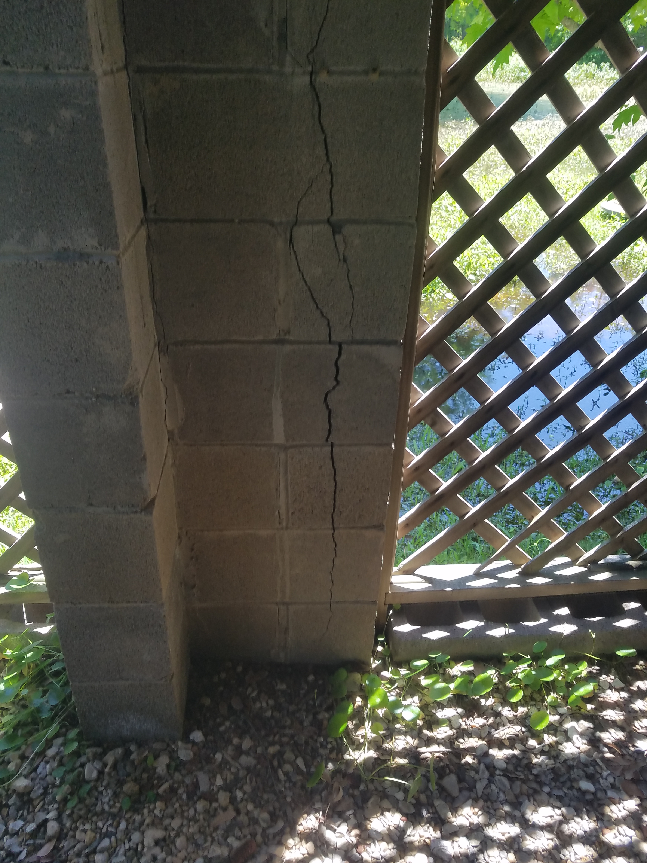

Remove and replace all CMU’s that have developed cracks. Repoint/tuck point all mortar using a non-shrink precision grout.

Exhibit #2

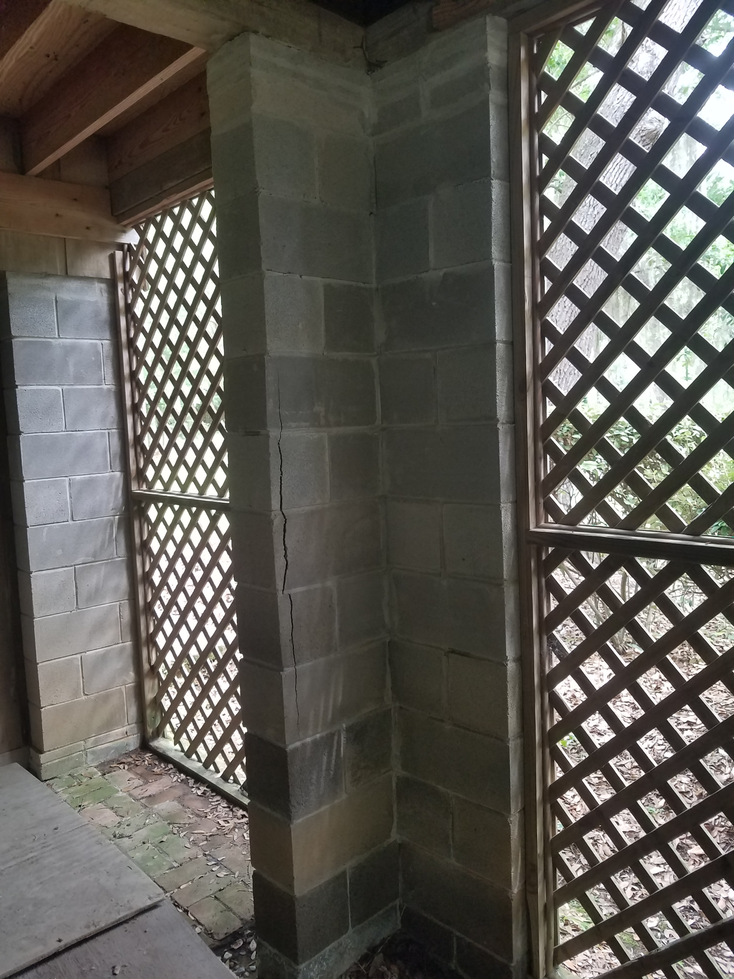
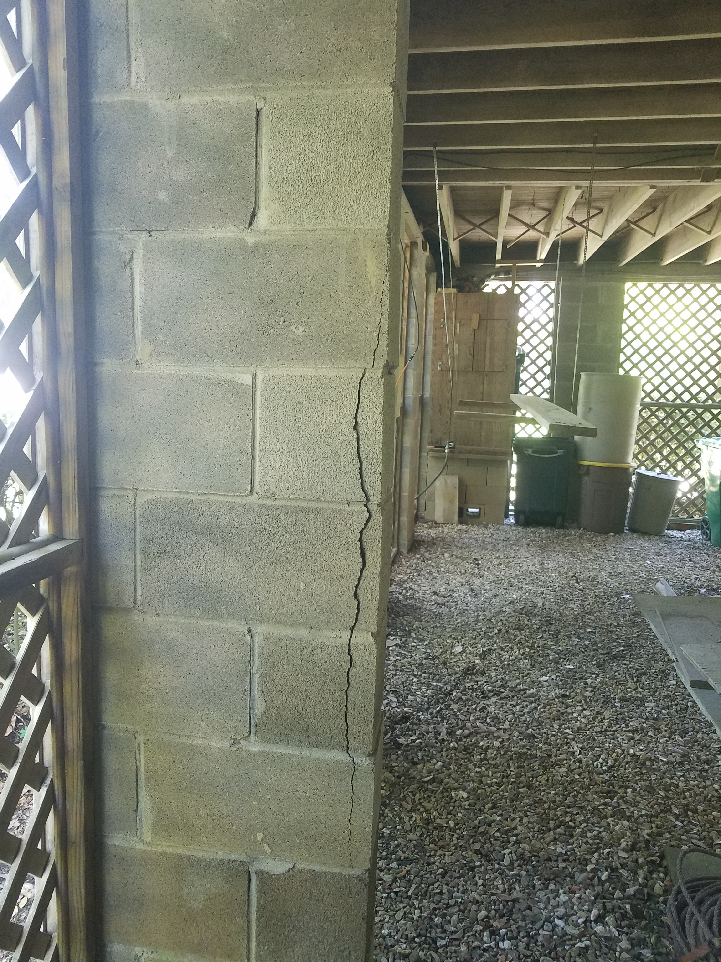
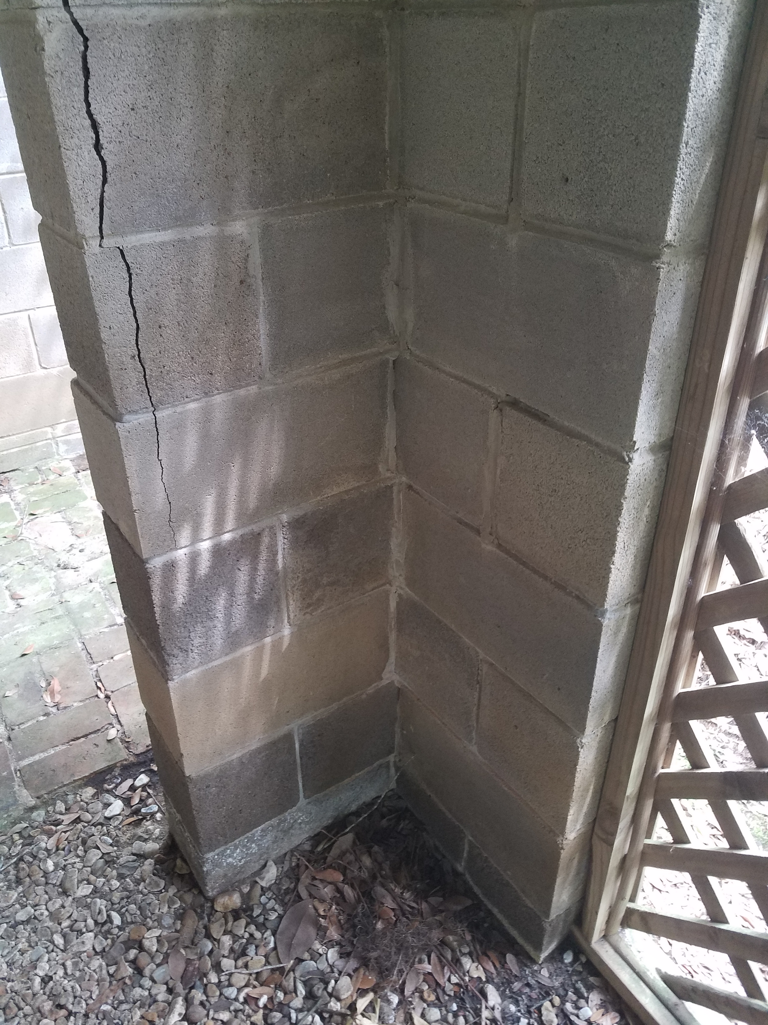

Remove and replace all CMU’s that have
developed cracks. Repoint/tuck point all
mortar using a non-shrink precision grout.

Exhibit #3

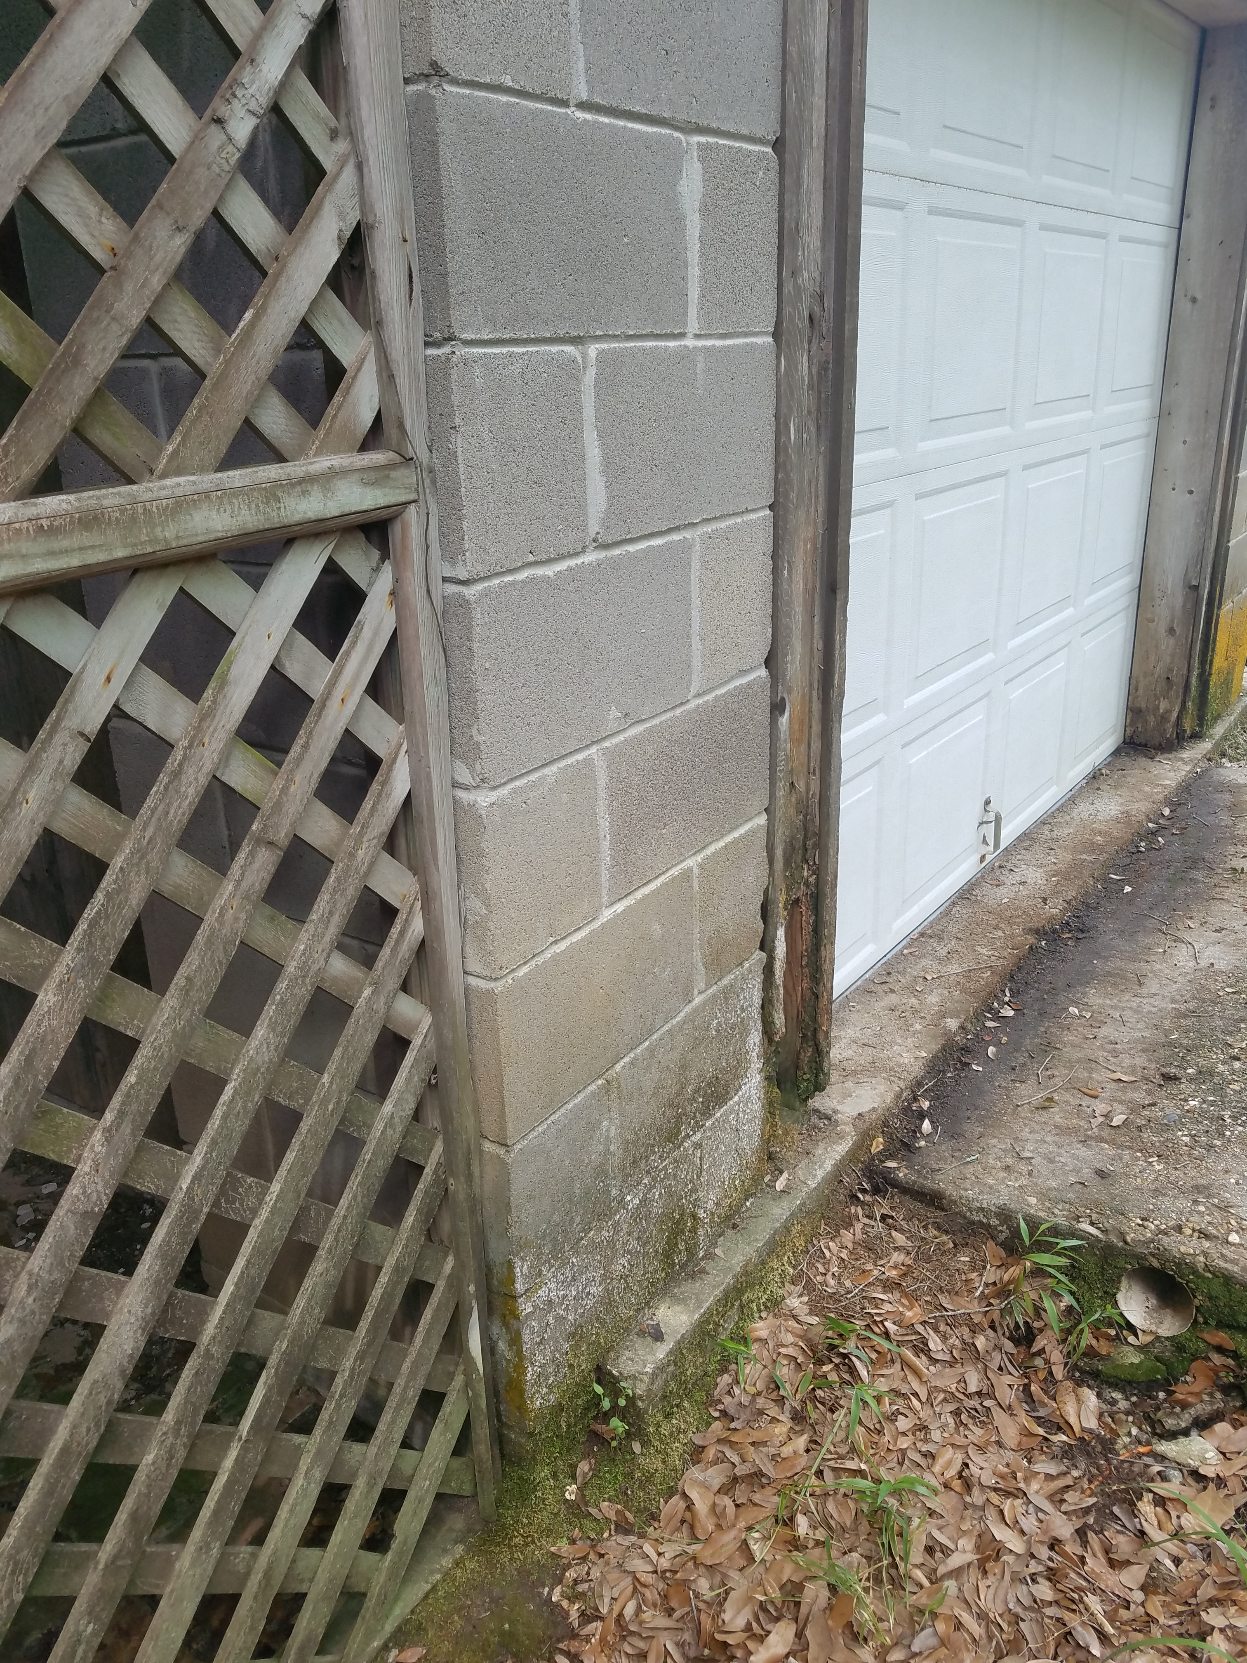
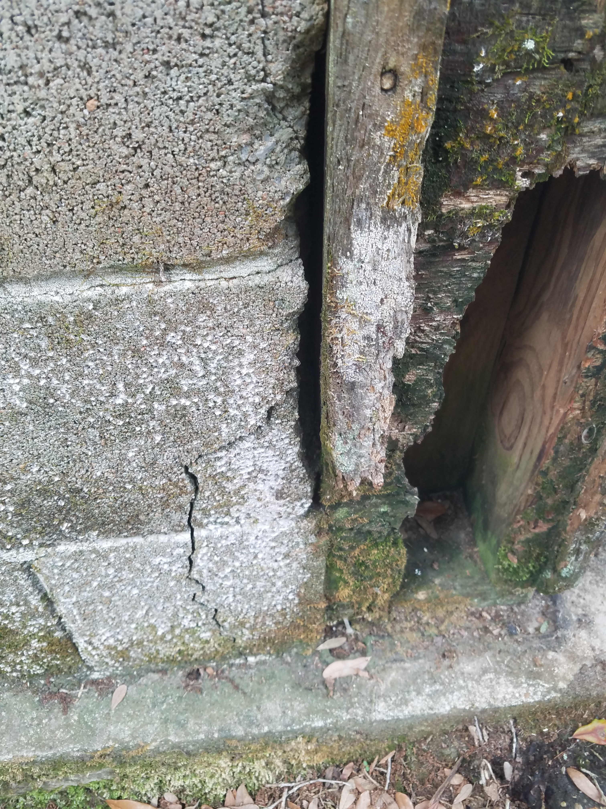

Repair all CMU’s that have cracks using an epoxy based foam. Replace rotten wood structure supporting garage door.

Exhibit #4
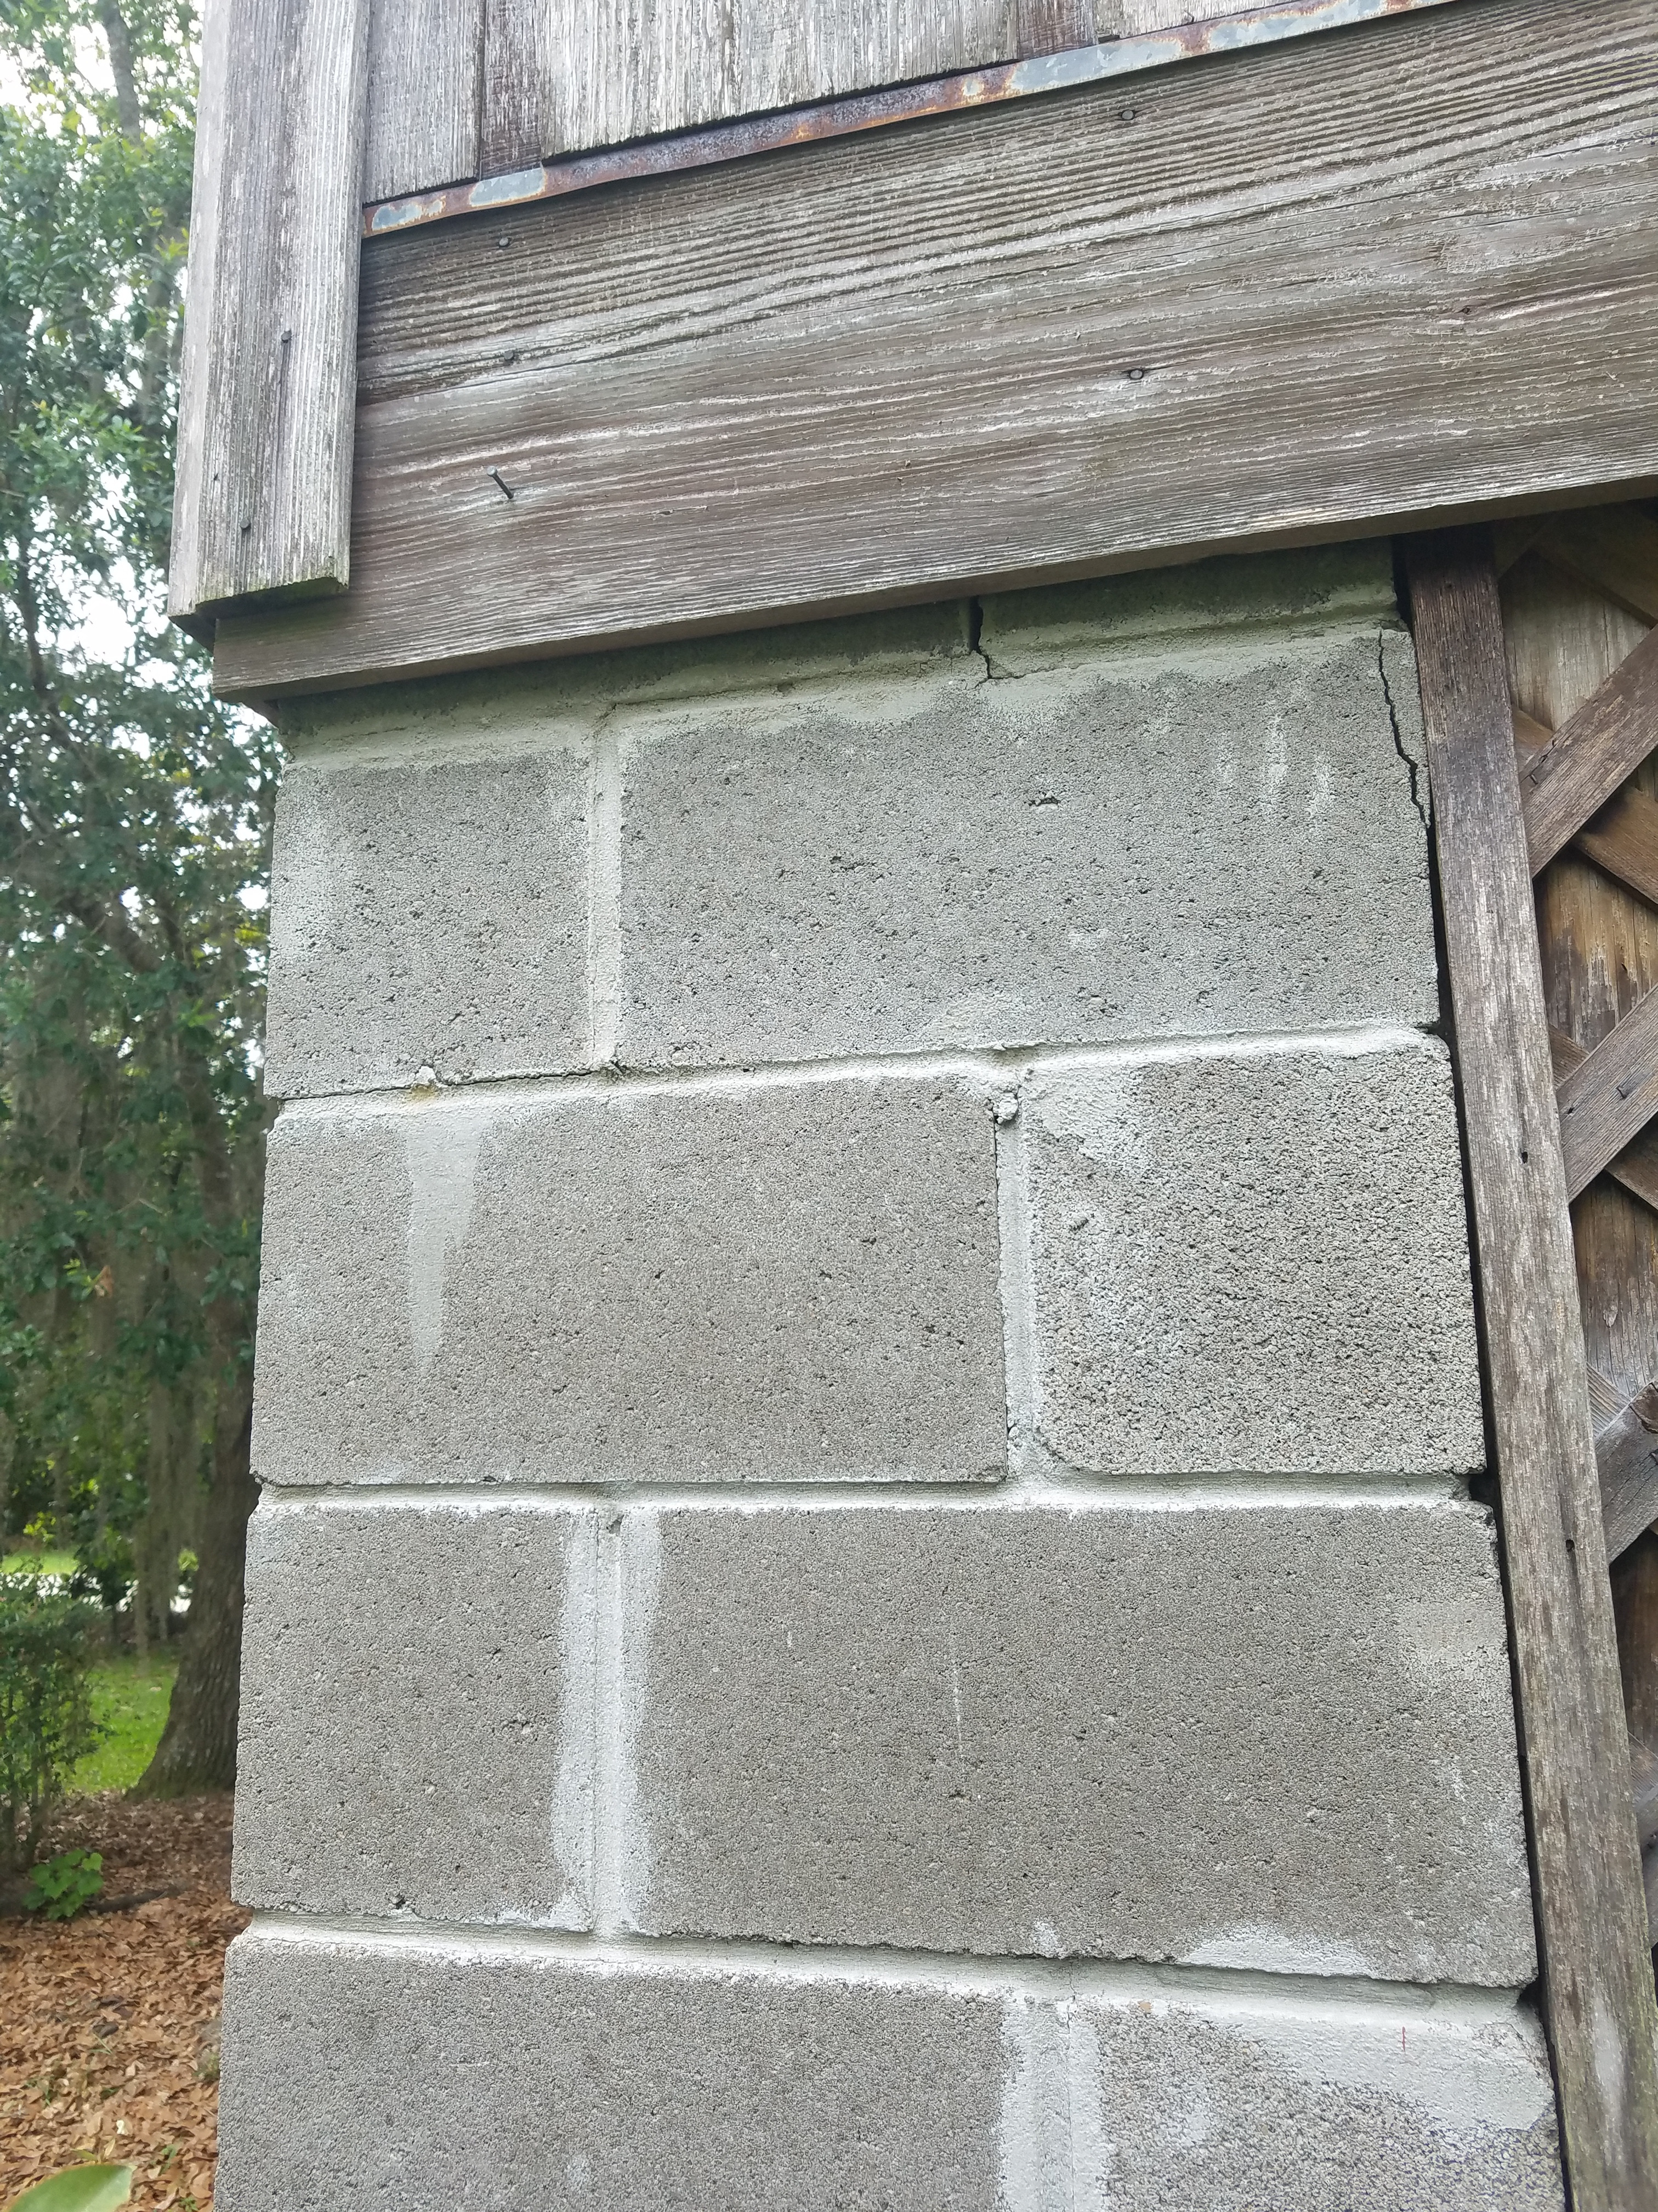
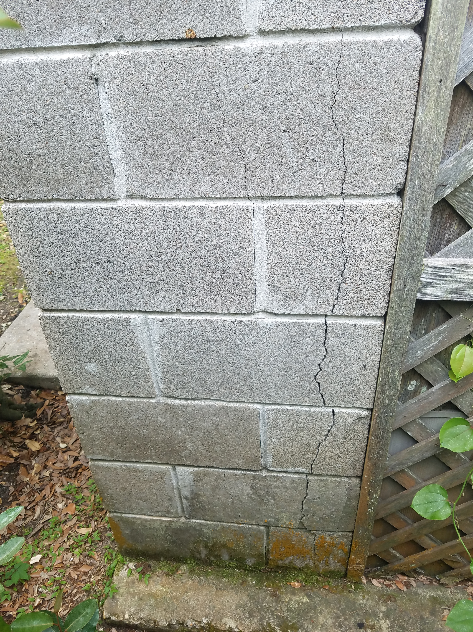

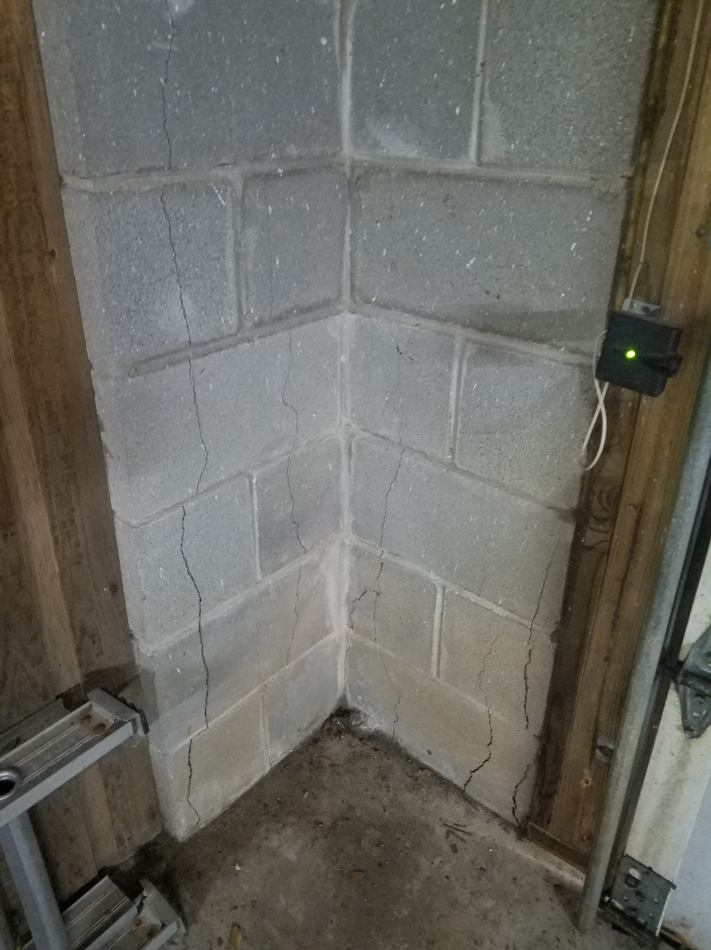
Remove and replace all CMU’s that have developed cracks. Repoint/tuck point all mortar using a non-shrink precision grout.

Exhibit #5

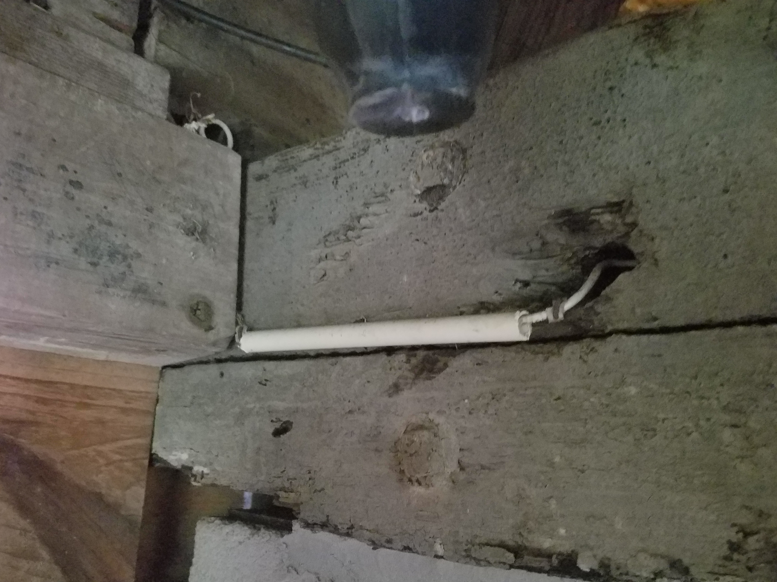

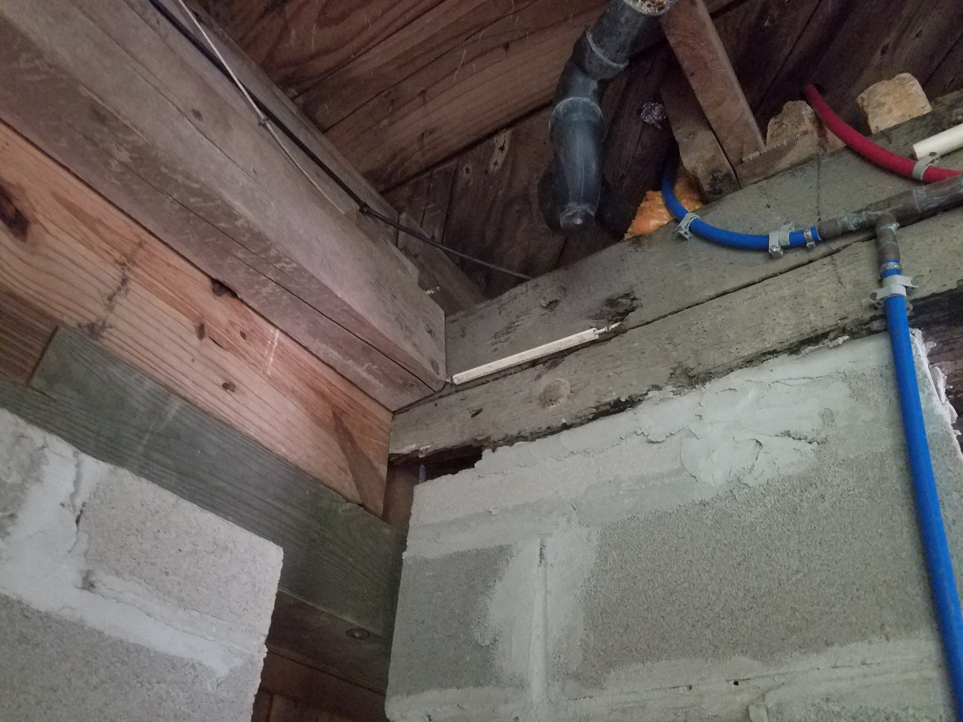
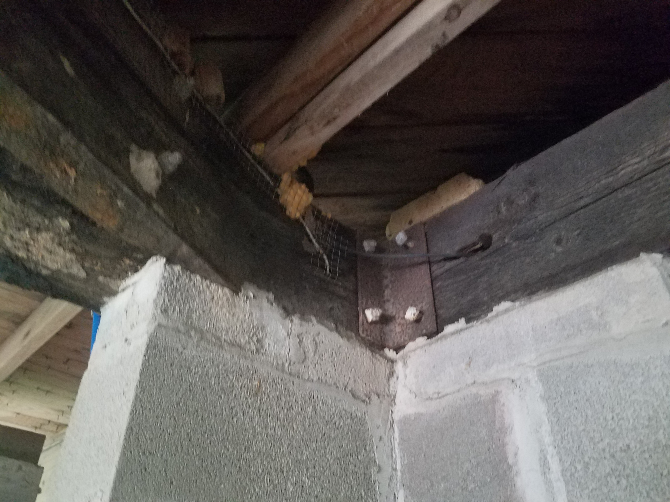

Remove any loose wood particles and apply epoxy spray foam to fill the cavity. Remove existing angle iron connection and replace with one, angle iron, that moves the connection point away from the repaired area by 4 inches.

Exhibit #6

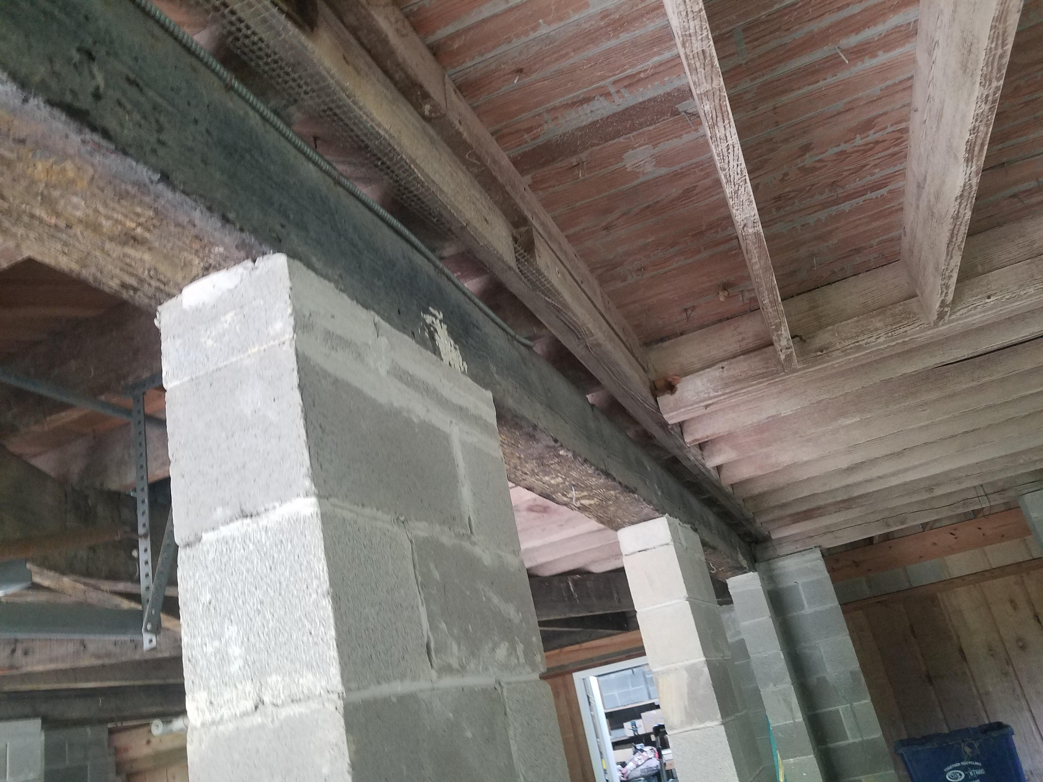
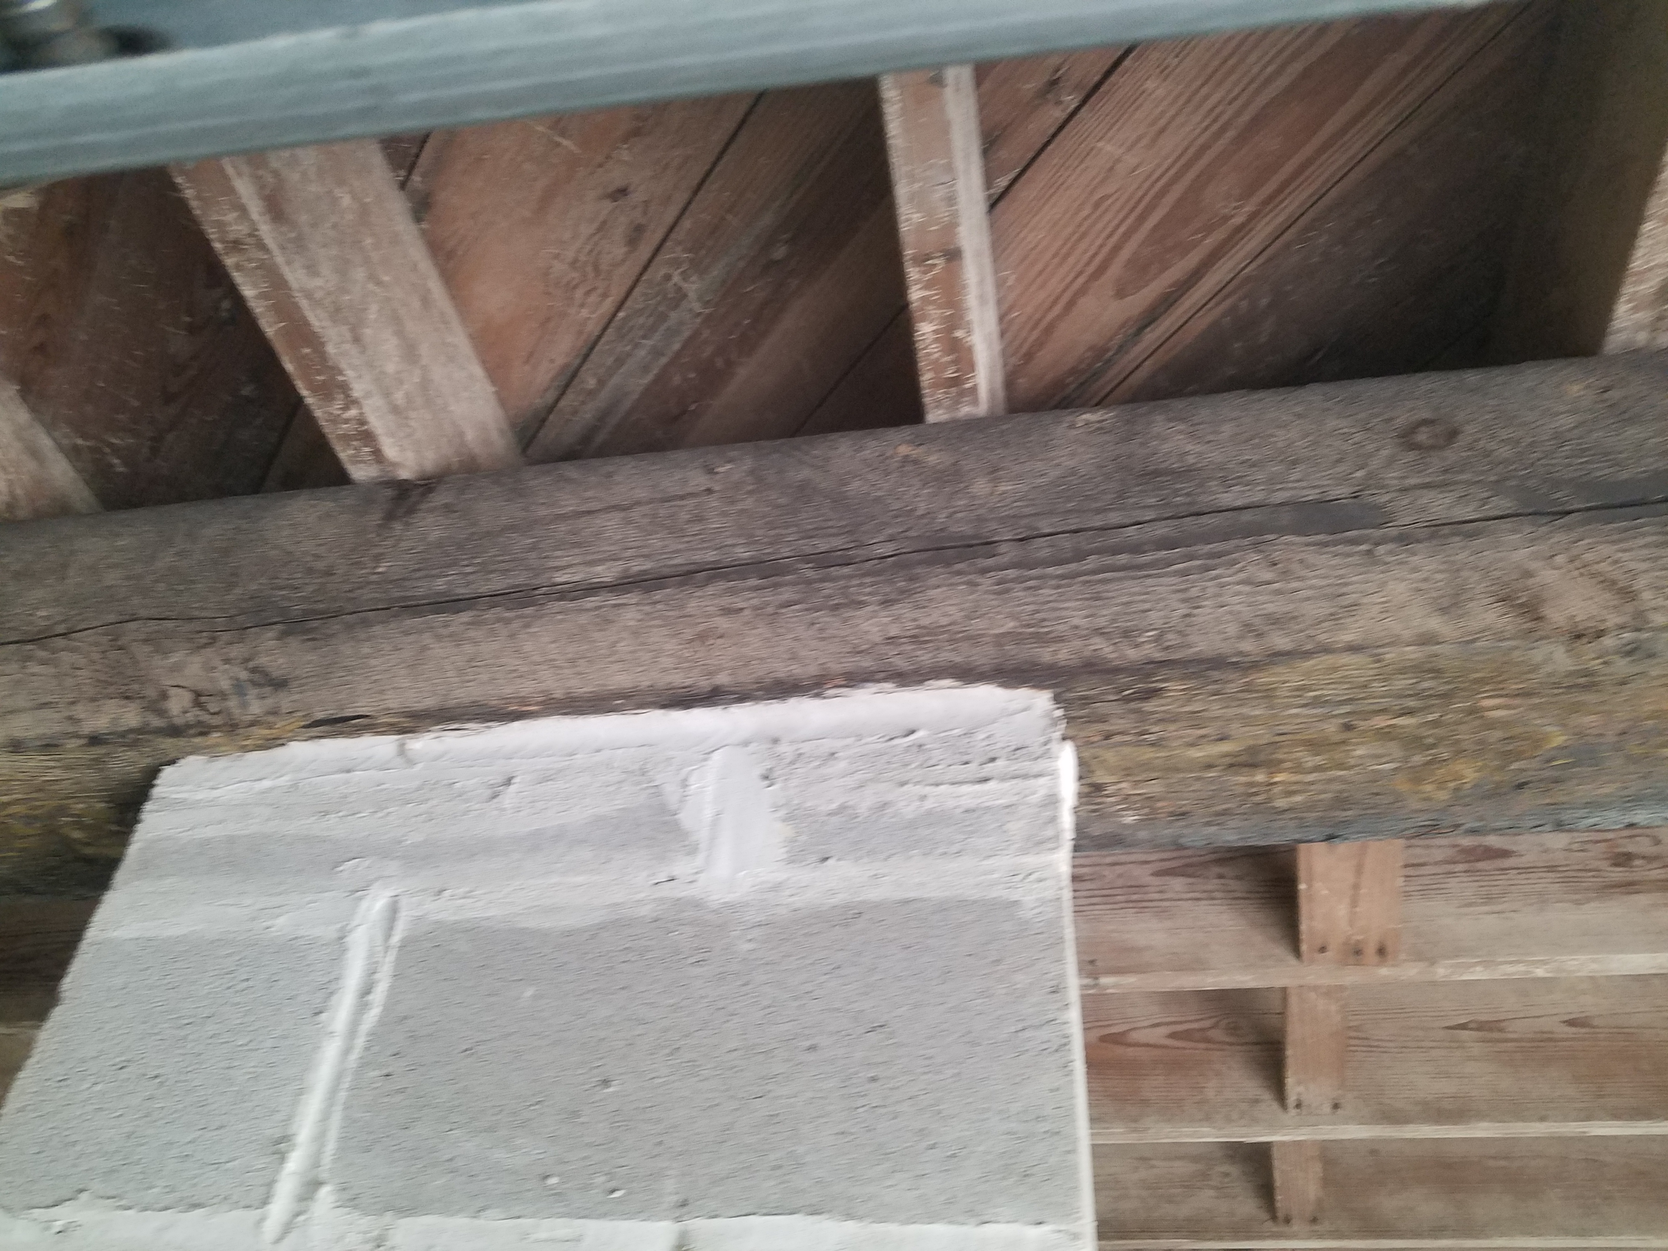
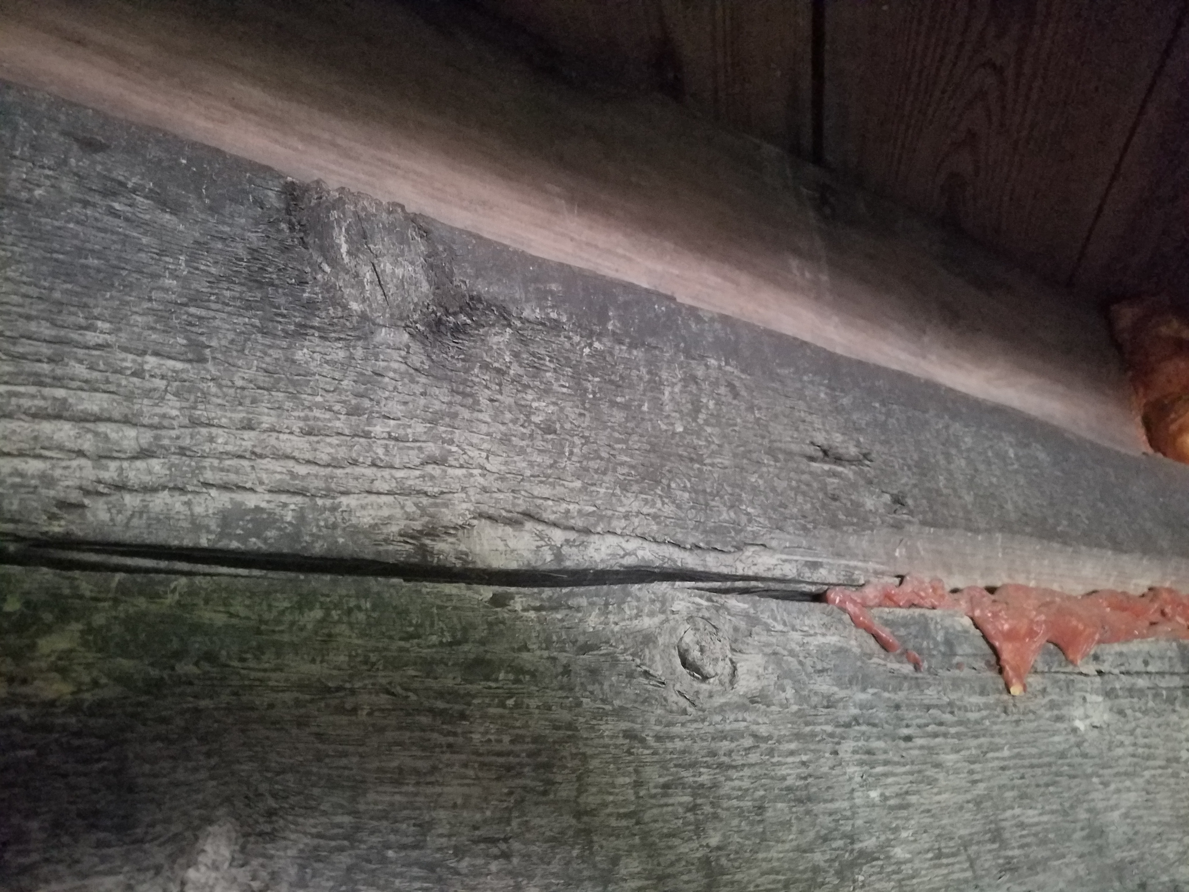
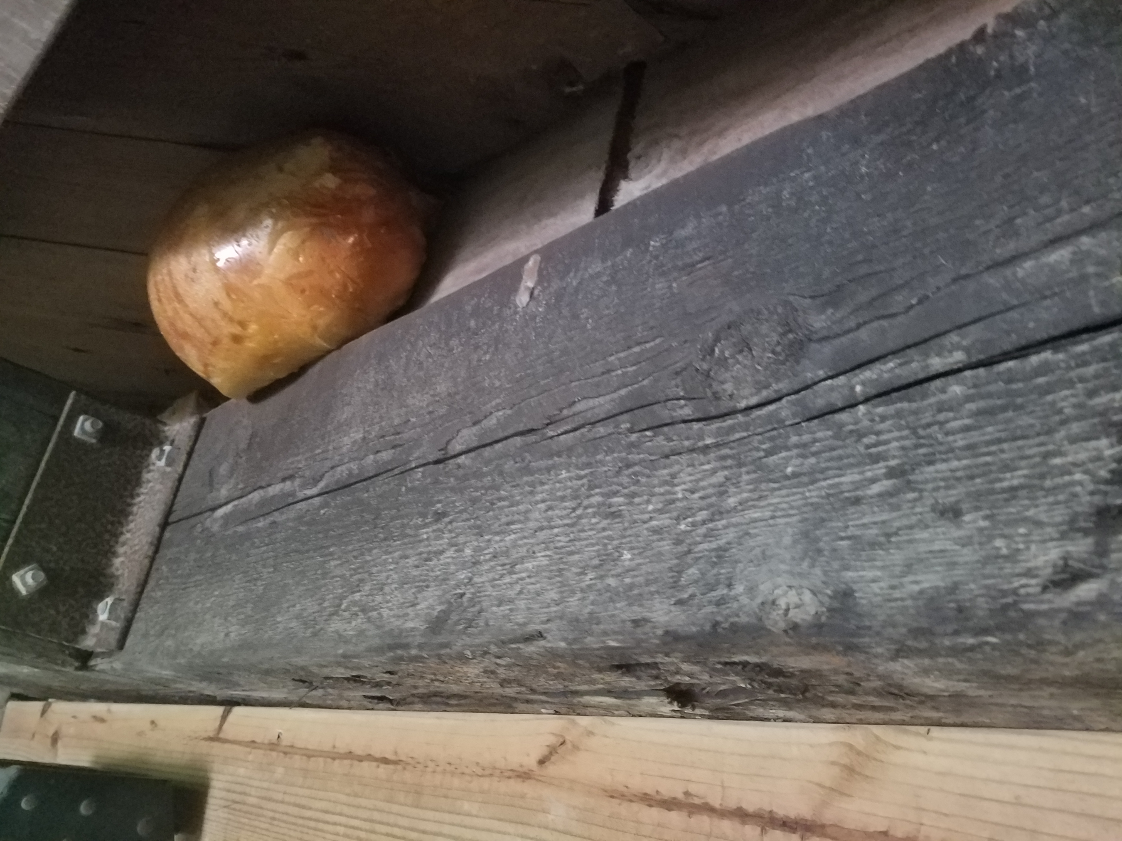

Cracks have developed along the horizontal plane along some of the creosote wood beams. Cracks like this normally do appear in these types of beams. Fill cracks with epoxy spray foam then install a Simpson Strong-Tie MP 3”x6” 20-Guage galvanized mending plate @ 24” o.c. along each bean where the crack(s) appear. Install mending plate according to manufactures recommendations.

Exhibit 7
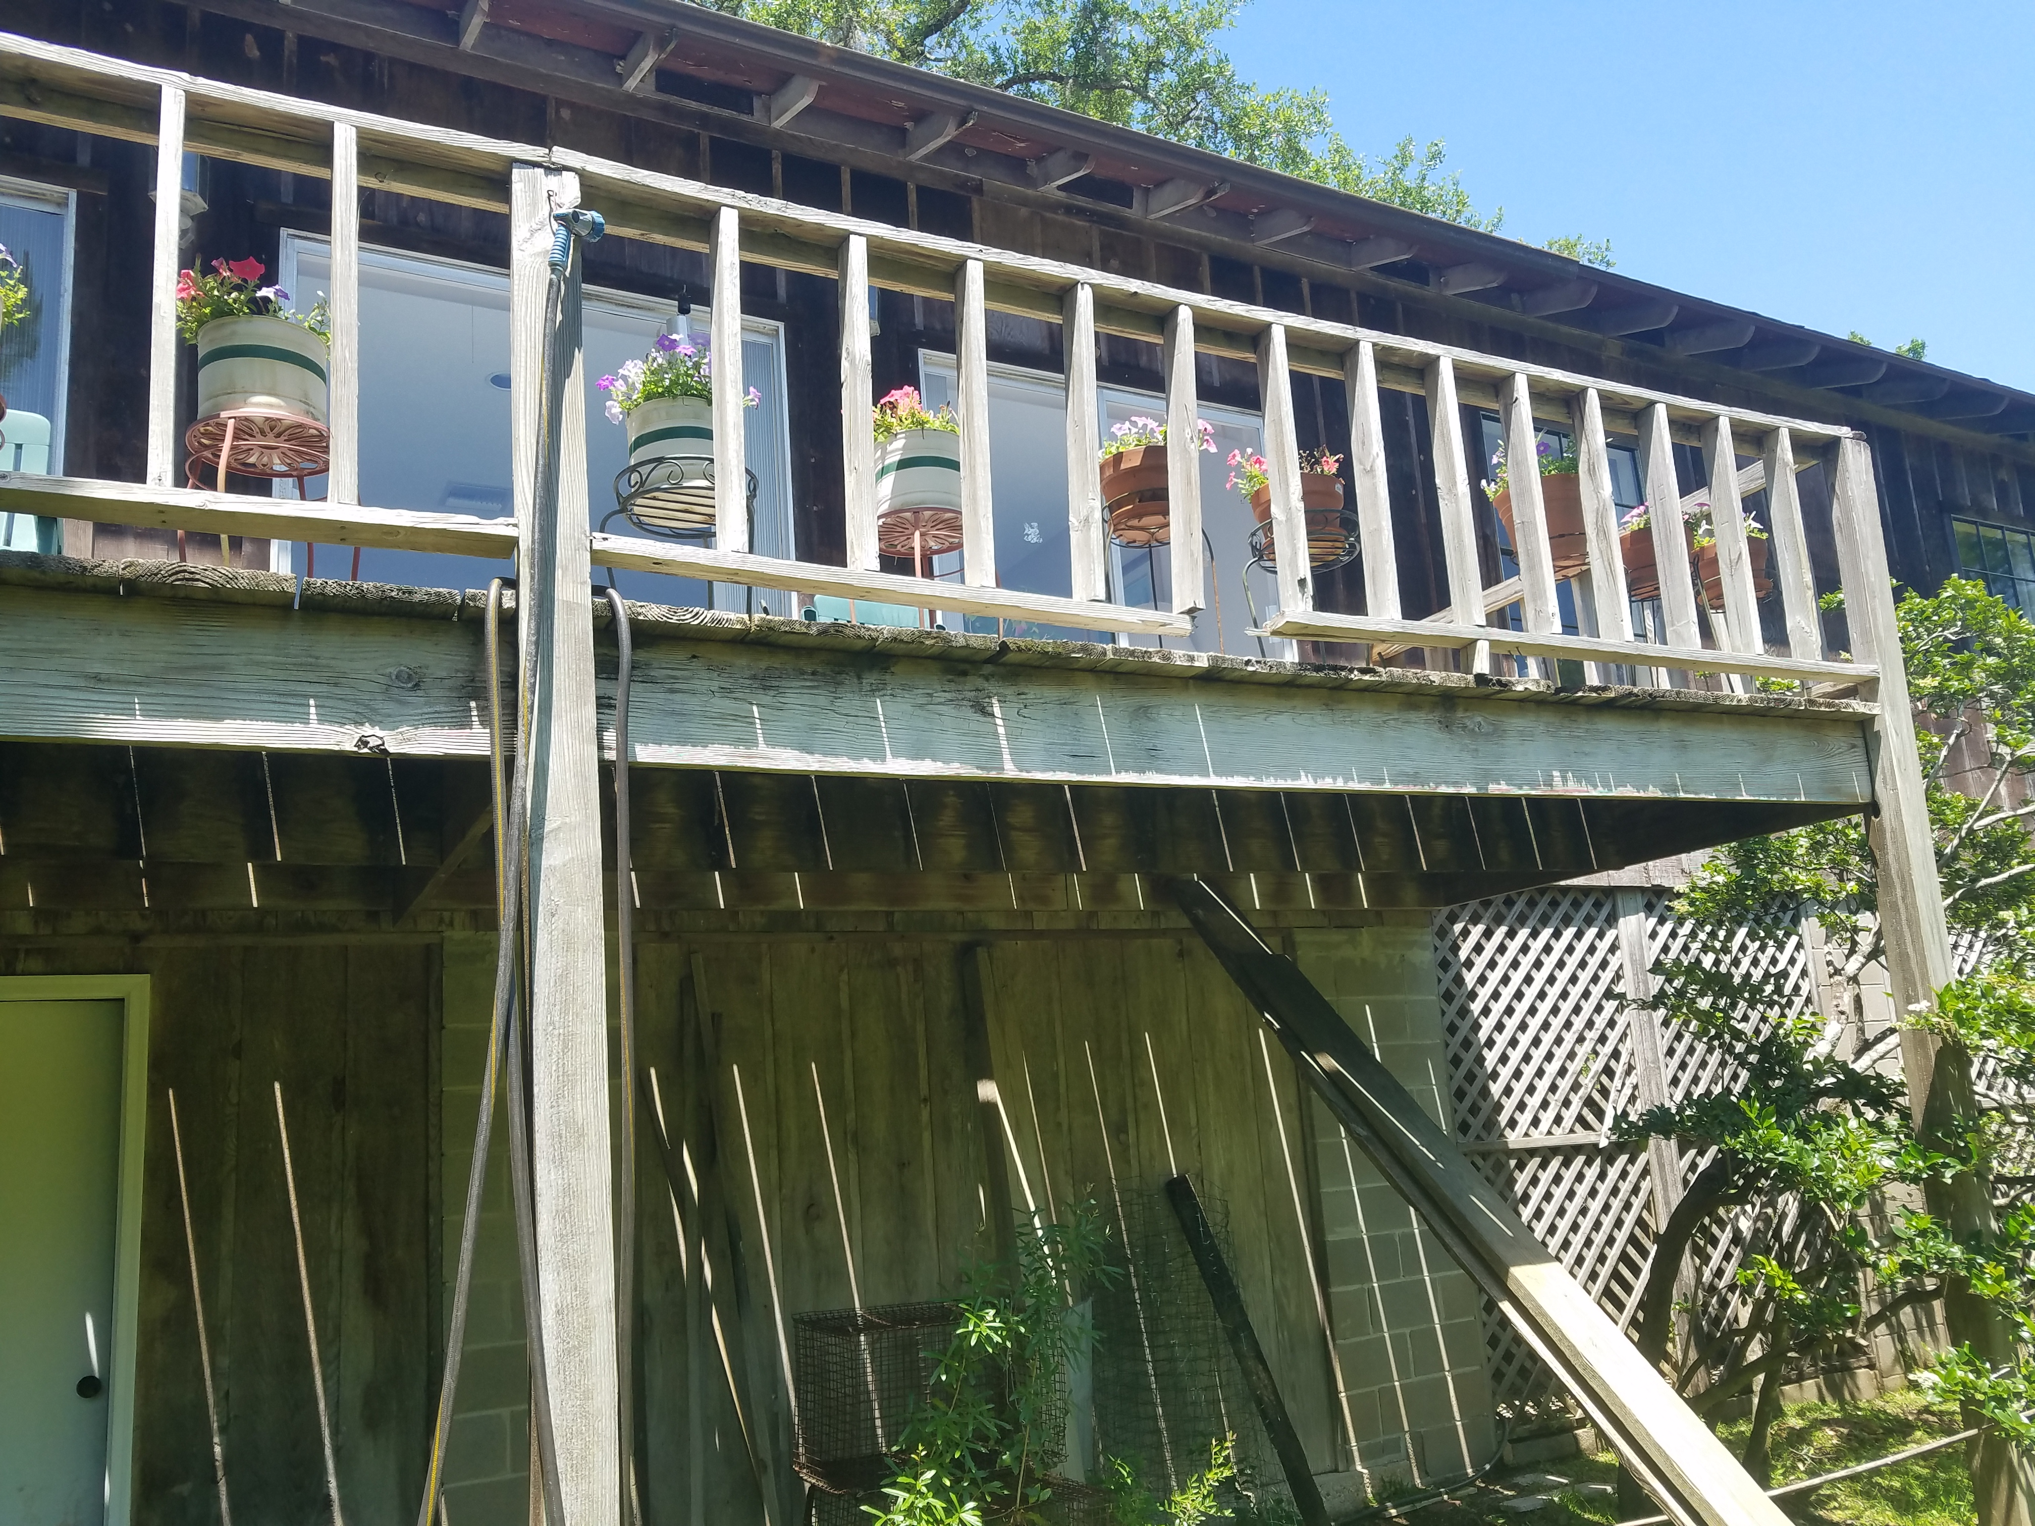
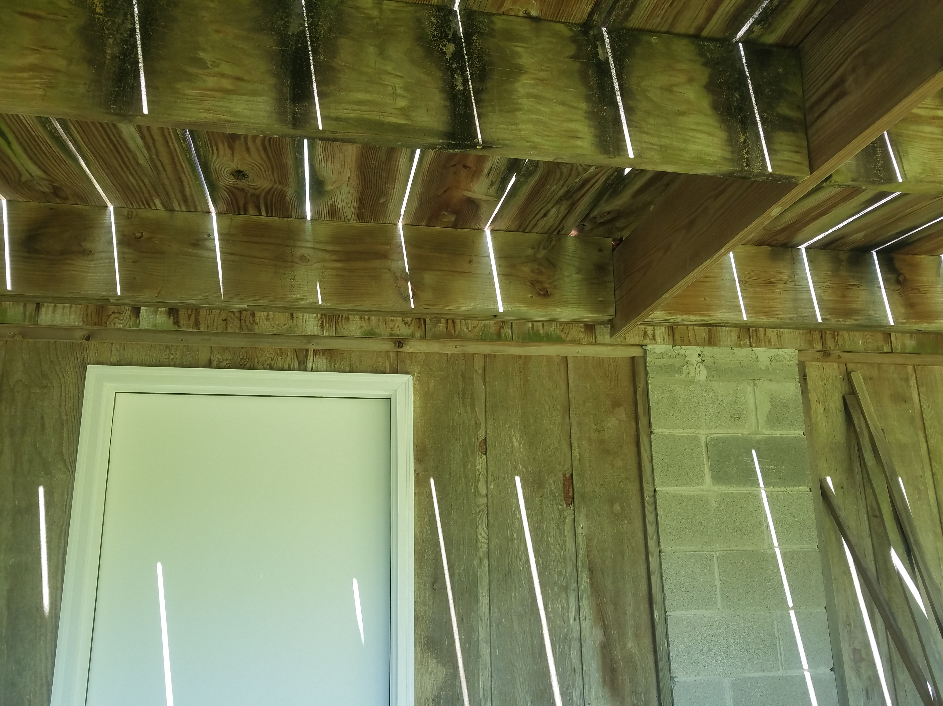

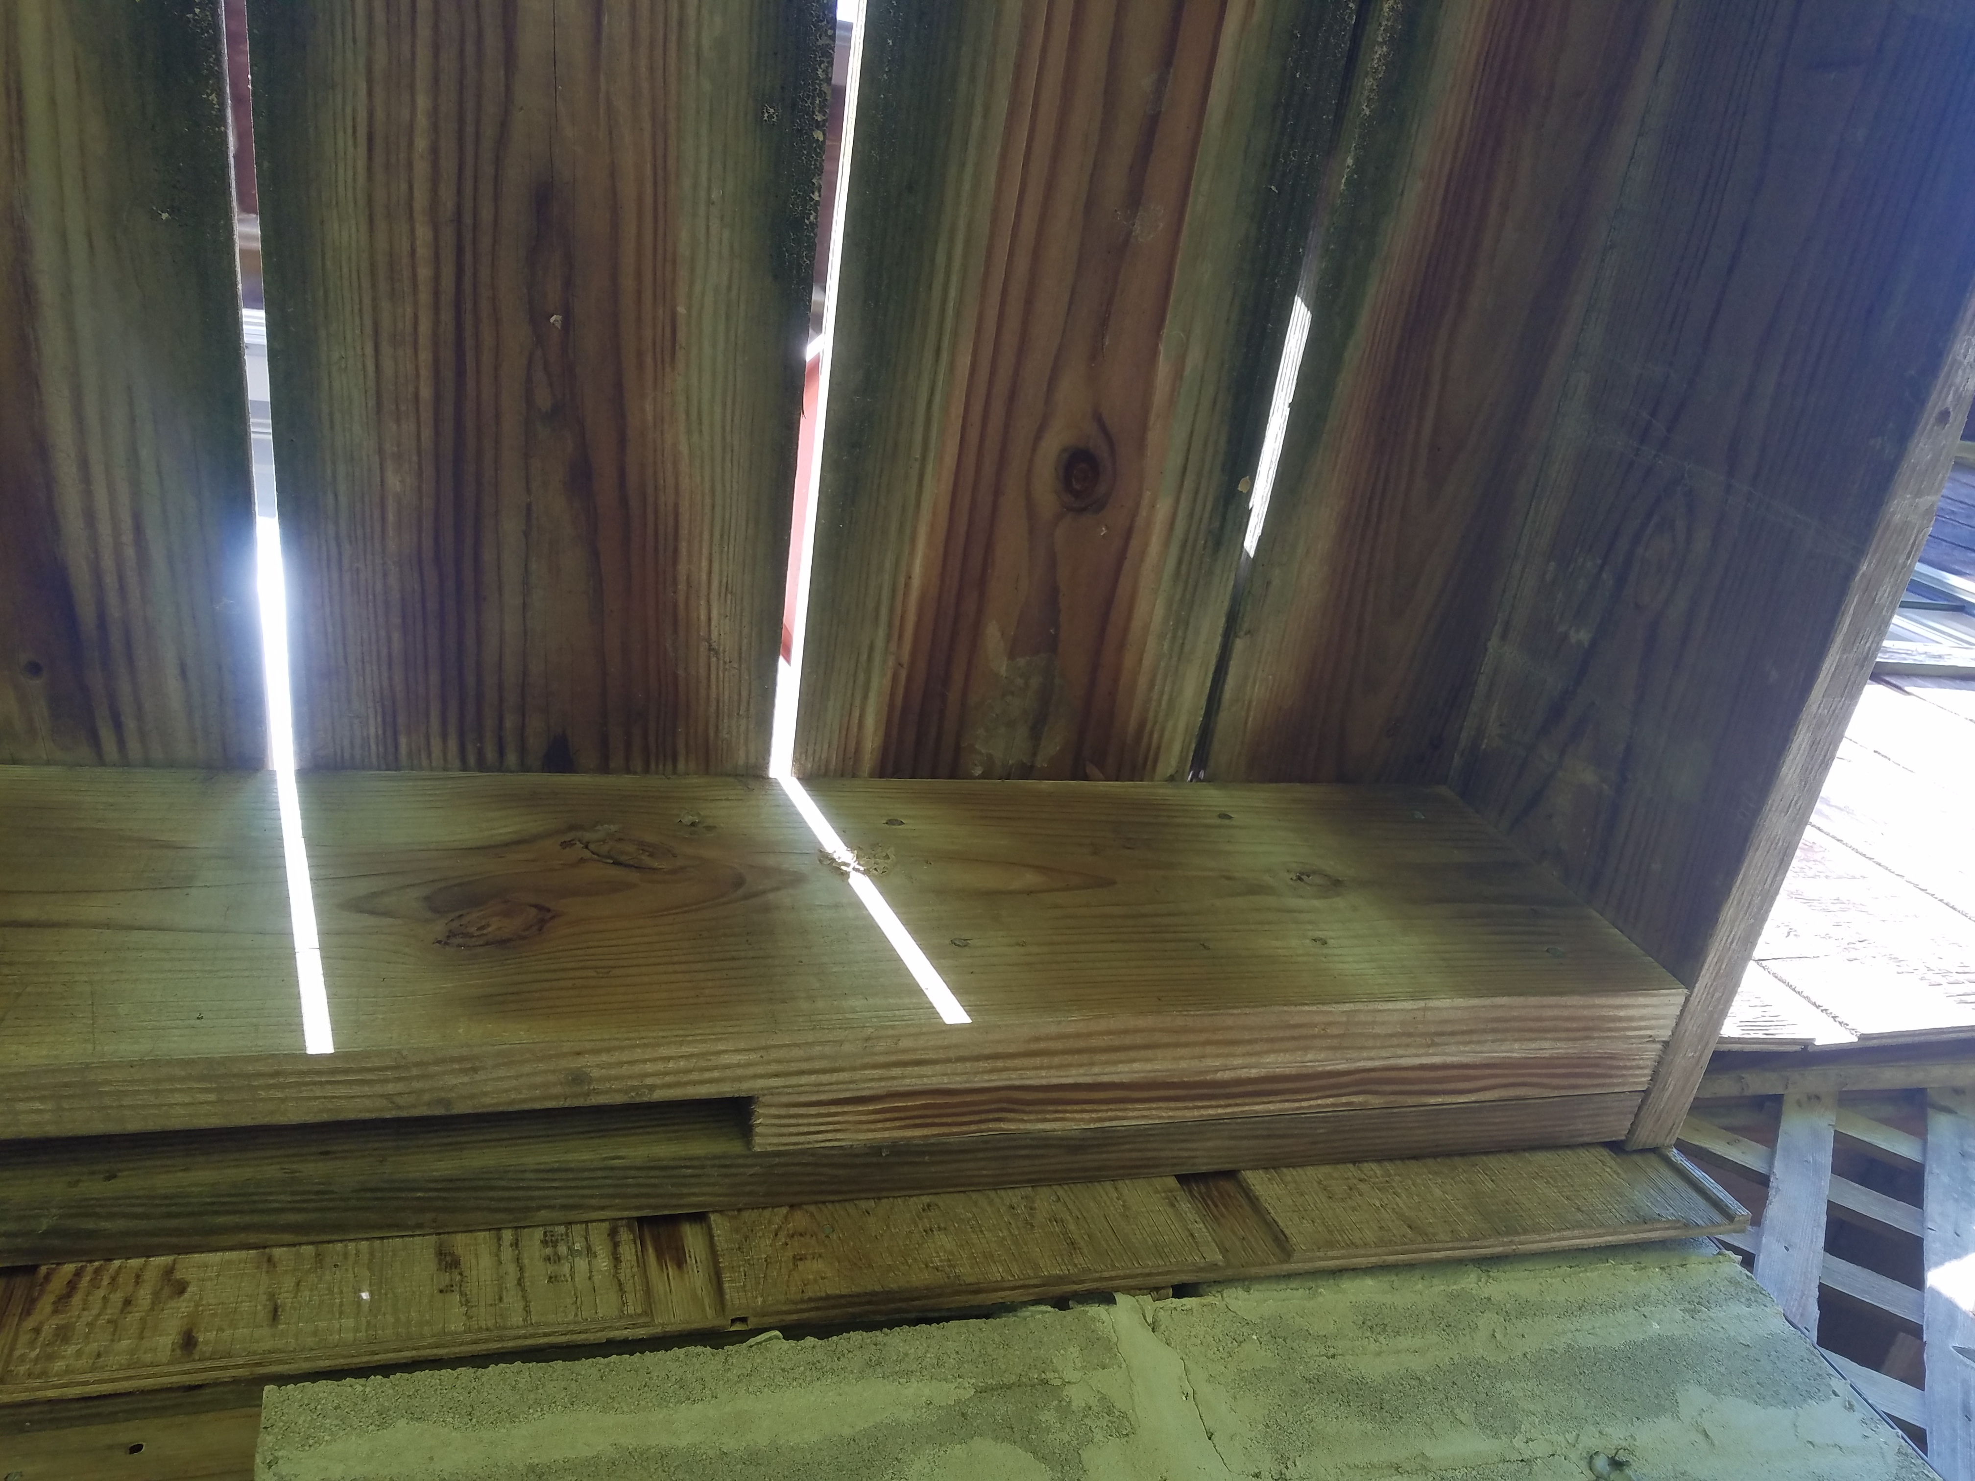
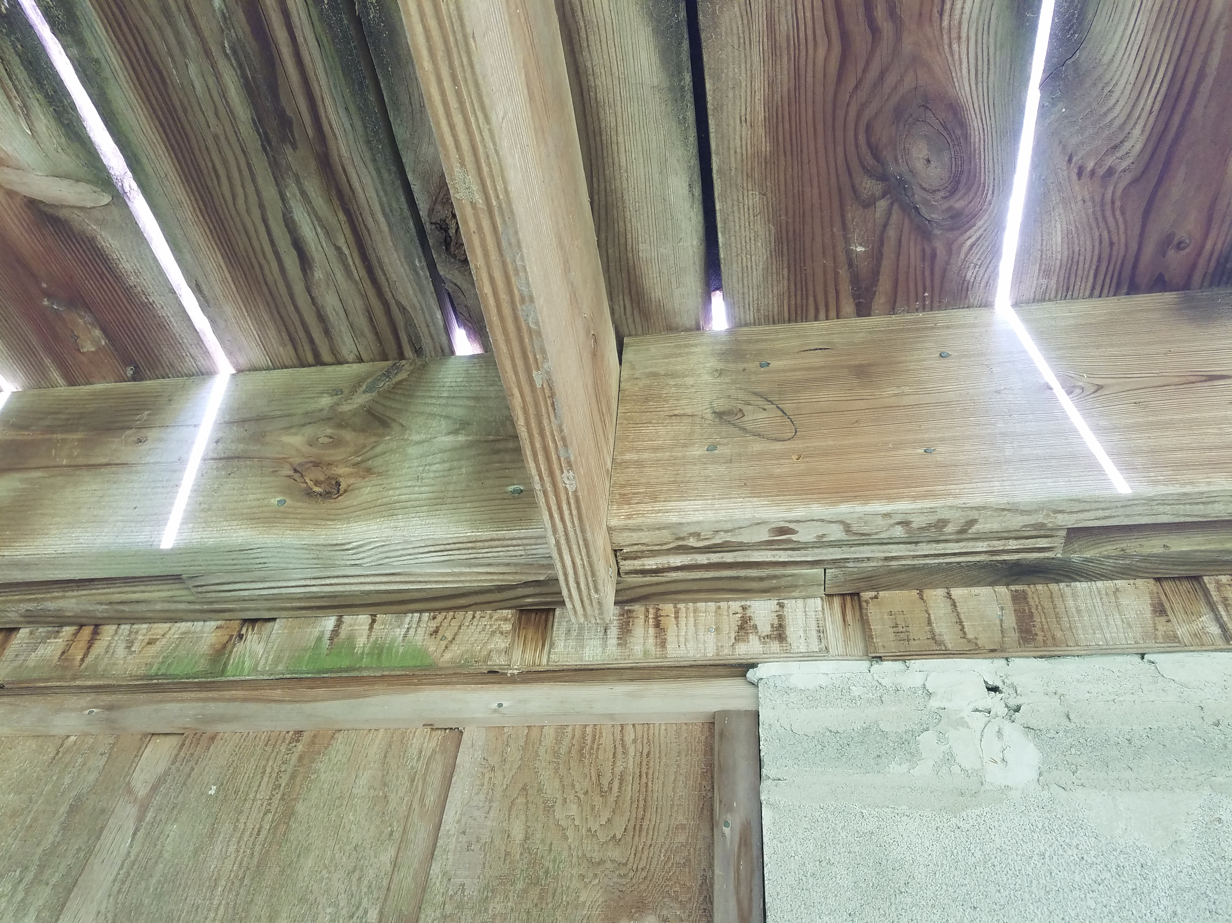
1. Some of the decking floor board have started to decay on the ends of the board that faces the sun. Replace the boards with new floor boards.

2. The bottom railing has been removed on one section of the deck. Replace the bottom rail with one single complete rail that extends from column to column.

3. The supports against the house have been modified to allow rainwater to drain before entering the sliding glass window. These supports shall be firmly attached to the structure. Use a minimum of 3 ½” carriage bolts @ each support location; space the bolts in a triangular configuration with a minimum of 6” between bolts. Carriage bolts shall be long enough to extend through all blocking used to create a gap between building and deck into the structure’s rim board which is directly supported by the CMU block wall.

4. There is one support board between the column and the house that is separating from the support board. Install a Simpson Strong-Tie joist hanger to support this member.

