
554 Old Spanish Trail
Slidell, LA 70458
Phone: 985-649-5832

dammonengineering.com
info@dammonengineering.com

August 26, 2025

M.S. Rau
Glynn Palermo
Chief Restoration Officer

Ref: M.S. Rau Warehouse
2223 Perdido St.
New Orleans La. 70119

Dear Mr. Palermo,

It was a pleasure to speak with you and discuss plans for the new lean to building for the warehouse at subject location. Dammon Engineering, Inc. is pleased to propose our services to design the following. We will provide a design package, including Site Plan, Floor Plan, Structural Plans for the Slab, Electrical, Mechanical, and Plumbing Plans ready for permitting. The metal building will be designed by the building manufacturer. We understand that a paint booth is to be installed, however we do not design paint booths. If a paint booth is selected we can incorporate the design into our plans.

We propose a fee of $17,500.00 (Seventeen thousand five hundred dollars) for this work.

Our fee includes five sets of plans provided to you following the Fire Marshal's review and response, as well as the Louisiana State Fire Marshal Review Fee.

Our fee does not include the cost of project management, local permits, soils analysis, survey, landscaping, drainage studies of property, wetlands determination, or other engineering studies that may be required by government agencies. Our fee also does not include design of the sprinkler or fire alarm systems.

If selected, we will invoice $3,000.00 at start up, our remaining fee after fire marshal review.

We believe that you will also need the following:
1. A current survey of the property including the topographical elevations with utilities.
2. A soil boring will be required.
3. Sprinkler System will be required to be updated. This can be easily done using your current provider.
4. Alarm System will be required to be updated. This can be easily done using your current provider.

We look forward to working with you on this project. Please indicate your acceptance of the above by signing below. If you have any questions, or require any further information, please feel free to call.

Sincerely,
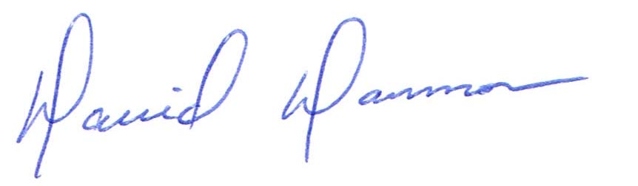

David Dammon, President
August 26, 2025

Accepted: _____________________ Date:__________________

