
554 Old Spanish Trail
Slidell, LA 70458
Phone: 985-649-5832
dammonengineering.com
info@dammonengineering.com

February 19, 2025

Andrew McIver
Southern Interior Solutions
404 E Gibson Street., 2
Covington, LA

Re: 332 N. New Hampshire Suite 209 MEP Drawings

Mr. McIver,

Thank you for considering Dammon Engineering. We are pleased to propose our services for the subject project in Covington La.
Our understanding is that this agreement is for the Mechanical, Electrical and Plumbing plans of the estimated 2,900 s.f. Office Build-Out. We propose a fee $8,500.00.
If selected, we will bill 100% of the total after the plans have been provided to your office.

Our fee does not include the cost of designing sprinkler or fire alarm systems, soils analysis, survey, drainage studies, wetlands determination, or other engineering studies that may be required by government agencies nor does it include the cost of plan review or permits by the municipality. These items, if provided by Dammon Engineering, will be billed at a "cost plus" fee.

We look forward to working with you on this project. Please indicate your acceptance of the above fee by signing below. If you have any questions, or require any further information, please feel free to call.

Sincerely,

If you have any questions, please contact me.

Thank You,

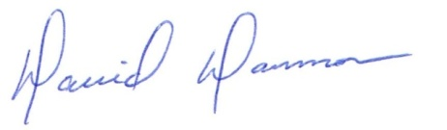
David Dammon __________________________________
President Andrew McIver

