To be used as Front Cover

TYPE I-A PROFESSIONAL SERVICES APPLICATION
Renovations and Additions Projects

ST. TAMMANY PARISH SCHOOL BOARD
July, 2013

QUALIFICATIONS STATEMENT
OF

Dammon Engineering, Inc.

for

 | Pontchartrain / Tchefuncte |  |  |  | Fontainebleau Jr. High
 | Pearl River High |  |  |  | Clearwood Jr. High
 | Mandeville Elementary |  |  |  | Abney Elementary
 | Slidell High |  |  |  | Northshore High
 | Lyon Elementary |  |  |  | Madisonville Elementary
 | Carolyn Park Middle |  |  |  | Mandeville Jr. High
 | Fontainebleau High |  |  |  | Chahta-Ima Elementary
 |  | X | ALL OF THE ABOVE

Mailing Address: | 554 Old Spanish Trail
 | Slidell, Louisiana 70458
Street Address: | 554 Old Spanish Trail
 | Slidell, Louisiana 70458
Contact Person: | Chuck Dammon
Title: | Vice President
Phone No.: | 985-649-5832
Fax No.: | 985-641-5950
E-Mail Address: | dammoneng@bellsouth.net

 | Yes* | X | No
Is this an association of two or more firms?

*If yes, provide details of the association as indicated on the next page ‘Project Team’.

PROJECT TEAM*

 | Pontchartrain / Tchefuncte |  | Fontainebleau Jr. High |  | Pearl River High |  | Clearwood Jr. High |  | Mandeville Elementary
 | Abney Elementary |  | Slidell High |  | Northshore High |  | Lyon Elementary |  | Madisonville Elementary
 | Carolyn Park Middle |  | Mandeville Jr. High |  | Fontainebleau High |  | Chahta-Ima Elementary | X | ALL OF THE ABOVE

ARCHITECT/ENGINEER Firm that will sign contract with St. Tammany Parish School Board: Dammon Engineering, Inc.

Associated Firm & Address (if applicable)**:

List consultants that will be retained for this project. All consultants must be listed. If selected, any changes or additions to this list will require the written approval of the Owner. Projects involving Kitchen design/renovation will require a Food Facility Consultant.

Consultant Type | Consultant Firm Name | Location  (City & State)
MECHANICAL
ELECTRICAL
CIVIL
STRUCTURAL
LANDSCAPING | Eric R. McQuiston, LLC | Slidell, Louisiana
FOOD FACILITY CONSULTANT
(projects with kitchen facilities only)
OTHER
Type: __________________

* If different project teams are planned for different projects, copy this sheet and include respective project team information.

**If this is an association of two firms, please indicate the planned organization and assigned duties of each firm on a continuation sheet.

Note: If more than one consultant is being considered for a particular discipline, please include at “other” line.

X | All Projects
 | Project(s) as listed below*:
Evaluation Criteria 10.1.1/10.1.4
Points 10

EDUCATION/EXPERIENCE OF KEY PERSONNEL
List all Key Personnel that will be assigned to the proposed project(s). Do not include Consultants. Provide a brief resume (see sheets following this section) for those key personnel that will be in direct charge at any/all phases of the project on the forms following this page. (text will wrap in cells) Use Continuation Sheet as needed.

Name | Title | Project Assignment | Years with Firm | Years with Other Firms | Professional License # | Year First Licensed | Degrees Earned
Kevin J. Kinchen | Chief Architect | Architectural Design/Design Oversight | 1 | 24 | 5590 | 2001 | B.S. Architecture
Emmett G. Dammon | Chief Engineer | Engineering Review/Approval | 27 | 21 | 8796 | 1965 | B.S. Engineering
David P. Dammon | Engineering Intern | Engineering Design | 9 | 29 | 31305EI | 2013 | B.S. Engineering

*If personnel to be assigned varies by project(s), copy this sheet and list particular projects as indicated in upper left hand corner.
Evaluation Criteria 10.1.1/10.1.4
Points 10

Continuation Sheet

Name | Title | Project Assignment | Years with Firm | Years with Other Firms | Professional License # | Year First Licensed | Degrees Earned

Evaluation Criteria 10.1.1/10.1.4
Points 10

QUALIFICATIONS OF INDIVIDUAL WHO WILL BE IN DIRECT CHARGE OVER ENTIRE PROJECT
Provide the name and resume (no more than 2 pages) of the individual within the Applicant’s organization who will have direct charge of the St. Tammany Parish School Board’s work.

Name: | Kevin J. Kinchen
Title: | Chief Architect
Years with Firm: | 1 | Professional License #: | 5590
Years with other Firms: | 24 | Year First Licensed: | 2001
Degrees Earned: | B.S. Architecture – Louisiana State University
Continuing Education: | Continuing Education is accomplished as required by licensing
 | board and Dammon Engineering, Inc.
Experience Relative to  Type I-A Projects: | Kevin Kinchen served as the Project Architect for RSD Bienville School and Camp Abby Renovations & Repairs. With Dammon Engineering he has been involved in both renovation and new construction projects. Mr. Kinchen was the Project Architect for the Textron Marine & Land Systems Renovations for the second floor of Building Three located in New Orleans. This project consisted of the renovation of 24,605 s.f. of office space. Mr. Kinchen has also served as the Project Architect on the Bikram Yoga renovation in New Orleans - which consisted of the renovation of an existing building to accommodate a new Yoga Studio & Living Quarters - as well as the new Woodhouse Day Spa location in Baton Rouge, Louisiana.

Evaluation Criteria 10.1.1/10.1.4
Points 10

EDUCATION/EXPERIENCE OF KEY PERSONNEL
Provide a brief resume (no more than one page) of each key professional/person who will be in charge of any/all phases of the proposed project. (Do not include consultants) Copy sheet as needed.

Name: | David P. Dammon
Title: | VP/Engineer Intern
Project Assignment: | Engineering Design
Years with Firm: | 9 | Professional License #: | 31305EI
Years with other Firms: | 29 | Year First Licensed: | 2013
Degrees Earned: | B.S. Engineering – University of New Orleans
Continuing Education: | Continuing Education is accomplished as required by the licensing
 | board and Dammon Engineering, Inc.
Experience Relative to  Type I-A Projects: | David Dammon has worked on countless renovation and addition projects for Dammon Engineering, including the complete office renovation for the People’s Health Network, totaling over 80,000 s.f. and including Architectural, Electrical Mechanical and Plumbing systems, as well has hospital renovations and numerous renovation/buildout locations for Quizno's, Papa John's Pizza & Marco's Pizza.

Evaluation Criteria 10.1.1/10.1.4
Points 10

EDUCATION/EXPERIENCE OF KEY PERSONNEL
Provide a brief resume (no more than one page) of each key professional/person who will be in charge of any/all phases of the proposed project. (Do not include consultants) Copy sheet as needed.

Name: | Emmett G. Dammon
Title: | President/Chief Engineer
Project Assignment: | Engineering
Years with Firm: | 26 | Professional License #: | 8796
Years with other Firms: | 18 | Year First Licensed: | 1965
Degrees Earned: | B.S. Engineering – Lamar University, Beaumont, TX
Continuing Education: | Continuing Education is accomplished as required by the licensing
 | board and Dammon Engineering, Inc.
Experience Relative to  Type I-A Projects: | Emmett (Pete) Dammon founded Dammon Engineering in 1986. Since opening Dammon Enginering, Mr. Dammon has been engaged inprojects that range from design of schools to city streets, to Superdome renovations, Department of Defense projects for facilities, local commercial, religious, school, and government project and health facilities.  Mr. Dammon was the Chief Engineering for the renovation of the ST. Tammany Parish Administrative Complex ("Towers" Building), which was heavily damaged during Hurricane Katrina.  Mr. Dammon has been honored by the Louisiana Engineering Society of multiple occasions and is involved in many local civic clubs dedicated to the betterment of our community.

Evaluation Criteria 10.1.2
Points 10

GENERAL PRIOR WORK EXPERIENCE
List architectural and/or engineering projects with a construction budget/cost of $1 Million – $20 Million for which applicant or any of its partners, shareholders, employees or joint ventures have been selected within three (3) years of the date of this application. If the project listed was not performed by the applicant firm, list the firm responsible in parentheses after the description. Projects by consultants should not be listed in this section. Copy sheet as needed..

Project Name and Location | Client | Project Description | Project Cost | Current Phase | Estimated Completion Date
Women’s Imaging Center  Slidell, LA | Slidell Memorial Hospital | New Women’s Imaging Center | $1,131,000.00 | Complete | 04/2012
Bingo Warehouse  Slidell, LA | K.B. Kaufmann & Co. | New Warehouse with Office Facilities | $1,000,000.00 | Construction Complete | 11/2012
Living the Word Church  Slidell, LA | K.B. Kaufmann & Co. | New Sanctuary with Fellowship Facilities | $2,500,000.00 | Construction Complete | 02/2013
LaQuinta Inn  Gonzales, LA | Dapco Ventures, LLC | New Hotel with Amenities | $3,510,000.00 | Complete | 08/2013
Fire Station #14  Slidell, LA | St. Tammany Fire Protection District No. 1 | New Fire Station with Apparatus/Bay area and Living Quarters | $1,057,000.00 | Construction Start | 02/2014
LaQuinta Inn Hattiesburg, MS | My Hospitality Hotels | New Hotel with Amenities | $3,500,000.00 (Est.) | Final Design Phase | 06/2014
Textron Marine & Land Systems  New Orleans, LA | Textron Marine & Land Systems | Renovation of 24,605 s.f. of office space | $1,500,000.00 | Final Construction Phase 99% | 08/2013
JD Plaza  Slidell, LA | K.B. Kaufmann & Co. | New 9,000 s.f. Retail Shopping Center | $1,080,000.00 | Construction Complete | 06/2011
Dr. Aduli Office  Covington, LA | K.B. Kaufmann & Co. | New Medical Facility with Treatment Rooms | $1,200,000.00 | Design 50% Complete | 01/2013

(Additions) Evaluation Criteria 10.1.2
Points 10

RELATED WORK EXPERIENCE: SCHOOL ADDITIONS

Applies to Pontchartrain/Tchefuncte, Fontainebleau Jr., Lyon Elementary, Madisonville Elementary, Mandeville Elementary, Clearwood Jr.

List up to six (6) projects which are under contract /were completed within the past 5 years for which the Applicant firm provided the prime architectural/engineering services that are similar to the proposed project. Provide photos.

Project Name and Location | Client | Project Description | Project Cost | Current Phase | Estimated Completion Date
Head Start  Opelousas, LA | Child Development Council of Acadiana | Addition of New Classrooms/Offices | $1,776,000.00 | Const. Complete | 2011
STPSB Ciruti Street Office  Slidell, LA | St. Tammany Parish School Board | Renovation of Office Space | $225,000.00 | Const. Complete | 2009
Sylvan Learning Center  Slidell, LA | TeamBG & Associates | New Classroom/Office Facilities | $175,000.00 | Const. Complete | 11/2012
Textron Building 3, Second Floor Renovations  New Orleans, LA | Textron Marine & Land Systems | Renovation of 24,605 s.f. of Office and Training Facility Space | $1,500,000.00 | 99% Const. Complete | 08/2013
Slidell Memorial Hospital Women's Imaging Center  Slidell, LA | Slidell Memorial Hospital | Addition of new 6,000 s.f. wing to existing Imaging Center on Gause Blvd. in Slidell, LA | $2,000,000.00 | Construction Complete | 2011
Tabernacle Missionary Baptist Church Addition | K.B. Kaufmann & Co. | Addition of new 3,687 s.f. Fellowship Hall & Classrooms | $500,000.00 | Construction 90% Complete | 09/2013

Please insert photos (brochure sheets are acceptable)

Textron Marine & Land Systems:
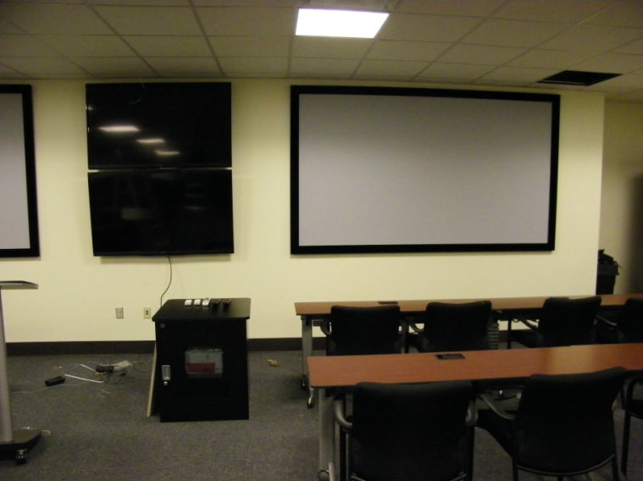
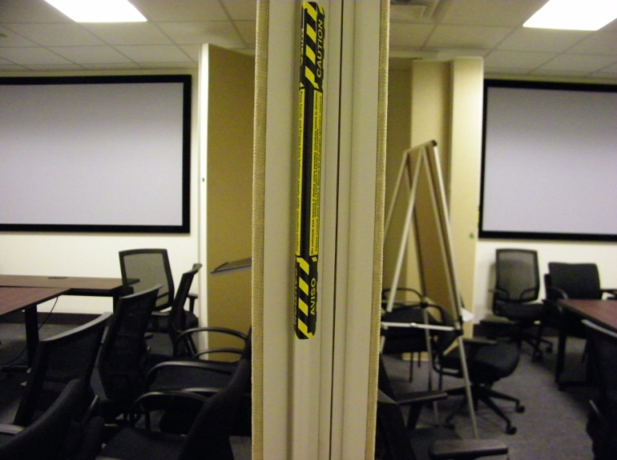

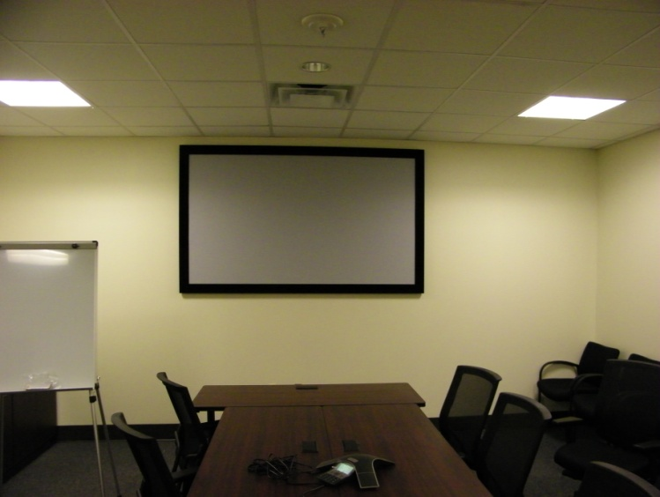
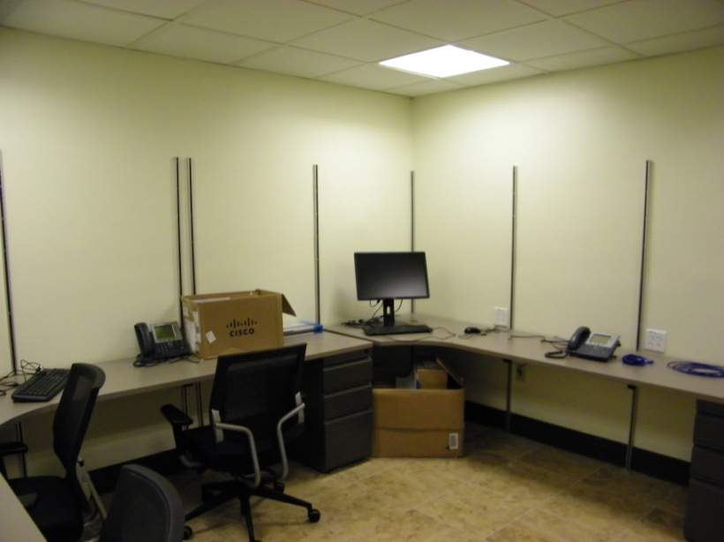
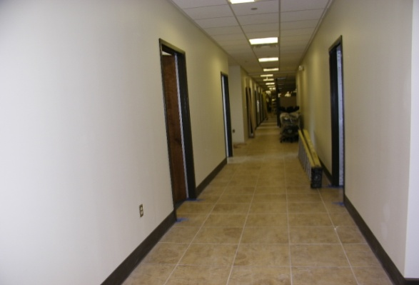
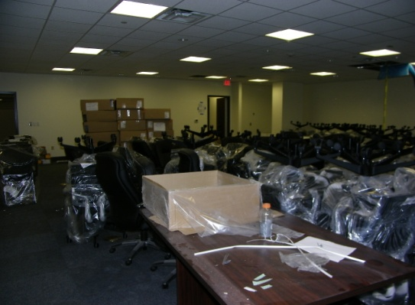
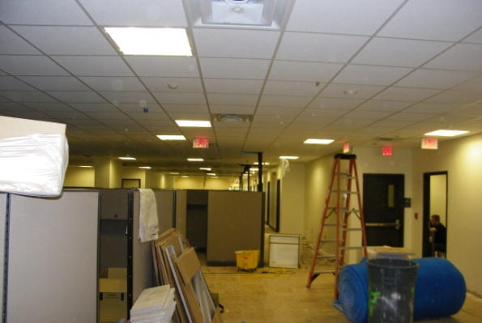

Head Start Opelousas:
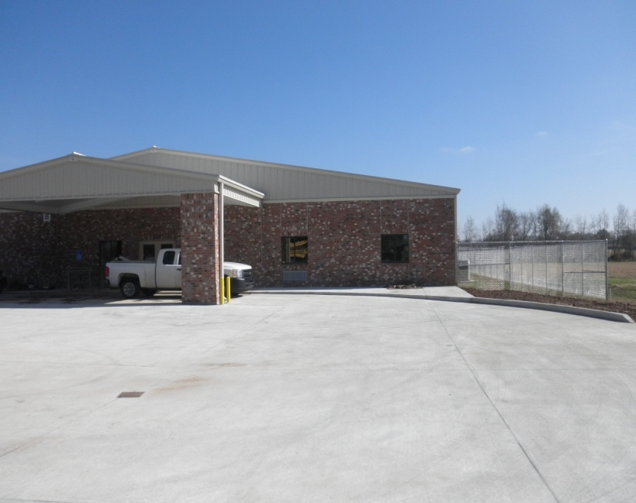
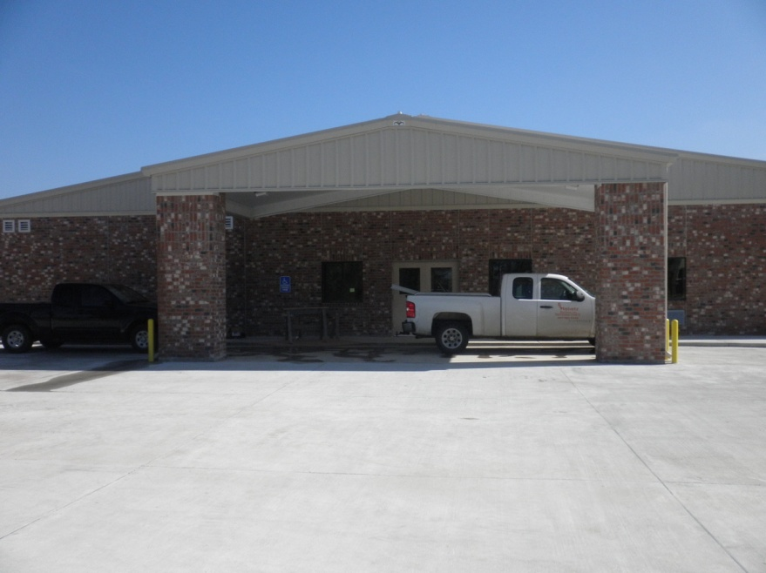

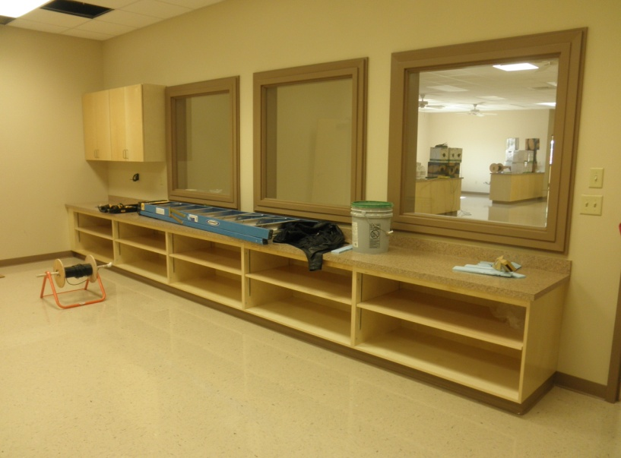
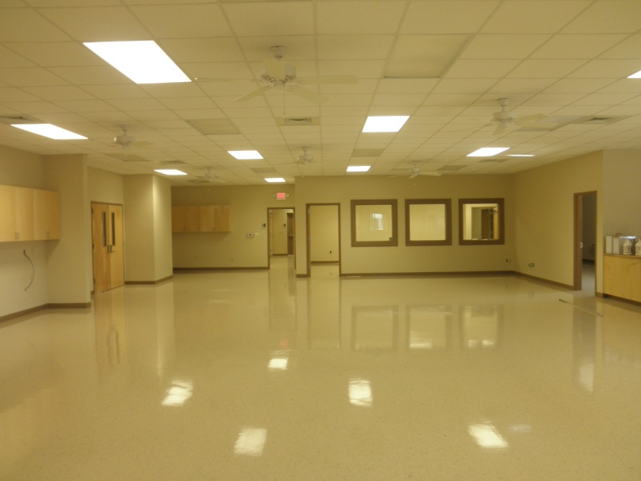
SMH/Women's Imaging Center:
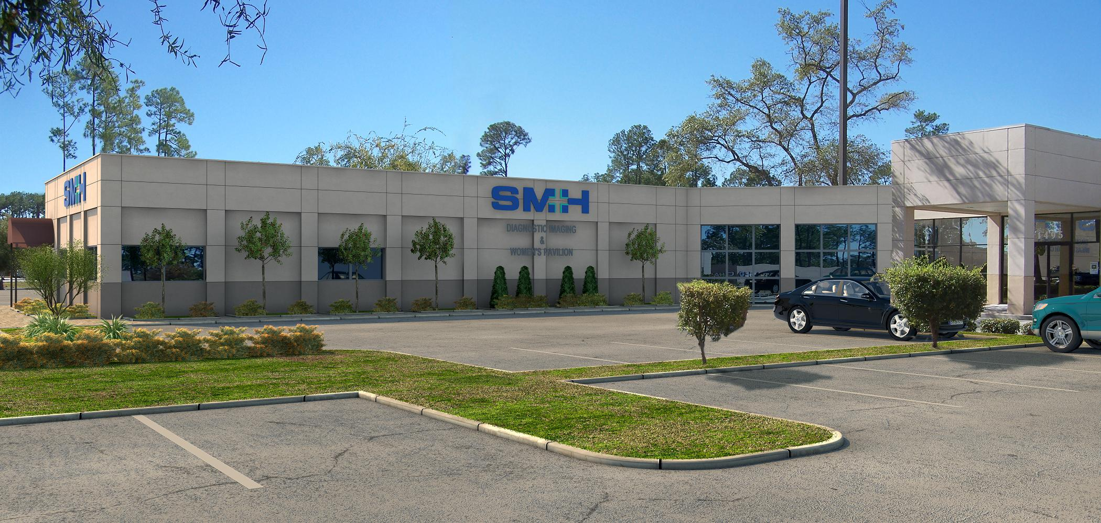

(Renovations) Evaluation Criteria 10.1.2
Points 10

RELATED WORK EXPERIENCE: SCHOOL RENOVATIONS

Applies to Pearl River High, Slidell High, Northshore High, Mandeville Jr. High, Clearwood Jr. High

List up to six (6) projects which are under contract /were completed within the past 5 years for which the Applicant firm provided the prime architectural/engineering services that are similar to the proposed project. Provide photos.

Project Name and Location | Client | Project Description | Project Cost | Current Phase | Estimated Completion Date
Pearl River High School Roof  Pearl River, LA | St. Tammany Parish School Board | New/Repair Roof Work | $20,000.00 | Const. Complete | 2009
STPSB Ciruti Street Office  Slidell, LA | St. Tammany Parish School Board | Renovation of Office Space | $225,000.00 | Const. Complete | 2009
Sixth Ward – Gym & Cafeteria Roofing  Pearl River, LA | St. Tammany Parish School Board | New Roof for Gym and Cafeteria Areas | $80,000.00 | Const. Complete | 2010
Head Start  Opelousas, LA | Head Start Opelousas | New Classrooms/Offices | $1,776,000.00 | Const. Complete | 2011
Sylvan Learning Center  Slidell, LA | TeamBG & Associates | New Classroom/Office Facilities | $175,000.00 | Const. Complete | 11/2012
Textron Building 3, Second Floor Renovations  New Orleans, LA | Textron Marine & Land Systems | Renovation of 24,605 s.f. of Office and Training Facility Space | $1,500,000.00 | 99% Const. Complete | 08/2013

Please insert photos (brochure sheets are acceptable)
Pearl River High School/Industrial Arts Building Roof:
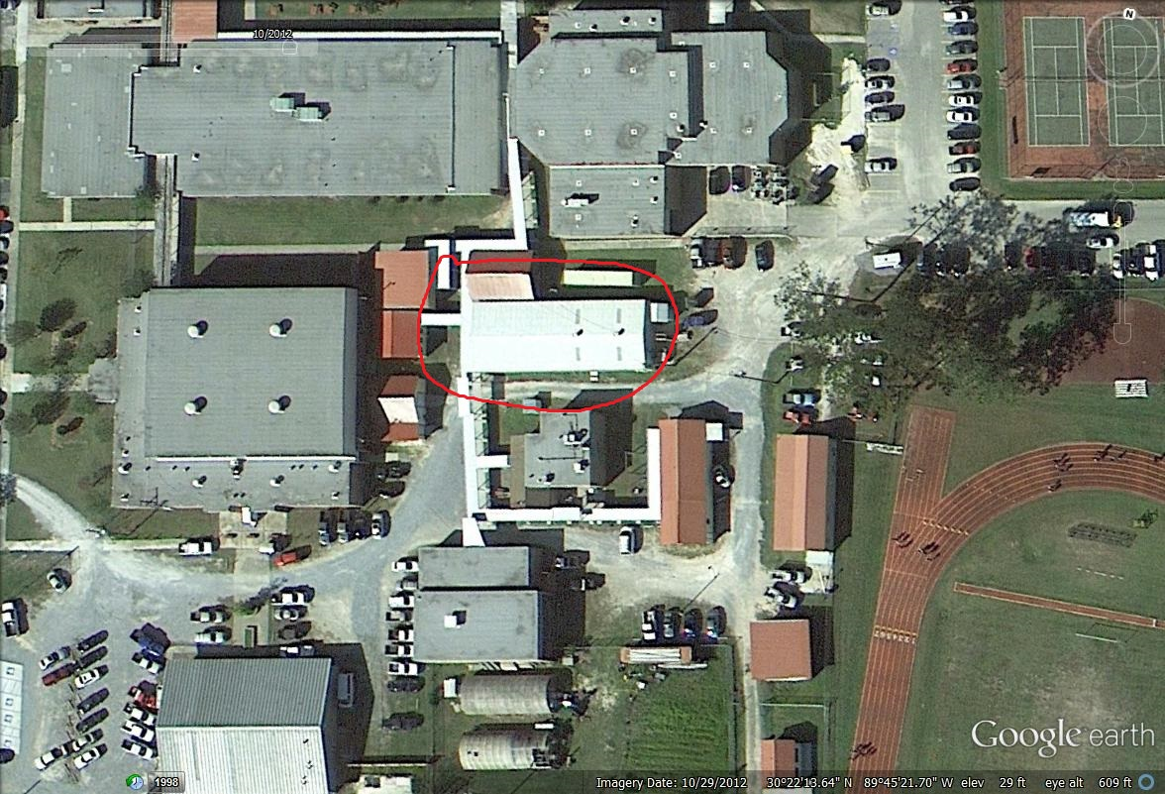
Sixth Ward Elementary/Cafeteria & Gym Roof:
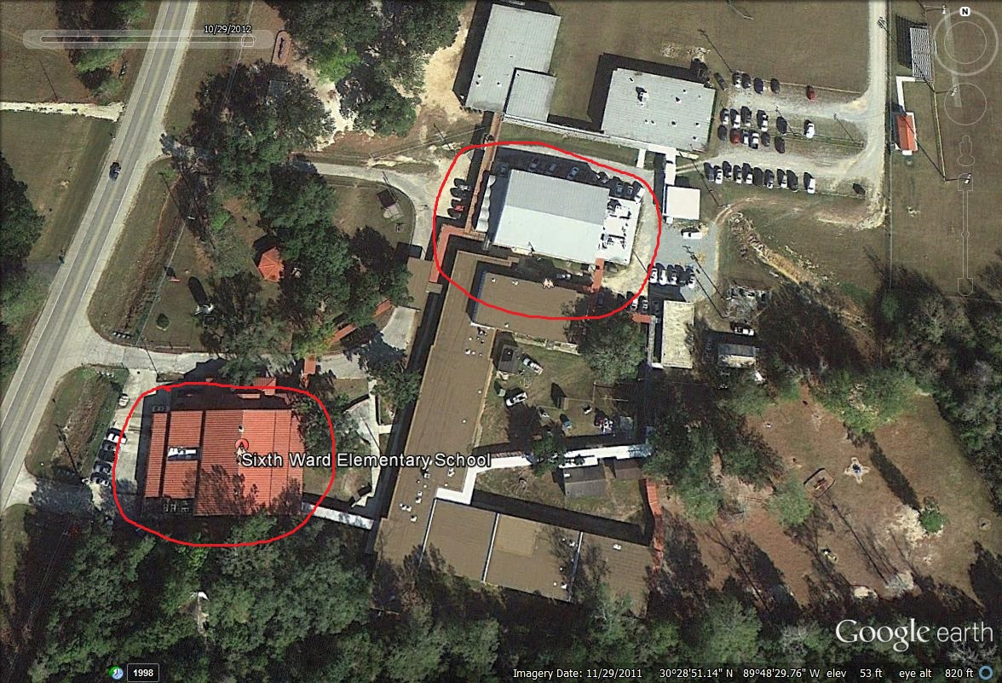

(Kitchen/Cafeteria) Evaluation Criteria 10.1.2
Points 10

RELATED WORK EXPERIENCE: KITCHEN/CAFETERIA/PROSTART: NEW/RENOVATION

Applies to Pearl River High, Slidell High, Northshore High, Carolyn Park Middle, Abney Elementary

List up to six (6) projects which are under contract /were completed within the past 5 years for which the Applicant firm provided the prime architectural/engineering services that are similar to the proposed project. Provide photos.

Project Name and Location | Client | Project Description | Project Cost | Current Phase | Estimated Completion Date
Slidell Memorial Hospital Cafeteria Renovation  Slidell, LA | Slidell Memorial Hospital | Cafeteria (Kitchen/Dining Room) Renovation | $270,000.00 | Const. Complete | 2011
McAllister’s Deli’s  Texas | Angie Odom & Associates | Various McAllister’s Deli locations throughout Texas (Keller, Plano, Fort Worth, Austin, Lubbock) | $750,000.00 (Typ.) | 1 = Initial Design Phase | 04/2014
Marco’s  Various | Mr. Robert Curtis | Various Marco’s Pizza Locations in Louisiana | $150,000.00 (Typ.) | Const. Complete | Various thru 2011
Quizno’s Subs  Various | David Lake/Quizno's Corp. | Various Locations Throughout Louisiana & Mississippi | $150,000.00 (Typ.) | Const. Complete | Various thru 2010
Papa John's Pizza  Various | Don Bauer/Rohoho, Inc. | Various Locations of Papa John's Pizza in New Orleans Area | $150,000.00 (Typ.) | Const. Complete | Various thru 2012

Please insert photos (brochure sheets are acceptable)
Slidell Memorial Hospital Cafeteria Renovation:
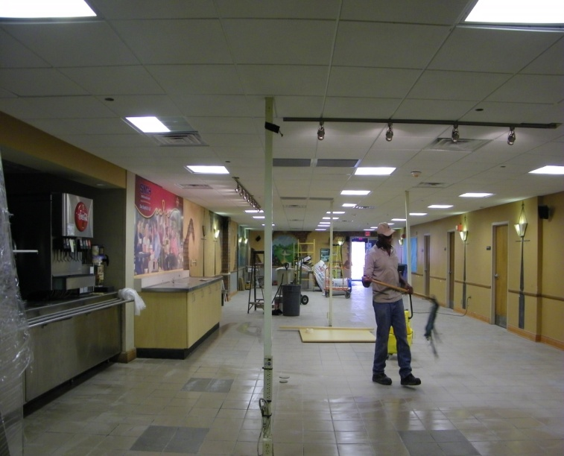
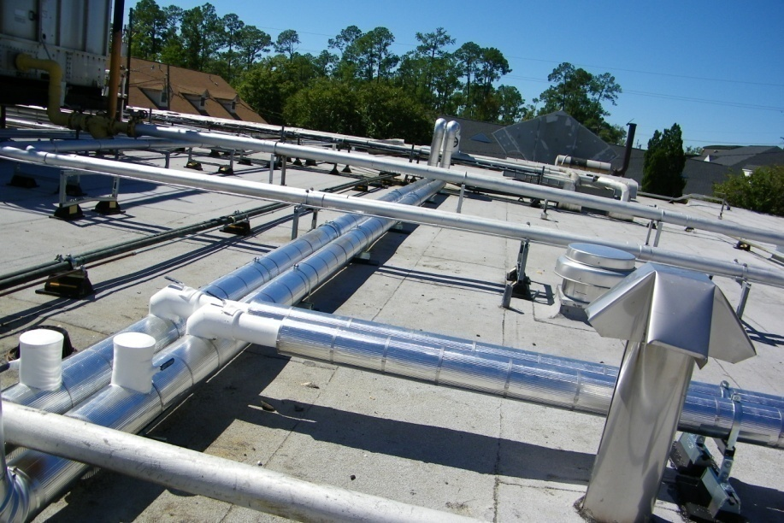

(New Administration) Evaluation Criteria 10.1.2
Points 10

RELATED WORK EXPERIENCE: NEW ADMINISTRATION/FRONT ENTRY TO SCHOOL

Applies to Chahta-Ima Elementary, Pearl River High

List up to six (6) projects which are under contract /were completed within the past 5 years for which the Applicant firm provided the prime architectural/engineering services that are similar to the proposed project. Provide photos.

Project Name and Location | Client | Project Description | Project Cost | Current Phase | Estimated Completion Date
STPSB Ciruti Street Office  Slidell, LA | St. Tammany Parish School Board | Renovation of Office Space | $225,000.00 | Const. Complete | 2009
Head Start  Opelousas, LA | Head Start | New Classrooms/Offices for Head Start | $1,776,000.00 | Const. Complete | 2011
Sylvan Learning Center  Slidell, LA | New Educational/Classroom Facilities | New Classroom/Office Facilities | $175,000.00 | Const. Complete | 2012
Slidell Memorial Hospital ER Entrance  Slidell, LA | Slidell Memorial Hospital | Relocation of existing SMH ER Entrance, including addition of new waiting room | $245,000.00 | Const. Complete | 2008
Living the Word Church  Slidell, LA | K.B. Kaufmann & Co. | New Sanctuary and Meeting Room Facilities | $3,200,000.00 | Const. Complete | 2012

Please insert photos (brochure sheets are acceptable)

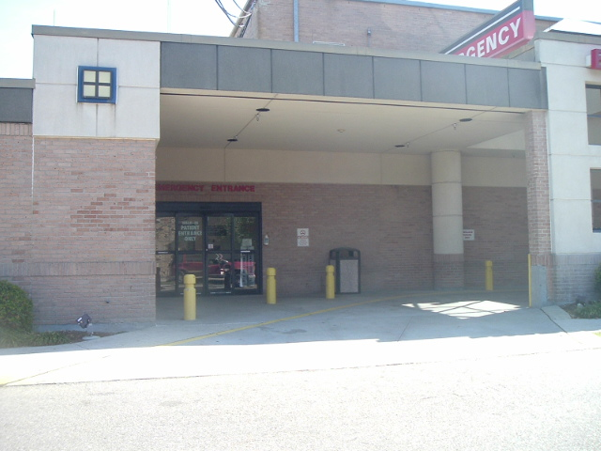
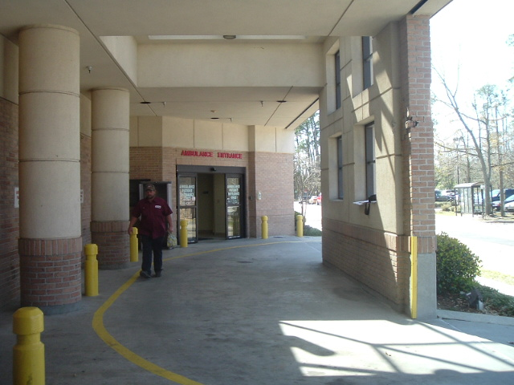
Slidell Memorial Hospital/ER Entrance Renovation

Living the Word International Church:
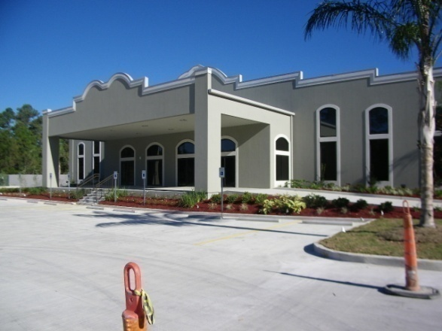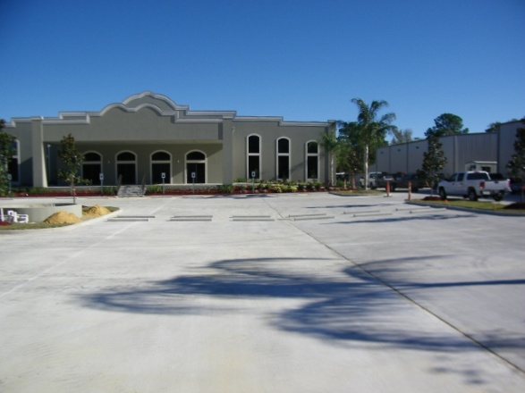

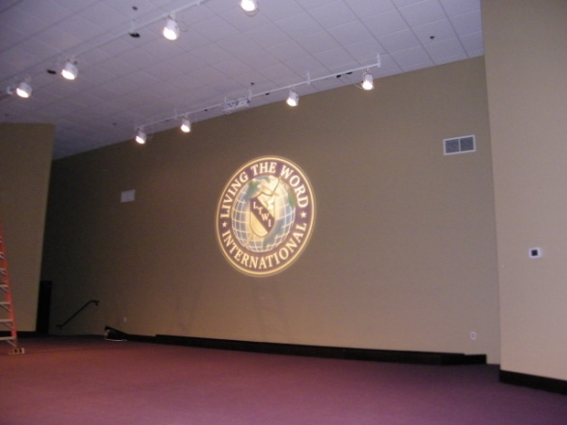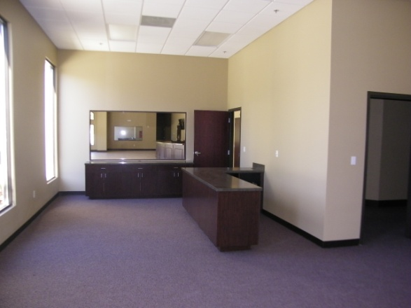

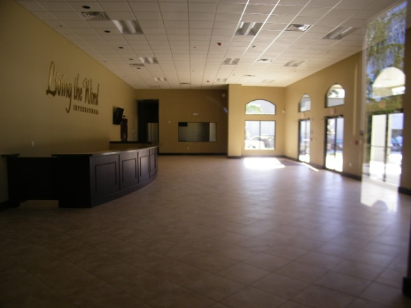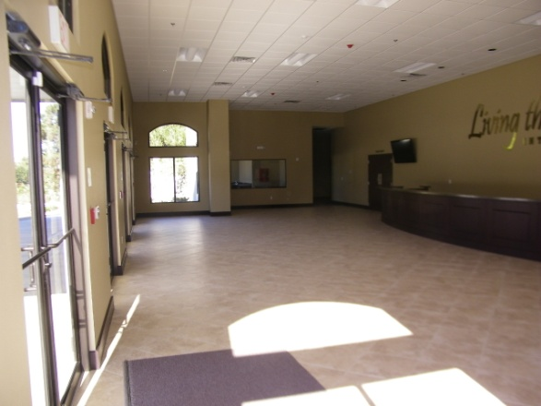

(Exterior Restoration) Evaluation Criteria 10.1.2
Points 10

RELATED WORK EXPERIENCE: EXTERIOR MASONRY RESTORATION, PAINTING, ROOF RECOATING Applies to Fontainebleau High

List up to six (6) projects which are under contract /were completed within the past 5 years for which the Applicant firm provided the prime architectural/engineering services that are similar to the proposed project. Provide photos.

Project Name and Location | Client | Project Description | Project Cost | Current Phase | Estimated Completion Date
Pearl River High School Roof  Pearl River, LA | St. Tammany Parish School Board | New/Repair Roof Work | $20,000.00 | Const. Complete | 2009
Sixth Ward – Gym & Cafeteria Roofing  Pearl River, LA | St. Tammany Parish School Board | New Roof for Gym and Cafeteria Areas | $80,000.00 | Const. Complete | 2010

Please insert photos (brochure sheets are acceptable)

Pearl River High School/Industrial Arts Roof
Sixth Ward Elementary/Cafeteria & Gym Roof:

Evaluation Criteria 10.1.5/10.1.16
Points 10

ADEQUATE STAFF, CONSULTANTS, FACILITIES, EQUIPMENT AND WORKLOAD

PROPOSER’S PERSONNEL
Indicate the number of personnel by discipline in your firm. (List each person only once by primary function.)

9 | Total Personnel

1 | Licensed Architects |  | Intern Architects | 1 | Specification Writers
1 | Construction Inspectors/Field Administrator | 1 | Draftsmen/CADD Operators | 1 | Designer/Technician
 | Interior Designers | 1 | Landscape Architects | 1 | Civil Engineers
1 | Electrical Engineers | 1 | Mechanical Engineers |  | Environmental Engineers
 | Other:

EQUIPMENT/SOFTWARE
Indicate your firm’s current use of AutoCAD/Revit/other software for production of documents.

Dammon Engineering utilizes the latest in technology, including AutoCAD and BricsCad. We also utilize Sketchup in the creation of 3-D color renderings.

PROPOSER’S WORKLOAD
List the Applicant’s five (5) largest current projects that are active or are anticipated to be active in the upcoming months, 2013-15. State how the Applicant will manage the successful and timely implementation of any additional projects with the Applicant’s anticipated workload. Include comment on workload of proposed consultants relative to meeting the Applicant’s production schedules on next page. Use Continuation Sheet as needed.

Project Name and Location | Project Cost | Phase | Estimated Completion Date
LaQuinta Inn  Hattiesburg, MS | $2,000,000.00 (Est.) | Final Design Phase | 06/2014
Fire Station #14  Slidell, LA | $1,057,000.00 | Construction Start | 02/15/2014
Rain Forest Carwash  Hattiesburg, MS | $970,000.00 | Construction Start | 12/2013
Woodhouse Day Spa  Baton Rouge, LA | $400,000.00 (Est.) | 50% Construction | 12/2013
Dr. Aduli Office  Covington, LA | $1,200,000.00 | Design Start | 01/2014

Comments:

Having just completed two large projects for Textron Marine & Land Systems, as well as two large area churches, above are the largest remaining projects Dammon Engineering has currently underway.

As a full service Architect & Engineering firm, we offer all disciplines of Architect & Engineering “in-house,” thereby streamlining the coordination between disciplines and reducing both Design Time and Construction Administration response time.

Evaluation Criteria 10.1.5/10.1.16
Points 10

Continuation sheet

Our current workload is not such that it would impede our progress, or timely completion, of any new projects. We strive to keep all of our projects on time and on budget, making whatever adjustments are necessary to keep our projects on track and to meet and exceed our clients’ expectations.

We have worked with our proposed consultant numerous times over the years and have found them to reflect Dammon Engineering’s professional work ethic and timely turnaround during design and construction administration. Our Landscape Architect complements our design process and has assured us of a generous prospective availability over the next18- 24 months.

Evaluation Criteria 10.1.5/10.1.16
X | All Projects
 | Project(s) as listed below*:
Points 10

ADEQUATE STAFF, CONSULTANTS, FACILITIES, EQUIPMENT Continued
If you have proposed different consultants for different projects provide the information for each team relative to projects. *If personnel to be assigned varies by project(s), copy this sheet and list particular projects as indicated in upper left hand corner.

CONSULTANTS

Firm Name | Discipline | No. of Professional Staff | No. of Other Staff
Eric McQuiston, Landscape Architect | Landscape Architecture | 1 | 1

CONSULTANTS’ EQUIPMENT/SOFTWARE: Are your prime consultants using software that allows them to utilize drawing files provided by your firm in production and coordination of documents? Please comment.

Any/all of Dammon Engineering’s consultants are required to utilize software compatible with our own to ensure seamless transmission of technical drawings/data.

CONSULTANTS’ WORKLOAD: Comments relative to Consultants’ workloads and meeting Architect’s production schedules.

We have worked with our proposed consultant numerous times over the years and have found them to reflect Dammon Engineering’s professional work ethic and timely turnaround during design and construction administration. Our Landscape Architect complements our design process and has assured us of a generous prospective availability over the next18- 24 months.

Evaluation Criteria 10.1.7
Points 5

PLAN FOR PERFORMING WORK: RELATIVE TO COORDINATION & COMPLETENESS OF DOCUMENTS For Additions/Renovations Projects

Indicate how your firm handles dissemination of project information to consultants, Owner representatives, governmental agencies, etc. for project coordination. How do you track and follow up that this information was incorporated into plans and specifications.

Dammon Engineering works in tandem with the all relevant parties throughout the design process.

The Owner (unless he/she elects otherwise) is included in every phase of design and construction. Each design phase is complete only up written acceptance by the Owner and no deviation from the Construction Documents shall be implemented during construction without the written approval of the Owner. Project information may be disseminated to the Owner’s Representative(s) through electronic means and/or hard copy as necessary to supplement coordination and progression of the project.

During the preliminary design phase, information is often disseminated via email or other electronic correspondence to government agencies including the state Fire Marshal, Department of Health and Hospitals, Louisiana Corps of Engineers, etc. for preliminary review and comment. We have found that by including government agencies during the preliminary design phase, we are able to expedite the design process and all but eliminate unforeseen delays during the final approvals/review phase. This practice also enhances the coordination between Dammon Engineering and these agencies, allowing not only for a smoother design and approval process, but also for fewer construction-period issues.

Feedback from each agency is immediately reviewed and, if appropriate, incorporated into the project documents. Each alteration to the project documents, following preliminary approval, is also noted in the contract documents and/or is addressed through written correspondence with the reviewing agency.

Consultants relevant to the specific project are contacted immediately at the outset of the project. Information and ideas are exchanged from the very beginning to enable seemless incorporation into the project documents. Each consultant is kept in constant communication throughout the design process via electronic and telephonic transmittal of project information and/or data to accommodate the fluidity of the design process and encourage the collaborative effort. Upon substantial design completion, each contributing consultant is provided a plan set for review and comment.

Upon completion of the final design phase, all parties collaborate on a final review prior to submittal to the Architect for final approval. At this time all changes and correspondence are reviewed to verify accurate incorporation into the project documents.

PLAN FOR PERFORMING WORK: RELATIVE TO PHASED CONSTRUCTION
For Additions/Renovations Projects

Many of these projects will require phasing of the construction and coordination with the school operations, facilities, etc. Planning the phasing and the considerations associated with this will be critical to the success of the project(s) and administration of the contract. Please indicate your ability and experience with providing documents that define phased construction in a very clear manner and with writing contract language that considers the planned schedule as well as the schedule as it may occur.

Dammon Engineering has worked on many projects that require both phasing of the implementation of the project plans as well as complex coordination with the project Owners.

Dammon Engineering is currently engaged by the State of Louisiana to design and oversee construction of the Renovations to the Sewer System at the Bridge City Center for Youth (BCCY). This project requires complex coordination of the trades, as well as a phasing of the construction work. Dammon Engineering works conjointly with the Administration of the BCCY at this low security lock-down facility to ensure that operations are not interrupted during these necessary improvements. This coordination includes determining the best timing for various portions of the work to eliminate service interruptions at inconvenient times; working with the contractor to meet the safety and security requirements of the BCCY and working with the Owner, Administrators and Contractor to schedule the daily portions of the work at the most optimal time based on the BCCY daily schedule.

Specifically, the BCCY contract documents state the following:

PHASING AND SEQUENCE OF WORK

1. PROPER PHASING AND SEQUENCE OF THE WORK IS OF UTMOST IMPORTANCE TO THE SUCCESS OF THE CONSTRUCTION PHASE AND IS THE CONTRACTOR'S RESPONSIBILITY. CONTINUOUS OPERATION OF THE FACILITY IS A MANDATORY REQUIREMENT IN ESTABLISHING SUCH PHASING, ALONG WITH SAFETY OF STAFF, RESIDENTS AND VISITORS TO THE FACILITY, AS WELL AS MAINTAINING A SECURE PERIMETER FENCE THROUGHOUT THE CONSTRUCTION PERIOD.
2. CONTRACTOR SHALL NOTIFY BCCY IN ADVANCE OF INITIATING OR COMPLETING A PHASE OF WORK TO ALLOW FOR PROPER PLANNING, SCHEDULING AND PLACEMENT OF EQUIPMENT AND RESOURCES, FENCING, BARRIERS, ETC. INCLUDING ANY TRANSITION PERIODS.
3. CONTRACTOR WILL BE RESPONSIBLE FOR INCLUDING ALL COSTS ASSOCIATED WITH PHASING OR SEQUENCE OF THE WORK. CONTRACTOR TO FINALIZE DETAILS OF SCHEDULING PRIOR TO START OF PROJECT AND REVIEW WITH BCCY AND ARCHITECT.
4. PHASING OF WORK:
- ALL OCCUPIED OR BUILDINGS IN OTHERWISE DAILY USE TO HAVE CONTINUOUS SEWAGE SYSTEM SERVICE THROUGHOUT THE DURATION OF THE PROJECT.
- CONTRACTOR TO PROVIDE BYPASS PUMPING IN ACCORDANCE WITH PROJECT PROGRAM TO MAINTAIN SEWAGE SERVICE WHILE RE-LINING EXISTING PIPE, REPLACING SERVICE PIPE OR CONNECTIONS, CUTTING SERVICE CONNECTIONS OR REPAIRING MANHOLES, ETC.
- CONTRACTOR TO COORDINATE WITH BCCY TO DETERMINE BUILDINGS NOT REQUIRING CONTINUOUS SERVICE AND OTHERWISE SCHEDULE SEWAGE SYSTEM OUTAGES NOT REQUIRING BYPASS PUMPING.
- CONTRACTOR TO DETERMINE EXTENT, DURATION AND TIMING OF SEWAGE SYSTEM SECTIONS TO BE BYPASS PUMPED.

Evaluation Criteria 10.1.9
Points 5

ABILITY TO WORK WITH STPSB STAFF AND OTHER PUBLIC AGENCIES
Please indicate if you have worked with:

 | YES | NO
STPSB Staff | X
Louisiana State Fire Marshal | X
Department of Health and Hospitals | X
Louisiana Department of Transportation | X
Corps of Engineers (Wetlands) | X
Parish of St. Tammany Government (Chahta-Ima Elementary, Fontainebleau Jr. High, Fontainebleau High, Madisonville Elementary) | X
City of Mandeville (Mandeville Elementary, Mandeville Jr. High) | X
City of Slidell (Slidell High, Northshore High, Carolyn Park Middle, Abney Elementary, Clearwood Jr. High) | X
Town of Pearl River (Pearl River High) | X

Evaluation Criteria 10.1.11
Points 5

PROPOSER’S KNOWLEDGE OF LOCAL CONDITIONS/CONSTRAINTS
List projects located in St. Tammany Parish which are under contract/were completed within the past three (3) years for which the Applicant firm is responsible for providing prime architectural/engineering services. Use Continuation Sheets as needed.

Project Name | Project Location | Construction Cost | Current Status
Sharon Greene Complex | Slidell, LA | $1,400,000.00 | Complete
SMH – Women’s Imaging | Slidell, LA | $1,131,000.00 | Complete
SMH – Pharmacy Upgrade | Slidell, LA | $151,500.00 | Complete
Horvath Tiles | Slidell, LA | $792,000.00 | Complete
Cecil Boyd Carwash | Slidell, LA | $457,000.00 | Complete
Marcos Pizza – Gause 1 | Slidell, LA | $175,000.00 | Complete
Marcos Pizza – Gause 2 | Slidell, LA | $175,000.00 | Complete
SMH – Generator Replacement | Slidell, LA | $122,000.00 | Complete
Andy Prude – Carey Renovation | Slidell, LA | $292,000.00 | Complete
SMH- Kitchen/Dining Renovation | Slidell, LA | $270,000.00 | Complete
City of Slidell – Sidewalks | Slidell, LA | $184,000.00 | Complete
STARC – Mandeville | Mandeville, LA | $926,000.00 | Complete
NorthPark Rainforest Carwash | Covington, LA | $1,100,000.00 | Complete
Dr. Aduli Office | Covington, LA | $1,400,000.00 | Complete
Dr. Hernandez | Covington, LA | $795,000.00 | Complete
Marco’s Pizza | Mandeville, LA | $150,000.00 | Complete
First Baptist Church | Pearl River, LA | $948,000.00 | Complete
Bingo Warehouse | Slidell, LA | $1,300,000.00 | Complete

Evaluation Criteria 10.1.11
Points 5

Continuation Sheet

Project Name | Project Location | Construction Cost | Current Status
City of Slidell – Park Drive Improvements | Slidell, LA | $82,000.00 | Complete
Papa John’s – Pontchartrain | Slidell, LA | $150,000.00 | Complete
Slidell Athletic Club | Slidell, LA | $480,000.00 | Complete
SMH – Fitness Park | Slidell, LA | $340,000.00 | Complete
Moreaux’s Heating & A/C | Slidell, LA | $450,000.00 | Complete
Living the Word Church | Slidell, LA | $2,400,000.00 | Complete
Dr. Fong Office | Slidell, LA | $750,000.00 | Complete
Textron – Front Street | Slidell, LA | $645,000.00 | Complete
Journey Fellowship Church | Lacombe, LA | $987,000.00 | Complete
Country Gardens – Renovations | Slidell, LA | $194,000.00 | Complete
Dudley Smith Office | Slidell, LA | $94,000.00 | Complete
Sylvan Learning Center | Slidell, LA | $175,000.00 | Complete
Horvath Warehouse | Slidell, LA | $945,000.00 | Complete
Fire Station #14 | Slidell, LA | $1,057,000.00 | Final Design Phase
Landis Transportation | Covington, LA | $200,000.00 | Complete
City of Slidell – Veteran’s Park | Slidell, LA | $64,000.00 | Design Start
Tabernacle Missionary Baptist Church | Slidell, LA | $746,000.00 | Complete
Tabernacle Missionary Baptist Church Addition | Slidell, LA | $590,000.00 | 25% Construction Completion
City of Slidell – Administrative Parking | Slidell, LA | $210,000.00 | Design Phase
Textron – Stone Road | Slidell, LA | $1,150,000.00 | Design Phase
Dr. Aduli/Mercantile Building | Slidell, LA | $1,200,000.00 | Design Phase
Hotard Bus Group | Slidell, LA | $980,000.00 | Design Phase
Council on Aging St. Tammany (Coast) | Slidell, LA | $50,000.00 | Design Phase
JD Plaza | Slidell, LA | $1,080,000.00 | Complete

Evaluation Criteria 10.1.17
Points 5

PROPOSER’S PAST EXPERIENCE WITH BUILDING SITE
Please indicate if your firm has done any work at the location of these projects previously. If so, indicate the project name, description of the project, and year completed.

Site | Project Name | Project Description | Year Completed
Pontchartrain / Tchefuncte
Fontainebleau Jr. High
Pearl River High | PRHS - Roof repair/replacement | Provide new coating on roof, repair/replacement of panels as needed
Clearwood Jr. High
Mandeville Elementary
Abney Elementary | Roof repair/replacement | Began design work on roof work – project placed on hold by STPSB, never resumed
Slidell High
Northshore High
Lyon Elementary
Carolyn Park Middle
Madisonville Elementary
Mandeville Jr. High
Fontainebleau High
Chahta-Ima Elementary

Evaluation Criteria 10.1.18/.19
Points 10

PROPOSER’S QUALITY CONTROL PROGRAM
What is your firm’s method for quality control and coordination of all documents through the design and construction? Also indicate how your firm reviews documents to ensure completeness of documents in house and from consultants to ensure a minimum of addenda items during bid phase and change orders items during construction administration.

As a full service Architect & Engineering firm, we offer all disciplines of Architect & Engineering “in-house,” thereby streamlining the coordination between disciplines. Our system of simultaneous, constant coordination with all disciplines throughout the project provides a failsafe against most common errors and omissions. Our Architect, Engineers, Designer, Drafters and Project Manager communicate and coordinate daily on each of their projects. Upon preliminary completion of each design phase (Initial, Schematic, etc.), construction documents are reviewed by each discipline simultaneously. Comments/corrections are then incorporated into the construction documents. Subsequently, a semi-final plan set is provided to the Architect for final review and approval prior to submittal to the Owner.

During the Construction Period our Chief Architect is responsible for the turnaround of all submittals. He receives and, if necessary, disseminates documents to the professional discipline necessary for review (Ex. Mechanical Engineer, Electrical Engineer, etc.). The documents are timely reviewed and returned to the Architect for final review and transmittal.

Each consultant is kept in constant communication throughout the design process via electronic and telephonic transmittal of project information and/or data to accommodate the fluidity of the design process and encourage the collaborative effort. Upon substantial design completion, each contributing consultant is provided a plan set for review and comment prior to submittal to the Architect for final review.

PROPOSER’S RECORD OF KEEPING PROJECTS WITHIN BUDGET
List the last 5 or more projects that your firm designed and that have bid, the contract budget, and the bid amount for each project.

Project | Construction Budget | Year of Const. Budget | Actual Bid Amount | Date of Bid
St. Tammany Fire Station #14 | $850,000.00 | 2012 | $1,057,000.00 | 07/2013
Bridge City Center for Youth (BCCY) | $360,000.00 | 2012 | $563,200.00 | 07/2013
City of Slidell – Sidewalk Improvement Project | $84,000.00 | 2012 | $74,800.00 | 2012
Textron Marine & Land Systems  Building 3 - Second Floor Renovations | $1,500,000.00 | 2012 | $1,500,000.00 | 2013

Comments:

BCCY - There was only one bidder for this project at the initial bid. The contractor (bidder) stated that 60% of the bid was due to the high cost for hand digging around trees (a stipulation put in place by the owner). Subsequent planning has eliminated this requirement and the project is set to re-bid.

Fire Station #14 - Soils reports returned during the design phase determined that additional fill would have to be removed from the jobsite and new fill installed. The St. Tammany Fire Protection District had the option to modify the plans to accommodate this additional expense, but elected to move forward with a first rate facility. Ultimately, they raised their budget to meet the lowest bid, with only minor modifications to the plans.

Evaluation Criteria 10.1.20
Points 10

PROPOSER’S CONSULTANTS’ QUALIFICATIONS
For each consultant listed in item 10.1.5 provide the following information and a one (1) page firm resume’ or brochure for each consultant. Copy sheet as needed for each consultant firm.

Consultant Information:

Discipline/Project Assignment: | Landscape Architect
Firm Name: | Eric R. McQuiston, LLC
Address: | 3534 Joyce Drive
 | Mandeville, LA 70448
Contact Person: | Eric McQuiston
Title: | Owner

Has Applicant worked with this Consultant in last year? yes last 3 years? yes

For each consultant, list all Key Personnel that will be assigned to the proposed project. Place an asterisk* by the name of the person who will have direct charge of the project and provide a one page resume’ of this person.
Name | Title | Project Assignment | Years with Firm | Professional License # | Year First Licensed | Degrees Earned | Continuing Education
Eric McQuiston | Owner/ Landscape Architect | Landscape Architect | 5 | 0310 | 2010 | B.S. | As required by licensing board.

Include a one (1) page resume’ or brochure of this firm.

See attached.
Evaluation Criteria 10.1.20
Points 10

PROPOSER’S CONSULTANTS’ QUALIFICATIONS
Provide a one page brief resume of the person who will have direct charge of the proposed project in the Consultant’s Firm who will be assigned to the proposed project. Copy sheet as needed for each consultant firm.

Name: | Eric McQuiston
Title: | Owner
Years with Firm: | 5 | Professional License #: | 0310
Years with other Firms: | 18 | Year First Licensed: | 2010
Degrees Earned: | Bachelor of Landscape Architecture - Louisiana State University
Continuing Education: | As required by licensing board.
Experience Relative to  Type I-A Projects: | Some recent projects that Eric has led include:  Providing the conceptual design and landscape architecture for four YMCA swimming pools located in Plaquemines Parish, Louisiana. Eric worked closely with aquatic engineers to create multiple unique pool options that featured beach entries, tanning ledges, leisure and lap pools, and splash pads, water slides and activities.  For Slidell Memorial Hospital in Slidell, Louisiana, Eric designed a 1.2 acre fitness park located adjacent to the hospital. The park features a 1/8th mile figure eight track linking four exercise stations. The design also included irrigation, drainage, planting and parking elements.  Eric created several conceptual designs for a new parking lot, courtyard and fountain for the City Hall Complex in Slidell, Louisiana. The final design package also included planting and irrigation designs and specifications.  Other projects that Eric has worked on include:  - Highland Commons, Picayune, Mississippi  - Fat City Neighborhood Park, Metairie, Louisiana  - Lafreniere Park, Kenner, Louisiana  - Historic Rivertown Beautification, Kenner, Louisiana  - Palace Casino Resort, Biloxi, Mississippi  - Hard Rock Casino, Biloxi, Mississippi  - Margaritaville Resort & Casino, Biloxi, Mississippi  - Base Housing, US Naval Station, Guantanamo Bay, Cuba  - Village Square for TerraBella, Covington, Louisiana  - Louisiana Film Studios, Slidell, Louisiana
Evaluation Criteria 10.1.20
Points 10

PROPOSER’S CONSULTANTS’ QUALIFICATIONS
For each consultant listed in item 10.1.5 provide the following information and a one (1) page firm resume’ or brochure for each consultant. Copy sheet as needed for each consultant firm.

Consultant Information:

Discipline/Project Assignment:
Firm Name:
Address:
Contact Person:
Title:

Has Applicant worked with this Consultant in last year? last 3 years?

For each consultant, list all Key Personnel that will be assigned to the proposed project. Place an asterisk* by the name of the person who will have direct charge of the project and provide a one page resume’ of this person.
Name | Title | Project Assignment | Years with Firm | Professional License # | Year First Licensed | Degrees Earned | Continuing Education

Include a one (1) page resume’ or brochure of this firm.

Evaluation Criteria 10.1.20
Points 10

PROPOSER’S CONSULTANTS’ QUALIFICATIONS
Provide a one page brief resume of the person who will have direct charge of the proposed project in the Consultant’s Firm who will be assigned to the proposed project. Copy sheet as needed for each consultant firm.

Name:
Title:
Years with Firm: |  | Professional License #:
Years with other Firms: |  | Year First Licensed:
Degrees Earned:
Continuing Education:
Experience Relative to
Type I-A Projects:

Evaluation Criteria 10.1.21
Points 5

PROPOSER’S CONSTRUCTION ADMINISTRATION SERVICES
What person(s) will provide construction administration for any STPSB projects selected? Please confirm that their resume’ is attached in Section 10.1.1. What person(s) within consultants firms will provide construction administration for any STPSB projects selected? What is your firm’s method of handling Construction Administration for projects? If the same person who was in direct charge of design is not the person overseeing construction administration, provide information as to how your firm transfers/transitions between those persons. With regard to workload, please indicate if/how additional projects in your office affect the identified CA personnel’s availability to effectively perform the CA tasks (in office and site related) for any STPSB projects for which you may be selected. What is your office’s method of ensuring that your firm and your consultants are tracking, producing, and reviewing in a time frame that is mindful of the construction contract and schedule, shop drawings, RFI’s, change proposal documents, field reports, and other CA related activities.

Our chief architect, Kevin Kinchen, will be the person in direct charge of both design and construction administration for any STPSB projects for which we are selected.

Construction administration is handled differently for each project depending on the Scope of Work, scheduling of trades, critical timeline, etc. However, our consistency in quality and execution is the same throughout. We are pro-active in our administration of construction activities, visiting the site(s) often, preparing field reports, recording jobsite conditions and reporting questionable or unsatisfactory conditions and/or workmanship to the Owner along with recommendations and/or a plan for resolution.

While our chief architect will be responsible for all submittals during the construction process, having all disciplines of engineers present in our office expedites our turnaround of submittals requiring specific engineering input.

We are always mindful of our client's schedule and are diligent in our efforts to meet those constraints.

Evaluation Criteria 10.1.24
Points 5

LOCATION, PROXIMITY TO ST. TAMMANY PARISH
Indicate your office’s proximity to St. Tammany Parish. If your office is not located in St. Tammany Parish, indicate if any of the key personnel that are to be assigned to the proposed projects live in/in close proximity to St. Tammany Parish. If you have a satellite office in St. Tammany Parish/Northshore Area indicate how the local office is staffed relative to the main office location.

Dammon Engineering is located at 554 Old Spanish Trail in Slidell. This location is our one and only business location. In addition, the Owner, both VP’s and most personnel reside in St. Tammany Parish and are readily available on site as often and expeditiously as necessary.

Evaluation Criteria 10.1.25
Points 10

NUMBER AND SIZE OF CONTRACTS WITH STPSB WITHIN PAST 5 YEARS
List the St. Tammany Parish School Board Type I-A Projects (projects greater than $500,000) received within five (5) years of the year of this qualifications statement. Include the construction cost of the project.

Dammon Engineering has received no projects greater than $500,000 from the St. Tammany Parish School Board within the past five years.

Evaluation Criteria 10.1.26
Points 10

OTHER SPECIAL CHARACTERISTICS
What is your firm’s and your consultants’ experience with meeting energy star label, building sustainably/green and designing to CHPS criteria or other criteria such as LEED, Green Globes, etc.?

Dammon Engineering was on the development team for the SOF Riverine and Combatant Craft Operations Facility. This facility, like most government projects, required LEED functionality. Sustainable design strategies are always at the fore front of each project that Dammon has designed. Energy conservation and minimizing affects to the environment while maintaining improved occupant productivity are some of the main criteria during the design process.

Evaluation Criteria 10.1.26
Points 10

OTHER SPECIAL CHARACTERISTICS
Please indicate in ½ page or less any particular thoughts you have for why your firm/project team would be best suited for each project you are applying for.

Pontchartrain / Tchefuncte
Fontainebleau Jr. High
Pearl River High
Clearwood Jr. High
Evaluation Criteria 10.1.26
Points 10

OTHER SPECIAL CHARACTERISTICS
Please indicate in ½ page or less any particular thoughts you have for why your firm/project team would be best suited for each project you are applying for. (continued)

Mandeville Elementary
Abney Elementary
Slidell High
Northshore High
Lyon Elementary
Evaluation Criteria 10.1.26
Points 10

OTHER SPECIAL CHARACTERISTICS
Please indicate in ½ page or less any particular thoughts you have for why your firm/project team would be best suited for each project you are applying for. (continued)

Carolyn Park Middle
Madisonville Elementary
Mandeville Jr. High
Fontainebleau High
Chahta-Ima Elementary
Evaluation Criteria 10.1.26
Points 10

OTHER SPECIAL CHARACTERISTICS

This continuation page may be used to tell the Evaluation & Screening Committee any information you would like relative to your firm, your design team, and the qualifications you bring relative to the planning, design, and administration of these projects.

Evaluation Criteria 10.1.6/10.1.23
MANDATORY

I certify that I am an architect or engineer and a principal (principal is defined as a licensed architect or engineer who has the right and authority to exercise control over the project; who shares in profits, losses, and responsibility for incurred liabilities), with the firm applying for this project, that the foregoing information is accurate and complete to the best of my knowledge, and that I have read the information contained in the Request for Qualifications Package.
Signature of Principal: |  |  |  | Date:
Typed Name and Title of Principal: |  |  | Emmett G. Dammon, Jr.
Louisiana License Number: |  | 8796

PLACE STAMP/SEAL HERE

CURRENT LICENSE
Attach a copy of the document that your firm receives from the licensing board indicating your firm’s current license to practice in the State of Louisiana.

LIABILITY AND PROFESSIONAL INSURANCE
Indicate your ability to provide all insurance required by the Professional Services Agreement. Attach a copy of your current insurance coverages from your insurance company. If your current coverages are less than those required, provide a certified letter from your insurance company verifying that you can meet the coverages required.

AFFIDAVIT
The following page contains an Affidavit which must be signed, notarized, and submitted as a part of this qualifications statement.

X | Yes |  | No
Have there been any problems with time delays, cost overruns, and/or design inadequacies on any projects for which the Applicant or any of its partners, shareholders, employees or joint ventures are in litigation or have been held to be at fault.

If yes, please explain.

Dammon Engineering designed and engineered a new LaQuinta Inn and Suites in Biloxi, MS. An error in installation of one of the beams, paired with its inadequate size, caused a sag in the ceiling of the lobby of the hotel. Dammon Engineering, along with the manufacturer of the beam, as well as the contractor shared liability for correction of the error.

Evaluation Criteria 10.1.6/10.1.23
MANDATORY

AFFIDAVIT

STATE OF LOUISIANA

PARISH OF ______________________

BEFORE ME, the undersigned authority, personally came and appeared
of (hereinafter referred to as “affiant”), who after being by me duly sworn, deposed and said that affiant has read this affidavit and does hereby agree under oath to comply with the applicable provisions of law set forth herein and affiant further states that Affiant or affiant’s firm is seeking to be selected by the St. Tammany Parish School Board to provide services to be rendered in connection with a contract for construction, alteration or demolition of a public building or project or in connection with providing services in a particular field or specialty for work to be performed on behalf of the St. Tammany Parish School Board and neither he or she or his or her firm has paid any individual or firm to solicit the contract on his or her or its behalf nor has he or she or his or her firm paid a Board member or employee or a Committee member to secure a contract.

Signature of Affiant

Sworn to and subscribed before me this Day of , 2013.

NOTARY PUBLIC

