
554 Old Spanish Trail
Slidell, LA 70458
Phone: 985-649-5832
Fax: 985-641-5950
dammonengineering.com
dammoneng@bellsouth.net

August 5, 2014

Mr. Vick Corso
Corso Fabricators, Inc.
538 JF Smith Ave
Slidell, LA 70460-4686

RE: Corso Multi Tenant Facility
10541 Outdoor Way
Gulfport MS

Dear Mr. Corso,

It was a pleasure to discuss your plans to renovate the existing 6,000 s.f. warehouse space in Bldg 1 at the property, 10541 Outdoor Way Gulfport MS. Dammon Engineering, Inc. proposes to offer our Architect and Engineering services to complete the design of this 6,000 s.f. renovation.
Our proposed fee for the complete design package is $3,500.00 (Three Thousand Five Hundred Dollars).
Our fee includes five sets of plans provided to you upon our completion of the project.
Our fee does not include the cost of permitting, any county or other government required studies or tests, nor the cost of traffic, or other engineering studies, which may be required. Our fee does not include sprinkler or alarm system design which may be required. Our fee also does not include construction site visits. Any requested site visit will be billed @ our standard hourly rate.
If selected, we ask for a deposit of $1,500.00. We propose to then bill the balance due at our completion of the project.
We look forward to working with you on this project. Please indicate your acceptance of the above by signing below. If you have any questions, or require any further information, please feel free to call.
Sincerely,

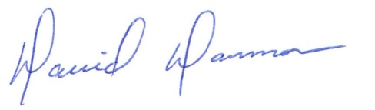
David Dammon, VP
Dammon Engineering, Inc.

Accepted: __________________________________ Date:__________________
Vick Corso

