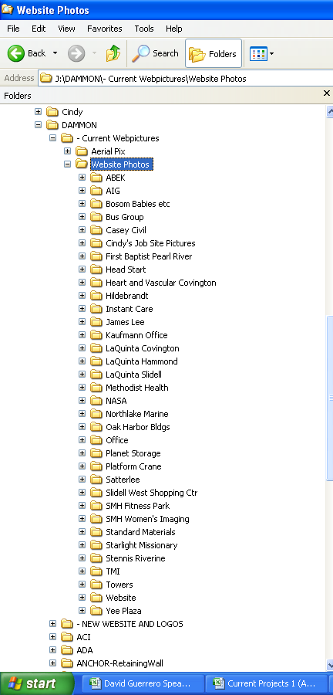
ABEK
AIG
BOSOM BABIES
BUS GROUP
CASEY CIVIL
FIRST BAPTIST PEARL RIVER
HEAD START
HEART AND VASCULAR COVINGTON
HILDEBRANDT
INSTANT CARE
JAMES LEE
KAUFMANN OFFICE
LAQUINTA COVINGTON
LAQUINTA HAMMONG
LAQUINTA SLIDELL
METHODIST HEALTH
NASA
NORTHLAKE MARINE
OAK HARBOR BUILDINGS
PLANET STORAGE
PLATFORM CRANEM
SATTERLEE
SLIDELL WEST SHOPPING CENTER
SMH FITNESS PARK
SMH WOMEN’S IMAGING
STANDARD MATERIALS
STARLIGHT MISSIONARY
STENNIS RIVERINE
TMI
TOWERS
YEE PLAZA

