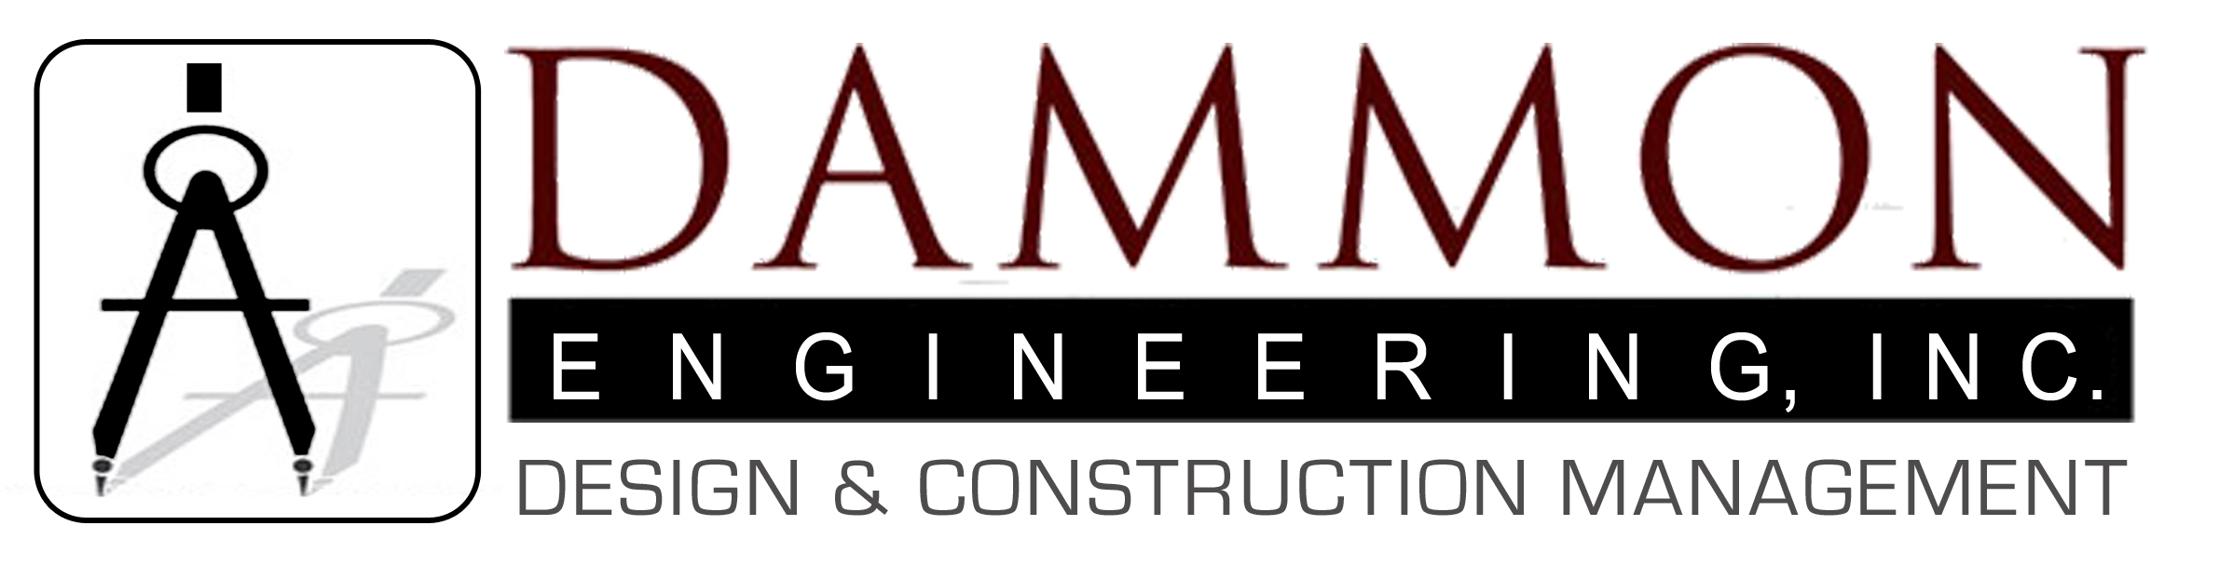

At Dammon Engineering, Inc. we believe the key to a successful project is communication and our primary goal is the complete satisfaction of every client. This begins with listening to the client to gain a clear understanding of their needs and goals. The staff at Dammon Engineering understand the significance of maintaining a high level of communication throughout project life-cycle. This approach makes the client an integral part of the Dammon Engineering design team and ensures that the end result is something the client can be proud of.
Our staff strives to keep pace with the constantly evolving construction industry. Our roles as architects, engineers and designers demand that changing economic patterns, technological developments, and construction practices are harnessed in our overall design concepts. We believe that building systems (i.e. electrical, mechanical, plumbing, etc.) should be simple to use, easy to maintain, and cost effective.

With every new project, our goals remain constant:
- stay within the budget
- meet the schedule
- provide a complete, functional design
- deliver a first class final product to a happy client

