David Dammon
285 Cross Gates Blvd.
Slidell, La 70461
Acct: 503-6643
March 28, 2017
Lincare
PO Box 15389
(913) 754-7996 (Fax)
Lenexa, KS 66285
Reference Letter (attached)
In reference to your Pre-Collection letter dated ???.
I have tried to resolve the issue with 2 letters and more than a dozen phone calls to call centers financial customer service personnel. Although talking with the customer service personnel and explaining the issue to them; this issue has not been resolved. To date, I have not received any written response to the letters I mailed and faxed to Lincare, where I have explained Lincare’s overcharging for supplies.
You can send this account to the collection agency or you can actually have someone respond to the letters that have been sent to Lincare; your choice. As a reminder in my first letter, I asked for my account to be audited and sent to me.
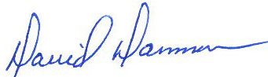
I have since terminated my association with Lincare for supplies.

David Dammon

