
554 Old Spanish Trail
Slidell, LA 70458
Phone: 985-649-5832

dammonengineering.com
info@dammonengineering.com

Structural Inspection

12-08-2025
Amrize
Honey Island Sand and Gravel
70164 Atlas Rd.
Pearl River, Louisiana 70452
November 6, 2025

TABLE OF CONTENTS

SECTION

1.0 BACKGROUND AND ASSIGNMENT

2.0 DESCRIPTION OF EQUIPMENT

3.0 OBSERVATIONS AND DESCRIPTION OF CONDITION

4.0 CONCLUSIONS

5.0 RECOMMENDATIONS

APPENDIX A general exterior photos

APPENDIX B field photos

1.0 BACKGROUND AND ASSIGNMENT

Dammon Engineering was retained by Honey Island Sand and Gravel Inc. to investigate the structural integrity and reparability of the Sand and Gravel Separation Plant.

The plant is located on the Pearl River at 70164 Atlas Rd Pearl River, Louisiana.

Dammon Structural Engineer Curtis Craig visited the site on November 1st and 2nd 2025 to evaluate the equipment.

The plant engineer Eugenio Nunez was present during both visits and provided access to the separator and also photographs of the structure. Additional photos were taken by the structural engineer to supplement the investigation along with external measurements.

No as-built drawings were available at that time.

All observations were visual. No material samples were extracted and no testing or probing of any kind was performed.

The inspection focused only on the structure and did not evaluate the condition of the operating equipment.

2.0 DESCRIPTION OF STRUCTURE

The Gavel and Sand Separation Plant consists of four separate enclosed rectangular box sections stacked and bolted on top of each other. It is supported by a rectangular wide flange beam skid and is not supported by a concrete foundation.

The support skid was completely covered by sand and was unavailable to be inspected.

Level 1: This section is an enclosed box approx 14’ W by 38’ L by 11’ H acts as a mixing vessel for the sand and gravel slurry for pumping to different locations. It also supports the vibratory shaker, access hatches, supply water piping and electrical power panels. The super structure consists of interior steel plates of various thickness and is supported externally by W 8 columns framing all four corners with 10” channels at 3’-5” O.C. along all 4 sides with a wide flange W 8 column centered on the east and west sides The vibratory screen equipment is supported on the east side. W 8 framing along the top perimeter provides support for connection to the second level.

Level 2: This section is an enclosed box approx 14’ W x 14’ ’L by 6’ H and serves as a spacer between the third and first levels. The super structure of level two consists of an exterior steel plate thick ⅜” thick supported internally by W 8 columns. Framing of all four corners consists of wide flange framing the top and bottom around the perimeter. 6” double angle lateral x bracing on three sides.

Level 3: This section is a partially enclosed box 14’ W x 14’ L by 8’ H open on one side and enclosed with plate on the other three sides. The super structure of level two consists of an exterior steel plate thick ⅜” thick supported internally by W 8 columns
The level contains a tapered hopper to feed the lower levels and provides support access stairs and platforms. The floor between the second and third level consists of galvanized bar grating supported by channels of various dimensions.

Level 4: This section is a cantilevered enclosed box section approx14’ W x 20’ L x 11’H and supports intake water sprayer piping ,feeder conveyor belt and access stairs and platforms.

3.0 OBSERVATION AND DESCRIPTION OF CONDITIONS

The following is a summary of conditions observed during the structural investigation the photo report of the field observation is provided in the
Appendix B

Level one: This level exhibits moderate to severe corrosion on interior structural support. Additional framing has been added in the past to shore up original framing. Exterior plates (photo A) show moderate to heavy surface scaling and several areas have been replated at previous dates. Interior plates (photo B) show moderate to heavy surface scaling. Process Water inlet feed line flanges appear in good shape. Access hatches appear to be in good shape. Structural framing supporting the vibratory shaker exhibits moderate scaling and additional framing has been added in the past to shore up original framing.

Level two: This section exhibits severe corrosion and deteriorated structural support members. Several of the lateral X bracing is completely deteriorated and missing. (Photo C and D) The bottom and top wide flange framing around the perimeter between level one and two and level 2 and three is severely deteriorated and in some areas non-existent. The south exterior plating has completely separated for the structural framing. The western vertical support shows bucking at the base. (Photo E)

Level three: This section exhibits moderate corrosion and deteriorated structural support members. (Photo D) Floor framing and bar grating appears to be generally intact. Some plates on the hopper are completely corroded thru and missing.

Level four: This section exhibits moderate corrosion and deteriorated structural support members with one cross member completely corroded and missing. (Photo E)

Access stairs and platforms appear to be generally intact.

4.0 CONCLUSIONS

The following conclusions are based on the structural engineer's visual observations and conversations with the plant engineer.

Deterioration of exterior and interior plating and all structural members is due to the high acidity (PH 4) of the process water and constant abrasion caused by dropping and pumping sand and gravel mixture. Attempts to coat the interior areas with a rubber based coating has shown some success. Replacing any level of the plant would involve unbolting the various sections. This would expose the corrosion between each section and which would make for more difficult replacement. Interior X-bracing in level 2 cannot be replaced due to the base metal needed to weld to is to far gone to accept welds.

The structure is in imminent state of collapse due to the deteriorated framing between level one and level two.

Salvage and reuse of the access stairs and platforms is possible.

Salvage and reuse of the fourth level is possible

5.0 RECOMMENDATIONS

It is my recommendation that the structure be completely replaced as soon as possible. Bracing to support the upper level sections will be required to keep the system in operation till a suitable replacement can be installed.

Due caution needs to be exercised to ensure the structure does not fail and injure employees.

During the investigation the plant engineer and I developed a temporary repair plan to keep the plant in operation. This is only a band aid repair.

APPENDIX A

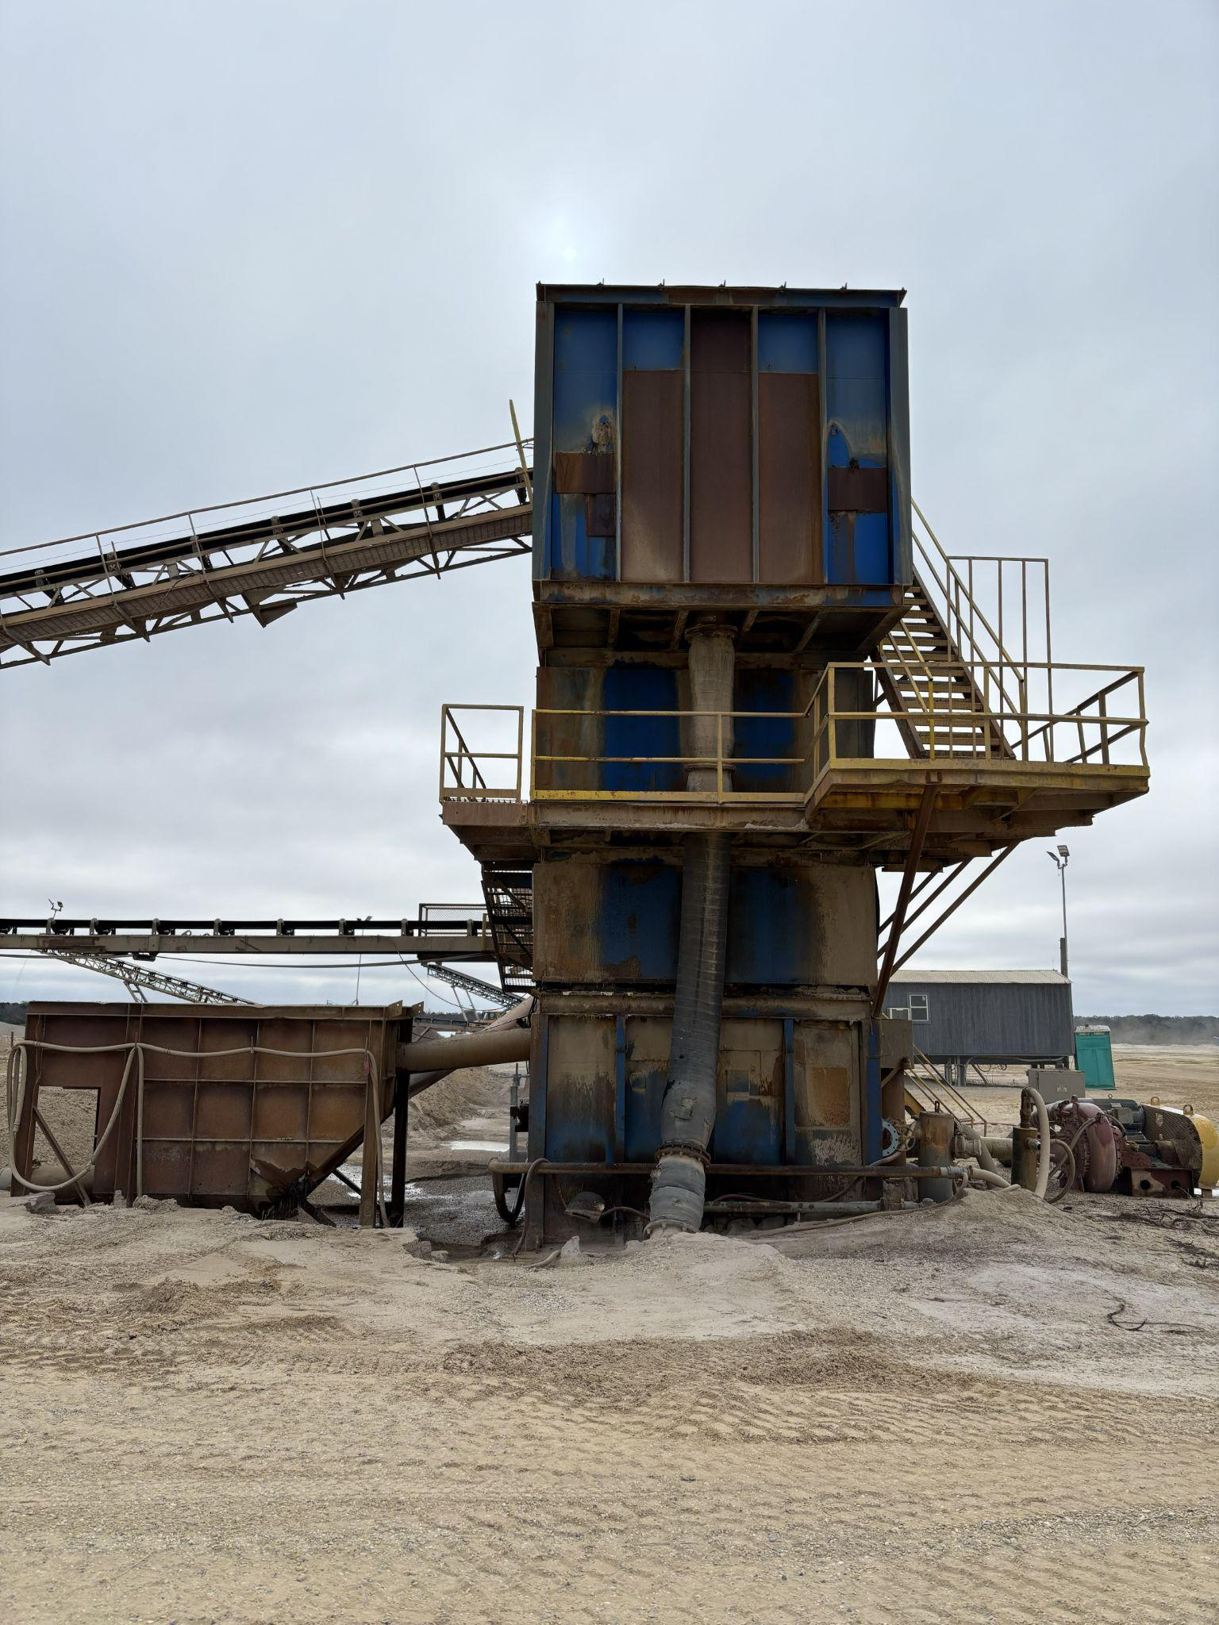
Exterior view looking east
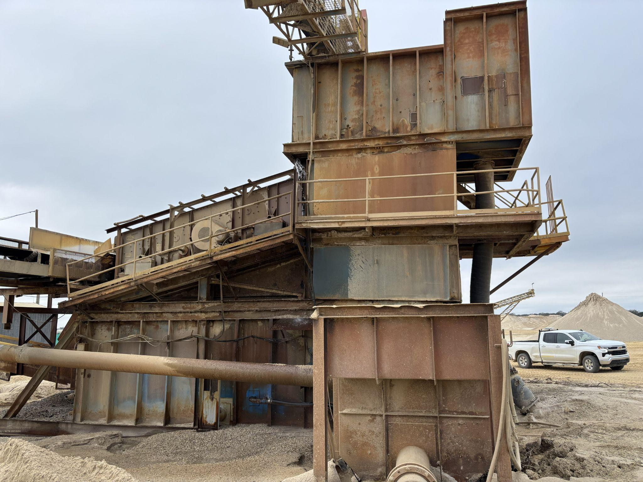
Exterior view looking south

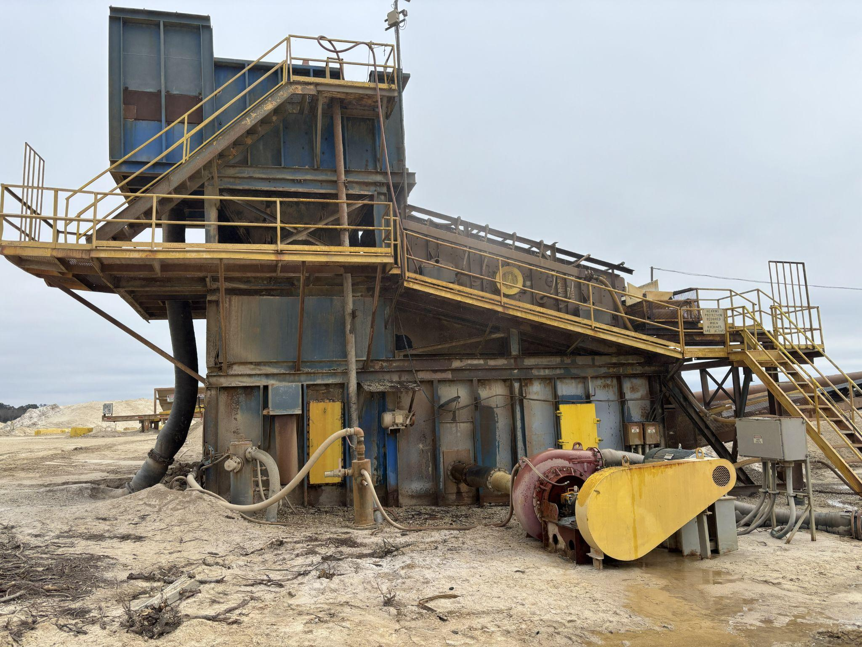
Exterior view looking north

Appendix B

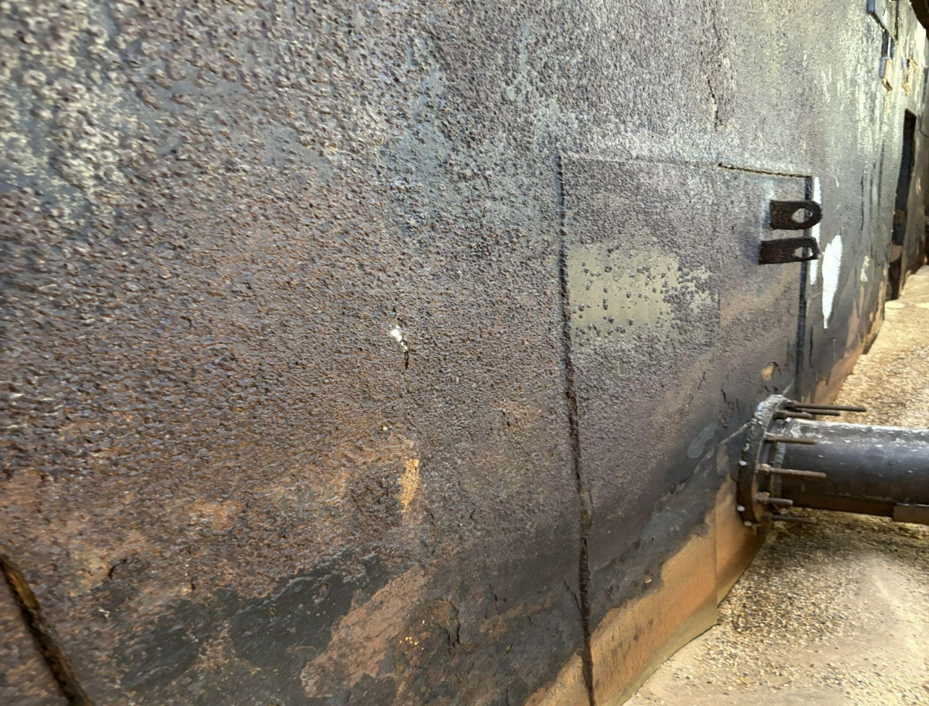

(Photo A) Exterior view level one looking northeast
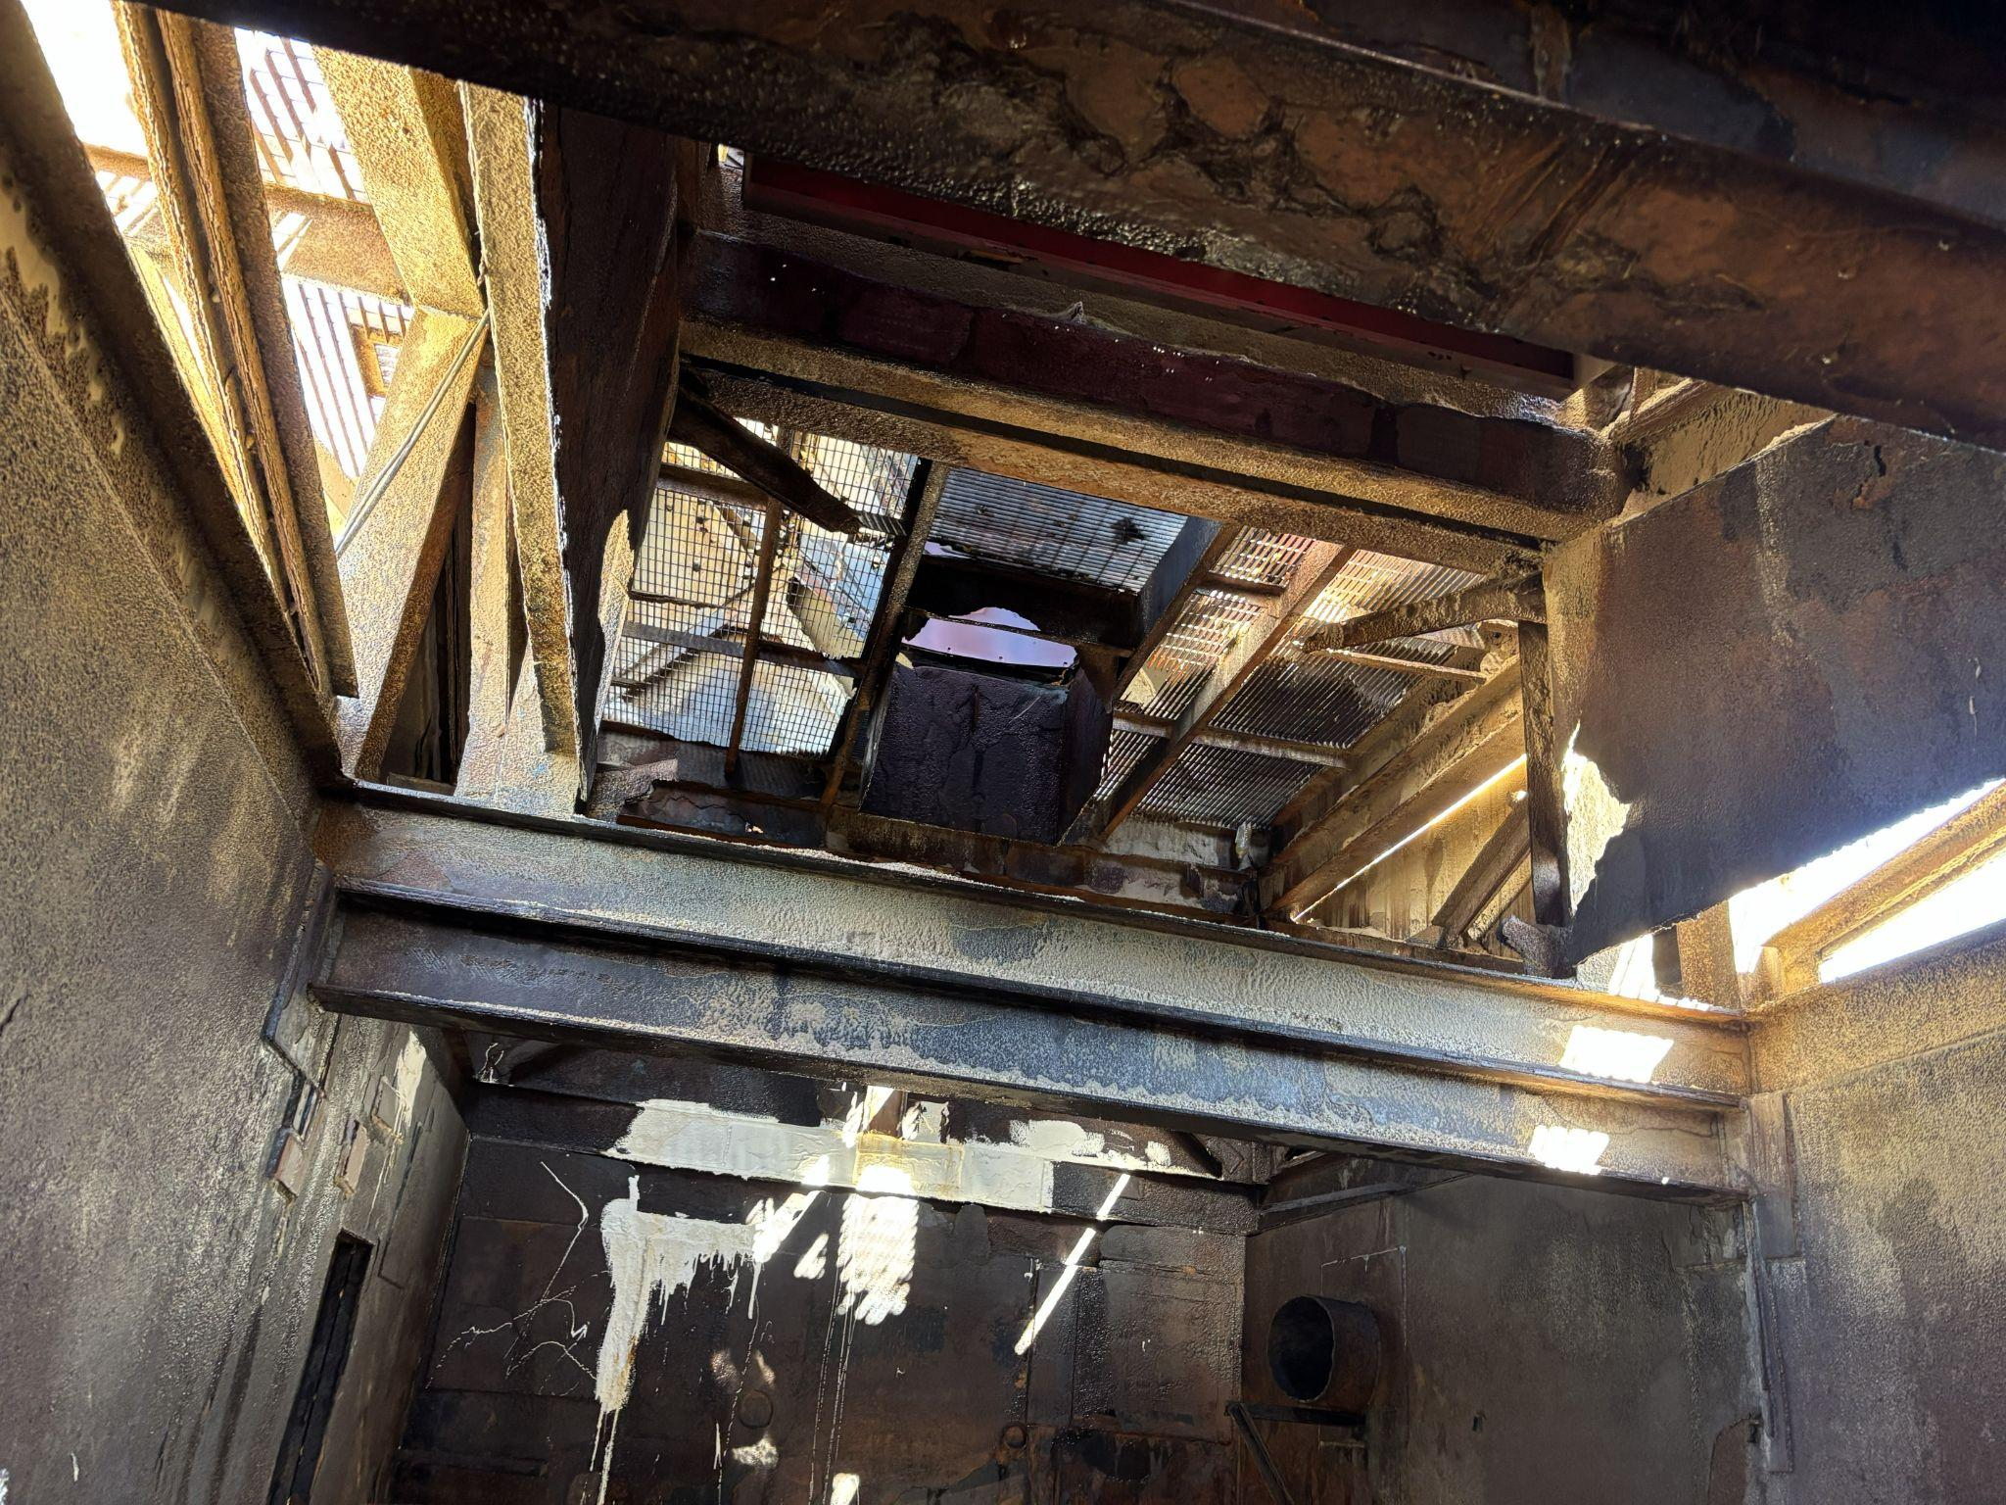
(photo B) Interior view level 1 under vibrator screen looking west
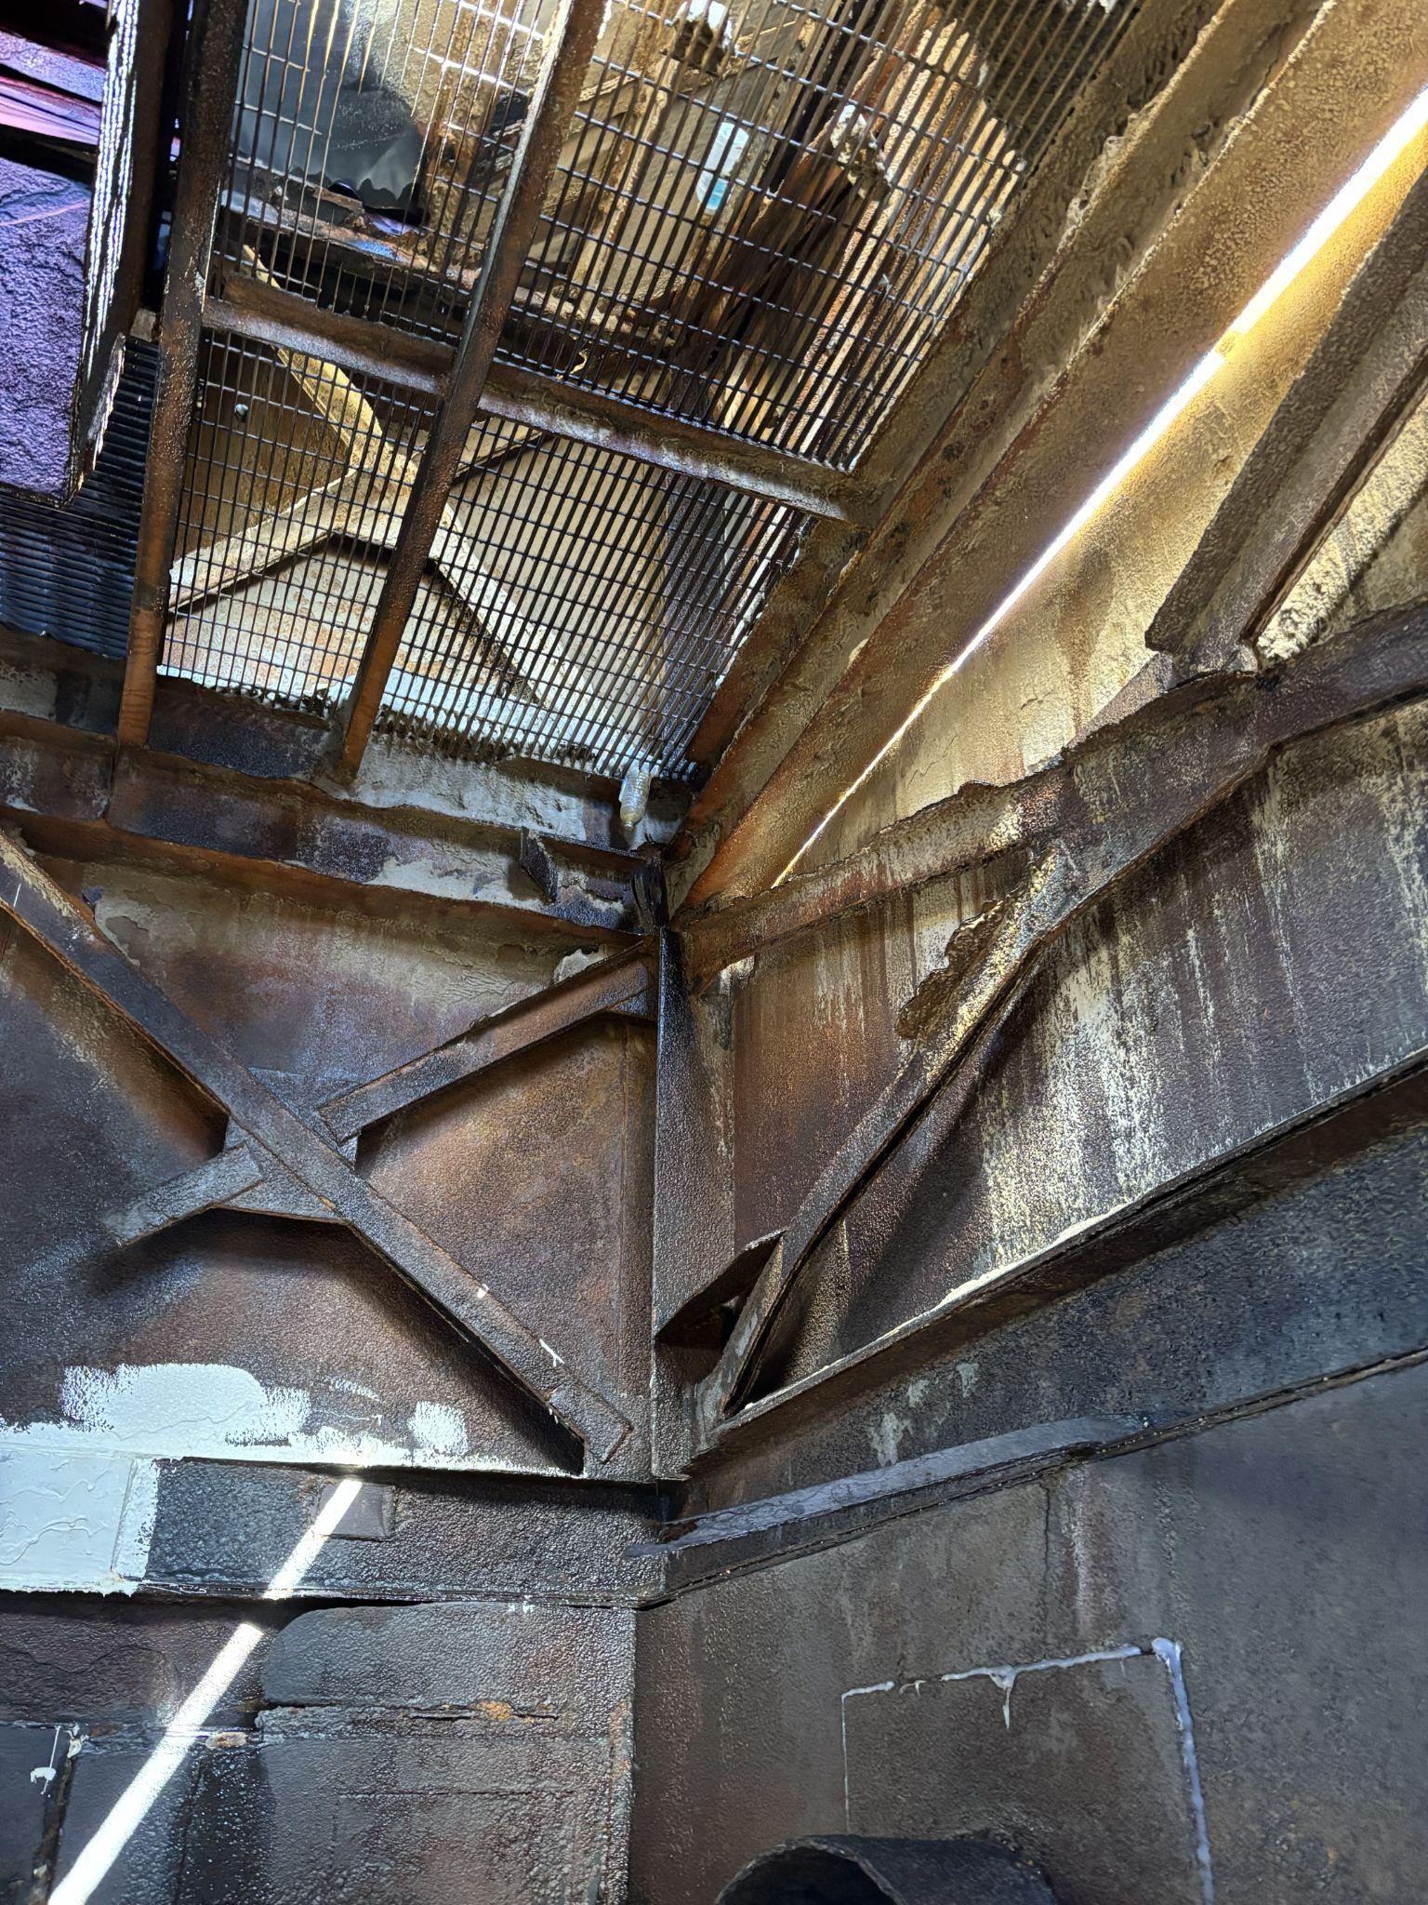(Photo C) interior view level two looking northwest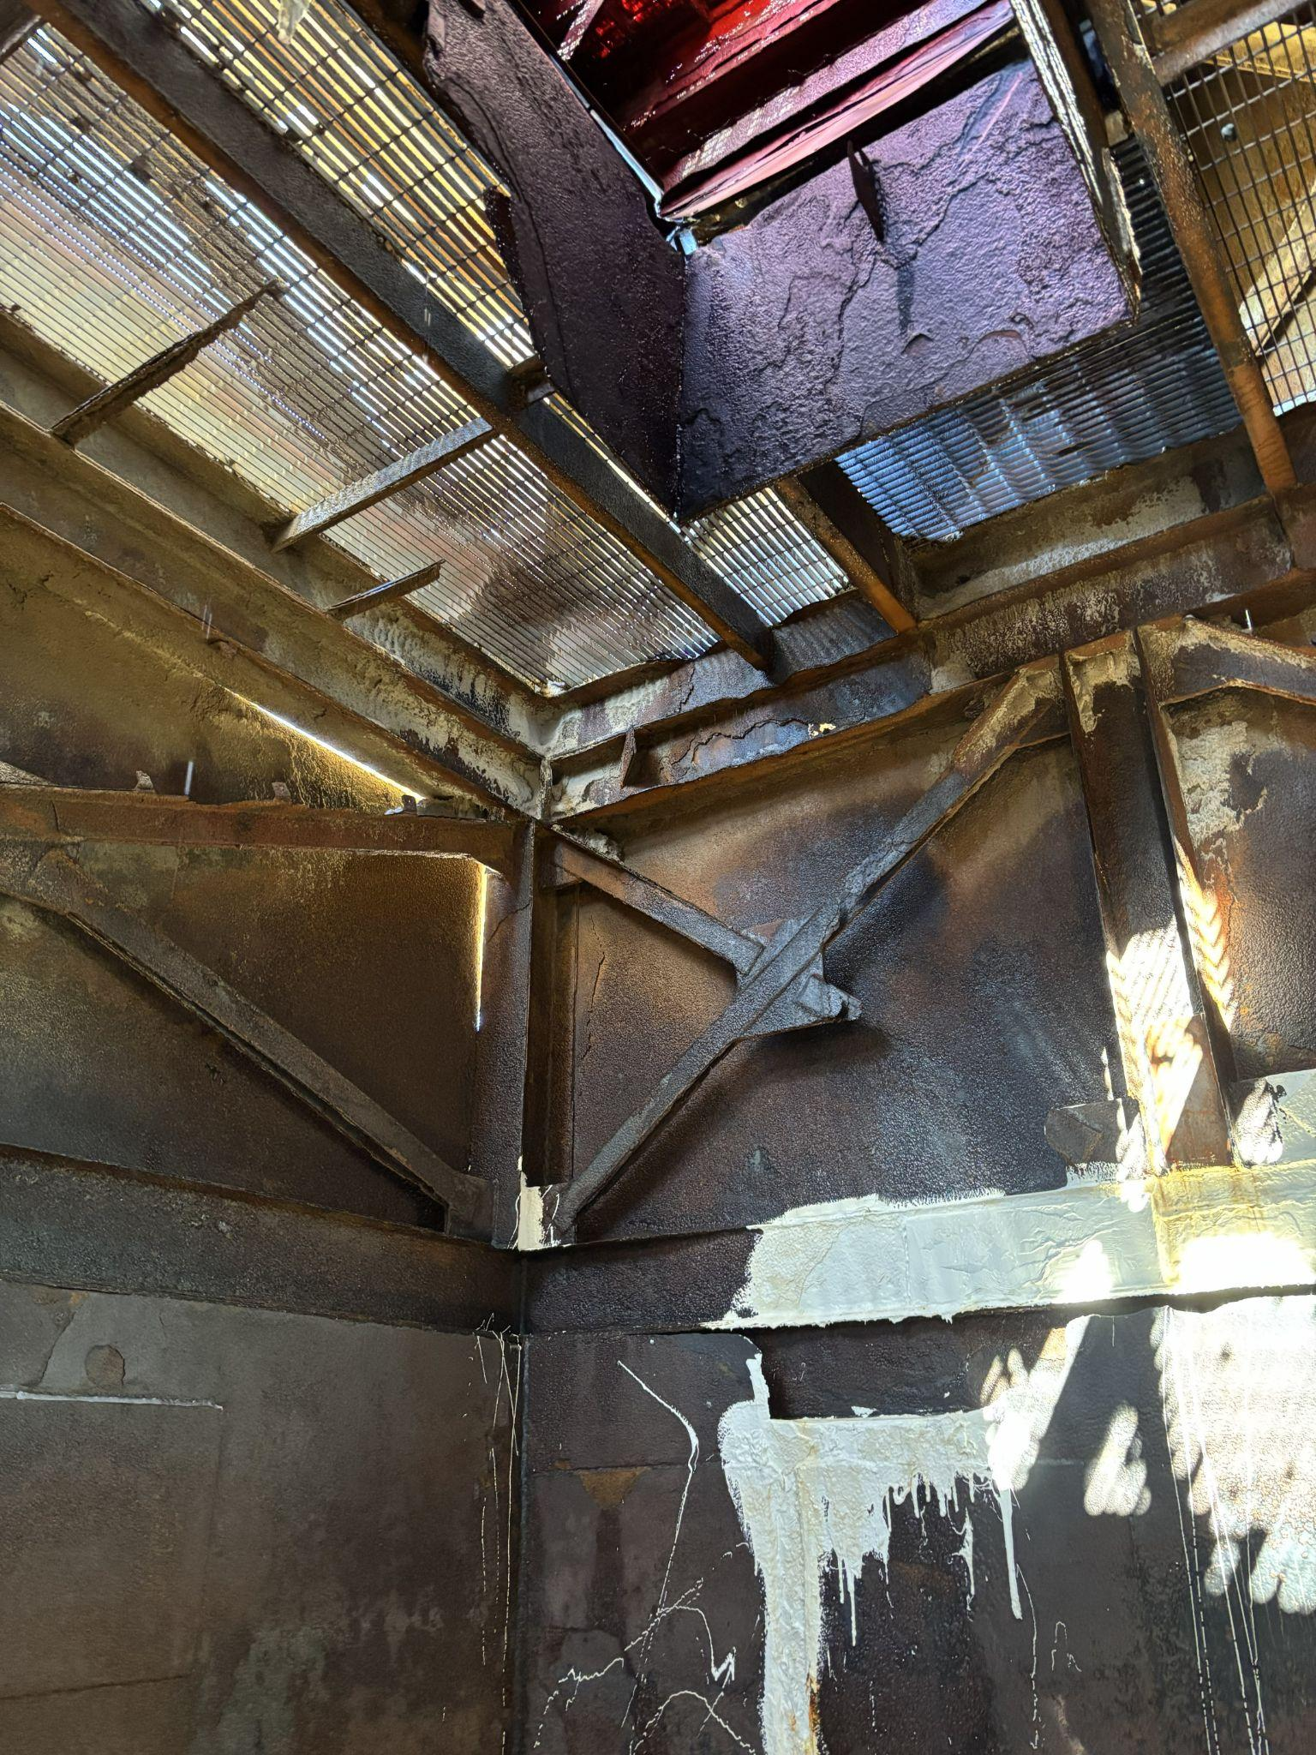 (Photo D) Interior view level 2 looking southwest
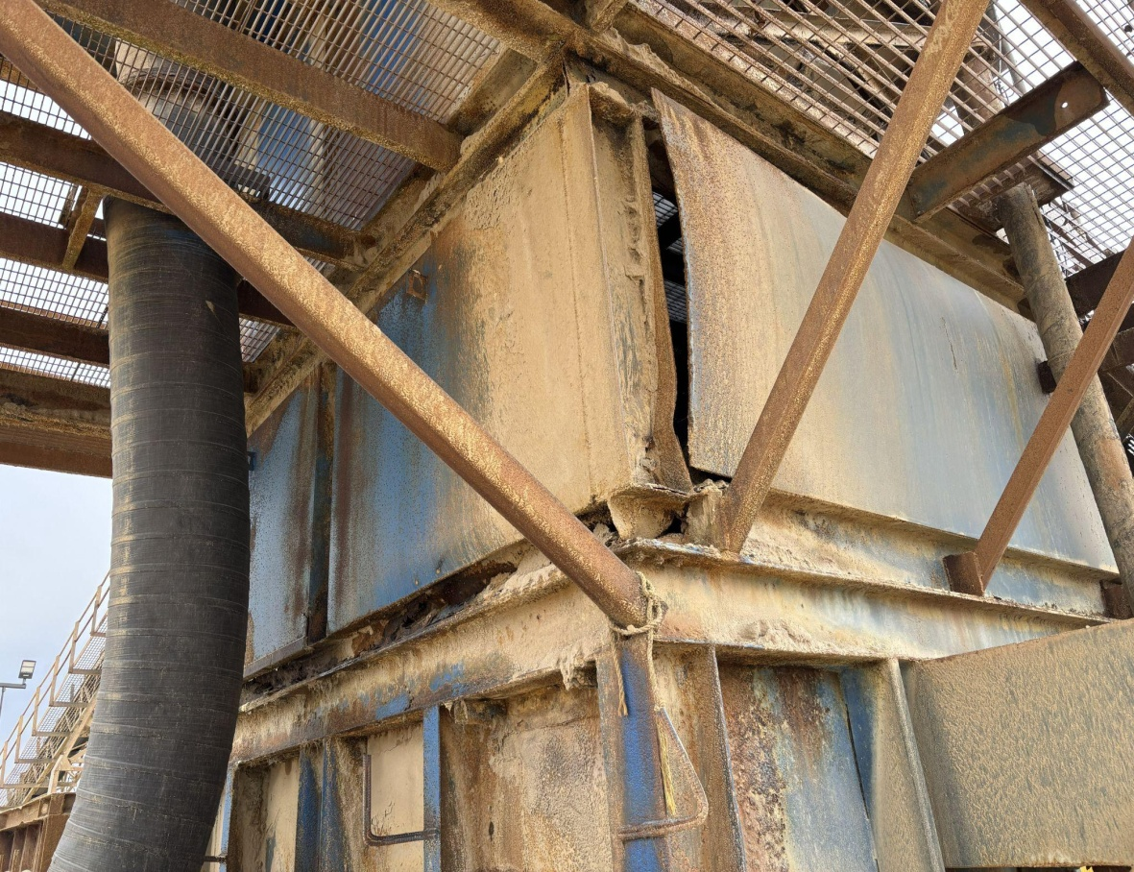

(Photo E) exterior view level 2 looking north east

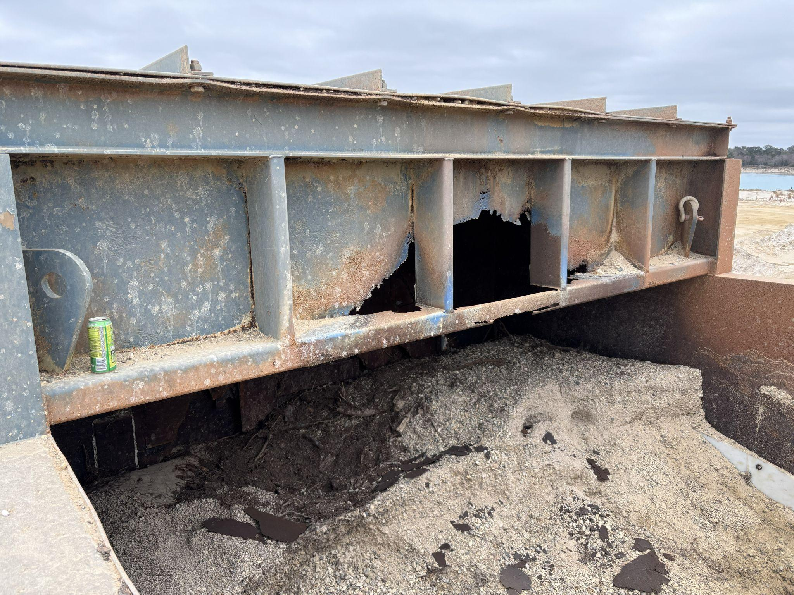
(Photo F) exterior view level 4 looking north west

Sincerely,

Curtis Craig
Structural Engineer

