
October 2014

In this issue…
- Wreath Fundraiser
- International Projects
- Speaker’s List
- Upcoming Events

ROTARY CLUB OF SLIDELL



shoes for orphan souls
Our club is collecting new socks and shoes for “Shoes for Orphan Souls” again this year. If you have not been able to contribute shoes yet we are still collecting shoes to send to the Orphans. If you would like, you may also donate money and Rotary will purchase socks and shoes to donate. These shoes are part of the largest humanitarian aid projects sponsored by Buckner International, a global Christian ministry dedicated to transforming the lives of vulnerable children, families and elders. According to the Buckner Shoes for Orphan Souls' website, a pair of simple shoes can go a long way to preventing disease from hookworms and other parasites, as well as protect feet from injury. In many communities, they allow children to attend school who would not have been eligible due to lacking the required footwear.
The donations will be distributed overseas, as well as in the United States, to vulnerable children and orphans. Since 1999, more than 2.5 million pairs of new shoes have been distributed to children in 74 countries.

Rotary International District 6840, made up of Louisiana and Mississippi chapters, last year collected 1,494 pairs of shoes and 1,390 pairs of socks for distribution. Buy a new pair of shoes and socks. (Sneakers and athletic shoes are best.) The greatest need is for sizes Youth 1 - Adult 7. Bring these new socks and shoes to our regular meeting.
"If you had ONE Chance, ONE Opportunity or ONE Moment to make a difference, how would you?"


CHRISTMAS WREATH FUNDRAISER
The Rotary Club of Slidell had another successful
fundraising event this past holiday season.
Thanks to all the active members taking ownership
of the annual Christmas Wreath Fundraiser, our club
was able to raise $4,500 for the scholarship program.
The reason this fundraising event is so successful is
because of the way the program works. Every
member of our club is given the opportunity to place
orders for as many Christmas wreaths as they can sell.
Each member is responsible for buying a mimum of
two wreaths at the cost of $30 each, whether or not
they place an order.

The wreaths are delivered in early December, and
Rotary members gather to sort and deliver the
wreaths to the members who placed orders. Our club
is furtunate to have Vicky Magas heading up and
coordinating the efforts of this fundraising event
from start to finish. Vicky let everyone in our club
know when we could start taking orders, passed out
colorful brochures so we could distribute and sell the
wreaths, and notified everyone of the order deadline and delivery date. Vicky then coordinated a group of vonunteers to help on delivery day. The wreaths are fresh, beautiful, and last throughout the holiday season. They make great gifts for the "had to buy for" person, and help so many students. We hope to continue to increase sales each year so more sponsorships will be possible.

Thank You Vicky Magas and to everyone else who participated and worde don this worthy fundraising event!

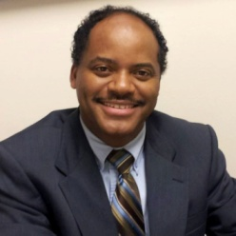



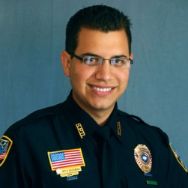


Date: January 9
Name:Kevin Davis
Topic: Office of Homeland Security

1st quarter Speakers

Date: January 30
Name: Kim Bergeron
Topic: Media and Fund-Raising

Date: January 16
Name: Bill Davis
Topic: Slidell Memorial Hospital

Date: February 6
Name: Clay Williams
Topic: Gulfport Airport

Date: January 23
Name: Michael Brady
Topic: Mandeville Rotary on new member orientation

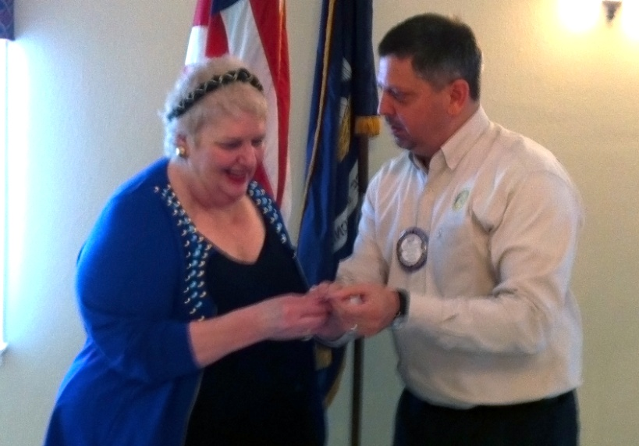
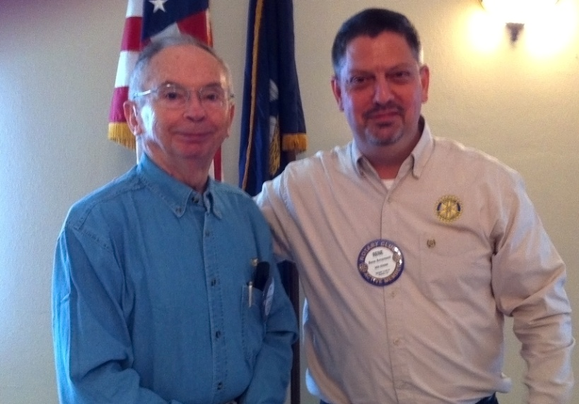
Date: February 20
Name: Karen Babbit
Topic: District Exchange Students

Date: February 13
Name: Kathy Lowery
Topic: Harbor Center

Dr. Joan Archer received an award for bringing in new members to the club.
Dick Graham received his 2nd Paul Harris for donating $1,000.

Club Meetings
Weekly: Every Friday, at 12:00 noon
Place: Pinewood Country Club
405 Country Club Blvd
Slidell, LA 70458
Remember to invite a friend. If you will be out of the area, attend another Rotary meeting.
Congratulations to Ken Thompson for getting another international project!
Our club has another international project and donated $500 to help fund a potable water storage tank for the Mexican village (700 population) of Puerto Lobos. There are several Rotary clubs teaming with local Mexican Rotary clubs to fund the $60,000 project.

International Projects


The District Conference will be a combined conference with District 6820. This year it is called the Rotary Rivage 2015. April 10-12, 2015.

If you are interested in getting your information in the newsletter, please email rotaryclubofslidell@gmail.com or contact one of the committee members after a meeting.
UPCOMING EVENTS:

