
554 Old Spanish Trail
Slidell, LA 70458
Phone: 985-649-5832
Fax: 985-641-5950
dammonengineering.com
info@dammonengineering.com

March 13, 2019

Jessica McCormick Walker
Architect, NCARB, AIA
Studio MV
(985) 867-5601

Re: Third Entry Building at Beau Chene

Ms. Walker,

Thank you for considering Dammon Engineering. Dammon Engineering, Inc. is pleased to propose our Engineering services to review and stamp your electrical plan for subject project.
We propose a fee of $800.00.
We look forward to working with you on this project. Please indicate your acceptance of the above fee by signing below. If you have any questions, or require any further information, please feel free to call.
By signing below you acknowledge that you are duly authorized to enter into and execute contracts/agreements on behalf of “Studio MV.”

Sincerely,

If you have any questions, please contact me.

Thank You,

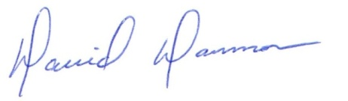
David Dammon __________________________________
President Jessica McCormick Walker

