
554 Old Spanish Trail
Slidell, LA 70458
Phone: 985-649-5832
Fax: 985-641-5950
dammonengineering.com
dammoneng@bellsouth.net

April 2, 2014

Mr. Brandon Rozga
Christopher Kidd & Associates
N48W16550 Lisbon Road
Menomonee Falls, Wisconsin 53051-6630
Phone: (262) 901-0505

RE: 7 ft Privacy Fence and Retaining Wall
10545 Lake Forest Blvd.
New Orleans, LA 70127

Dear Mr. Rozga,

Thank You for contacting Dammon Engineering, Inc., we are pleased to propose our Engineering services for the design of the 7 foot high, approximately 500 feet long Privacy Fence and approximately 250 feet long Retaining Wall at subject property.

We propose to design the new wooden privacy fence to meet the requirements in IBC 2012, Section 1600. We will also provide a design of the chain/retaining wall to protect the natural slope of the grounds around the existing facility near the edge of the referenced property.

Our design fee for the above mentioned project is $5,500.00 (Five thousand five hundred dollars). We will provide you with 5 stamped sets of drawings. Our design fee does not include supervision during the construction. Our fee also does not include the cost of permits, soils analysis, drainage studies, traffic studies, wetlands determination, or other engineering studies that may be required by government agencies.

It is agreed that Christopher Kidd & Associates will limit any and all liability for any damage on account of any error, omission or other professional negligence to a sum not to exceed $10,000 or the amount of the design fee, whichever is greater. If Christopher Kidd & Associates prefers to have higher limits of professional liability, the limits can be increased to a maximum of one million ($1,000,000.00) dollars upon Christopher Kidd & Associates written request at the time of acceptance of this proposal provided that Christopher Kidd & Associates agrees to pay additional specified consideration.

Christopher Kidd & Associates agrees to defend, indemnify and hold Dammon Engineering, Inc. harmless from any claim, liability or defense cost in excess of the limits determined above for injury or loss sustained by any party from exposure allegedly caused by Dammon Engineering, Inc.'s performance of services hereunder, except for injury or loss caused by the sole negligence or willful misconduct of Dammon Engineering, Inc.

We look forward to working with you on this project. Please indicate your acceptance of the above by signing below. If you have any questions, or require any further information, please feel free to call.

By signing below you acknowledge that you are duly authorized to enter into and execute contracts/agreements on behalf of Christopher Kidd & Associates.

Sincerely,

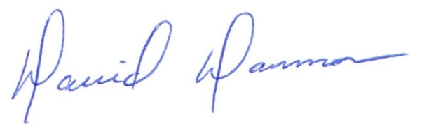
David Dammon, VP

Accepted: ____________________________ Date:__________________
Brandon Rozga, Project Manager

