
554 Old Spanish Trail
Slidell, LA 70458
Phone: 985-649-5832
dammonengineering.com
info@dammonengineering.com

November 10, 2020

Don McMath
McMath Construction
1125 Causeway Blvd.
Mandeville, LA 70471

Re: Hammond Medical Surgery Facility

Mr. McMath,

Thank you for considering Dammon Engineering. Dammon Engineering, Inc. is pleased to propose our A&E services for the subject project.
It is understood that this project will be constructed in Hammond La. with a building foot-print of 7,000 s.f. and a two story building wood frame building on this foot-print. The total building size is estimated to be 14,000 s.f.
We propose a fee of $3.50 per s.f. of total build-out; a total fee of $49,000.00. For this fee we will take over as Professional of Record and provide you with Civil, to include paving, structural and stormwater, Mechanical, Electrical and Plumbing plans.
If selected we will bill 50% of the total after the plans have been accepted the State Fire Marshal; then 25% of the total after the building construction has started; then the remaining 25% of the total will be billed when the building construction is 50% completed.
If the building size or location is changed then a re-assessment of our fees may be warranted.
We look forward to working with you on this project. Please indicate your acceptance of the above fee by signing below. If you have any questions, or require any further information, please feel free to call.

Sincerely,

If you have any questions, please contact me.

Thank You,

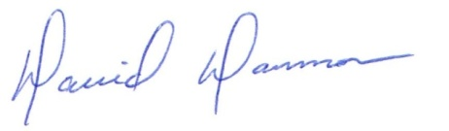
David Dammon __________________________________
President Don McMath

