
554 Old Spanish Trail
Slidell, LA 70458
Phone: 985-649-5832
Fax: 985-641-5950
dammonengineering.com
info@dammonengineering.com

December 2, 2015

Mr. Earl Weber
The Natchez, New Orleans, LLC
620 Decatur suite E,
New Orleans, LA 70130
(504) 528-8090

Re: 530 Natchez St. Pool Design

Mr. Weber,

It was a pleasure to communicate with you about your plans to construction a pool at the subject location. Dammon Engineering, Inc. is pleased to propose our Engineering services to provide you with plans for permitting with the Louisiana Department of Health.
We propose a fee of $3,200.00 to design the pool systems for permitting with the Louisiana Department of Health.
We look forward to working with you on this project. Please indicate your acceptance of the above by signing below. If you have any questions, or require any further information, please feel free to call.
By signing below you acknowledge that you are duly authorized to enter into and execute contracts/agreements on behalf of “The Natchez, New Orleans, LLC”

Sincerely,

If you have any questions please contact me.

Thank You,

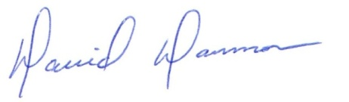
David Dammon
President

