
554 Old Spanish Trail
Slidell, LA 70458
Phone: 985-649-5832
Fax: 985-641-5950
dammonengineering.com
info@dammonengineering.com

March 7, 2019

Thank You,

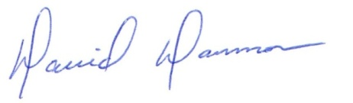
David Dammon
President
Dammon Engineering, Inc.
(985) 649-5832

