https://www.peps.apps.its.ms.gov/
Renewing the State of Mississippi Certificate of Authority (Firm License)
1st is to login to the state site, but under Brian’s Information:
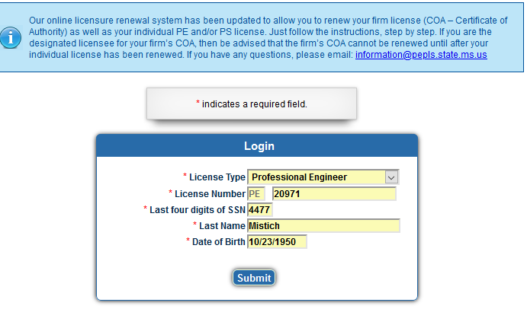
Click on Renew License and our Certificate of Authority should show up for renewal.

Click on Renew License and our Certificate of Authority should show up for renewal.
Then click on payment tracking, I think if pay balance does not work.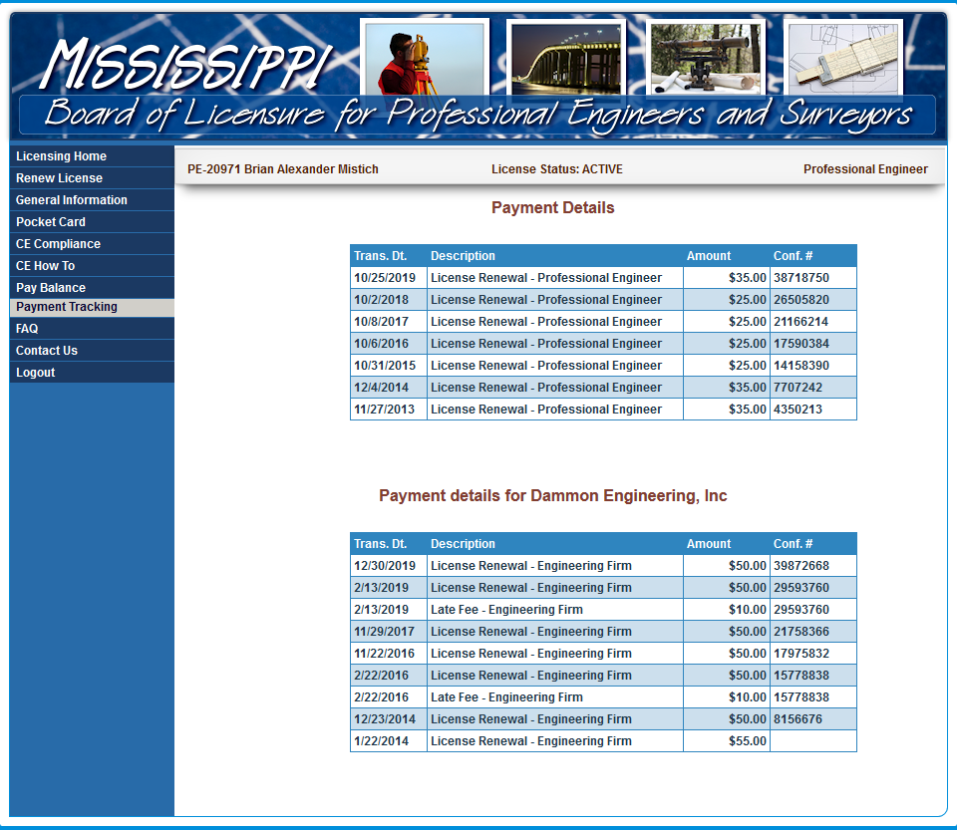

Something should take you to where you can pay for the COA
