
554 Old Spanish Trail
Slidell, LA 70458
Phone: 985-649-5832
Fax: 985-641-5950
dammonengineering.com
dammoneng@bellsouth.net

July 9, 2014

Mr. Eric James (Poncho)
P.O. Box 18457
Hattiesburg, MS
(601) 299-0577

RE: Office Inside Existing Warehouse on 646 N. Carnation St.

Dear Mr. James,

It was a pleasure to discuss your plans to build-out a 600 s.f. office inside the existing warehouse. Dammon Engineering, Inc. proposes to offer our Architect and Engineering services to layout the office space in the existing warehouse for your client.
Our proposed fee for the office layout, Phase I, is $500 (Five Hundred Dollars).
We look forward to working with you on this project. Please indicate your acceptance of the above by signing below. If you have any questions, or require any further information, please feel free to call.
Sincerely,

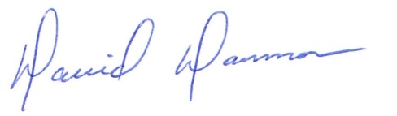
David Dammon, VP
Dammon Engineering, Inc.

Accepted: __________________________________ Date:__________________
Eric James

