
554 Old Spanish Trail
Slidell, LA 70458
Phone: 985-649-5832
Fax: 985-641-5950
dammonengineering.com
dammoneng@bellsouth.net

January 24, 2014

Mr. Dale Galloway
Northshore Church
P.O. Box 2369
Slidell, LA 70459

RE: Northshore Church Phase II
Old Schwegmann Building
Slidell, LA

Dear Mr. Galloway,

It was a pleasure to discuss your plans to build-out Phase II at the Northshore Church in the old "Schwegmann’s building" in Slidell. Dammon Engineering, Inc. proposes to offer our Architect and Engineering services to complete the design of this 9,000 s.f. build out.
Our proposed fee for the complete design package is $1.25 per s.f., for a total of $11,250.00 (Eleven Thousand Two Hundred Fifty Dollars).
Our fee includes five sets of plans provided to you following the Fire Marshal's review and response, as well as the Louisiana State Fire Marshal Review Fee, as well as the IBC review fee, which is estimated to be $1,015.00. Our fee also includes one site visit every other week. Additional site visits will be billed @ our standard hourly rate.
Our fee does not include the cost of permitting, any parish or other government required studies or tests, nor the cost of traffic, or other engineering studies, which may be required.
If selected, we ask for a deposit of $2,500.00. We propose to then bill $4,375.00 at 50% completion, with the balance due following the Fire Marshal's review and response.
Unless this offer is previously accepted, it will be withdrawn automatically at 5:00 p.m., 30 days from the date of issue.
We look forward to working with you on this project. Please indicate your acceptance of the above by signing below. If you have any questions, or require any further information, please feel free to call.
Sincerely,

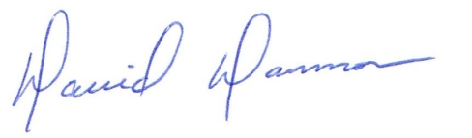
David Dammon, VP
Dammon Engineering, Inc.

Accepted: __________________________________ Date:__________________
Dale Galloway/
Northshore Church

