
554 Old Spanish Trail
Slidell, LA 70458
Phone: 985-649-5832
dammonengineering.com
info@dammonengineering.com

May 05, 2026

Dynamic Constructors, LLC
1028 Market Street
Metairie, La. 70003

Re: Notice to Proceed

This is your notice to proceed with St Tammany Fire Protection District #1 Fire Station 10 located at 2745 Lakeshore Vista Blvd. Slidell, La. 70461, previously agreed upon date of May 11th, 2026 in accordance with your construction contract dated April 19, 2026.

Thank You,

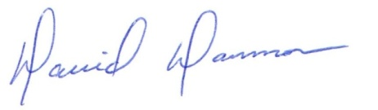
David Dammon
President
Dammon Engineering, Inc.

cc : Chris Kaufmann
Jay Gross

