
554 Old Spanish Trail
Slidell, LA 70458
Phone: 985-649-5832
Fax: 985-641-5950
dammonengineering.com
dammoneng@bellsouth.net

January 10, 2014

Mr. Kevin Boudreaux
Senior Buyer
Textron Marine & Land Systems
An Operating Unit of Textron Marine
1010 Gause Blvd.
Slidell, LA 70458

RE: Purchase Order #96782
Stone Road Building Addition
Additional Vehicle Ramps and Changes to Plans

Mr. Boudreaux,

Per our recent conversation regarding the additional design work performed on the Stone Road Building Addition & Renovations project, please note the following.

Changes outside of the original Scope of Work for this project include: the addition of two ramps with rollup doors; a 350' wall with two personnel doors and two rollup doors; the removal of portable offices; a new cased opening; enlarging an existing cased opening and two new exit doors with stairs.

Due to the above changes and additions, the Construction Cost was increased from $1,132,536.00 to $1,494,001.00 ($1,312,000.00 for the current contract and $182,001.00 for the Estimated Construction Cost for the Office Renovation not currently in contract).

Based on this new Construction Cost, our total fee comes to $104,580.07 ($1,494,001.00 x .07). Our current Purchase Order covers $23,000.00 for the preliminary work and $79,277.52 for the work described above. The result is a difference of $25,302.55.

We ask that you approve an amendment to our exiting Purchase Order (#96782) in the amount of $25,302.55 to cover the above additional design work.

If you have any questions, or require additional information, please feel free to call.

Sincerely,

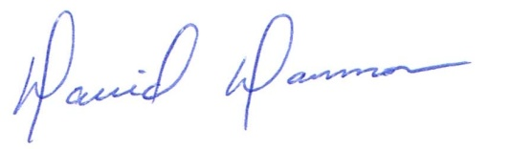
David Dammon, VP
Dammon Engineering, Inc.

