
554 Old Spanish Trail
Slidell, LA 70458
Phone: 985-649-5832

dammonengineering.com
info@dammonengineering.com

March 10, 2026

Design Group LLC
Attn: Neeraj Kumar

Ref: Fremaux Gas Station, C-Store
Fremaux Blvd
Slidell, La. 70458

Dear Mr. Kumar,

It was a pleasure to discuss with you a new C-Store Gas Station on Fremaux Blvd in Slidell to be built at the above location. Dammon Engineering, Inc. is pleased to propose our services to design the structural slab, the building structure and MEPs.

We propose a total fee of $60,165.00 (Sixty Thousand One Hundred Sixty Five Dollars) this will include three sets of printed plans and pdfs provided to you following design completion. This fee is for drawings only and not specifications. All pertinent data will be on the drawings. The steel provider must provide shop drawing connection details for the building structure.

This fee does not include cost of soils analysis, Fire Alarm, Sprinkler Systems or other government agency fees. This fee also does not include the cost of the landscaping plan, survey/top/elevation certificate, drainage plan of the site, traffic study, or other engineering studies, which may be required. This fee also does not include any Construction Management.

We require a deposit of $10,000.00; then 50% of completion we will bill for progress once you have reviewed the plans at 50% completion; the remainder will be billed at 100% at design completion for the balance.

Unless this offer is previously accepted, it will be withdrawn automatically at 5:00 p.m., 30 days from the date of issue.

We look forward to working with you on this project. Please indicate your acceptance of the above by signing below. If you have any questions, or require any further information, please feel free to call.

Sincerely,
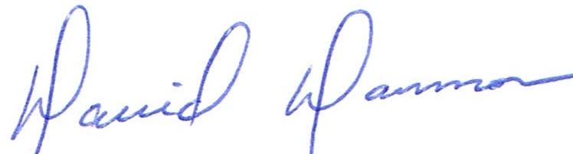

David Dammon, Vice President

Accepted: ____________________________ Date:__________________
Neeraj Kumar

