To be used as Front Cover

PROFESSIONAL SERVICES APPLICATION
Small Projects

ST. TAMMANY PARISH SCHOOL BOARD
AUGUST, 2024

QUALIFICATIONS STATEMENT
OF

Dammon Engineering, Inc

For

Services provided by your firm:

 | Architectural
XX | Civil Engineering
XX | Structural Engineering
XX | Mechanical Engineering
XX | Electrical Engineering
 | Landscape Architecture
 | Other

Mailing Address: | 554 Old Spanish Tr.
 | Slidell, La 70458
Street Address: | 554 Old Spanish Tr.
 | Slidell, La 70458
Contact Person: | Chuck Dammon
Title: | Vice President
Phone No.: | (985) 649-5832
E-Mail Address: | info@dammonengineering.com

Evaluation Criteria 9.1.26
Points 10
INTRODUCTION/OVERVIEW

Please provide firm resumé’, overview or brochure of your firm and qualifications for these projects.

*It is acceptable to add photos, use brochure sheets, etc. (This should not be more than two pages front and back or 4 pages front only)

* It is acceptable to delete this and the above statements in the design of this response*

Evaluation Criteria 9.1.1/9.1.4
Points 10

EDUCATION/EXPERIENCE OF KEY PERSONNEL
If applicable, list all Key Personnel that will be assigned to the proposed project. Provide an expanded resumé for the individual that will be in direct charge at any/all phases of the project on the forms following this page. (Text will wrap in cells)Use Continuation Sheet as needed.

Name | Title | Project Assignment | Years with Firm | Years with Other Firms | Professional License # | Year First Licensed | Degrees Earned
Brian A. Mistich | Chief Engineer | Engineering Design | 12 | 12 | 30187 | 1991 | B.S. Engineering
David P. Dammon | Civil Engineering | Engineering Design | 19 | 29 | 31305EI | 2013 | B.S. Engineering
Chuck K. Dammon | Project Manager Design | Project Management | 35 | 8

Evaluation Criteria 9.1.1/9.1.4
Points 10

Continuation Sheet

Name | Title | Project Assignment | Years with Firm | Years with Other Firms | Professional License # | Year First Licensed | Degrees Earned

Evaluation Criteria 9.1.1/9.1.4
Points 10

QUALIFICATIONS OF INDIVIDUAL WHO WILL BE IN DIRECT CHARGE
Provide the name and resumé of the individual within the Applicant’s organization who will have direct charge of the St. Tammany Parish School Board’s work.

Name: | Brian Mistich
Title: | Chief Engineer
Project Assignment: | Project Engineer
Years with Firm: | 12
Professional License #: | 30187
Year First Licensed: | 1991
Degrees Earned: | B.S. Engineering
Continuing Education: | Continuing Education is accomplished as required by
 | The licensing board
Experience Relative to
Small Projects:
(projects less than $1,500,000.00 estimate)

Fire Station 19

New Training Facility

Salmen High School Press Box

Dental Office

Pope John Paul II High School Classroom addition

Evaluation Criteria 9.1.2
Points 10

GENERAL AND PRIOR WORK EXPERIENCE
List example projects valued at $1,500,000.00or less, including roofing, parking and drainage projects of a general type for which applicant or any of its partners, shareholders, employees or joint ventures have been selected within approximately three (3) years of the date of this application. If the project listed was not performed by the applicant firm, list the firm responsible in parentheses after the description. Use Continuation Sheets as necessary.

Project Name and Location | Client | Project Description | Project Cost | Current Phase | Estimated/ Completion Date
Fire Station 19  Slidell La | St. Tammany Fire Protection District #1 | New apparatus bay and living quarters | 1.4 million | Complete | 2023
New Training Facility  Slidell La | St. Tammany Fire Protection District #1 | New Classrooms for training personal | 700 K | Complete | 2024
Salmen High school Press box Slidell La | St. Tammany Parish School Board | New Press Box | 384K | Complete | 2023
Dental Office  NOLA | Dr. Chaney | New Dental Office | 800K | Under construction | 2024
Pope John Paul II High School  Classroom Addition | Pope John Paul II | Additional Classrooms | 275K | Complete | 2024
St Tammany Parish Coroners  Parking Lot | St Tammany Parish | New Parking Lot | 470K | Complete | 2022

Evaluation Criteria 9.1.2
Points 10

GENERAL PRIOR WORK EXPERIENCE
Please insert photographs/project information of approximately six (6) projects for which you provided services (brochure sheets are acceptable) which best illustrate Applicant’s general qualifications for small projects. Include name of project, year completed, and a brief description of the project.

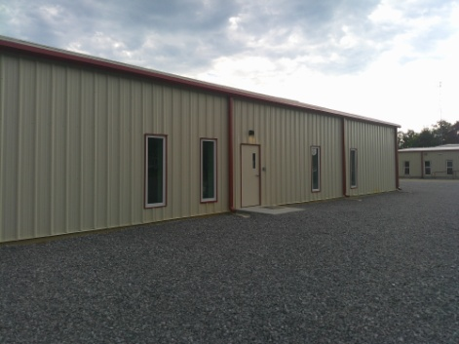

St. Tammany Fire Protection District #1
New Training Facility 2024

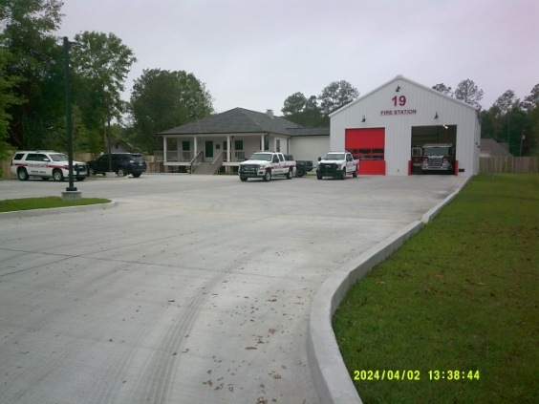

St. Tammany Fire Protection District #1
New Apparatus bay & Living Quarters 2023

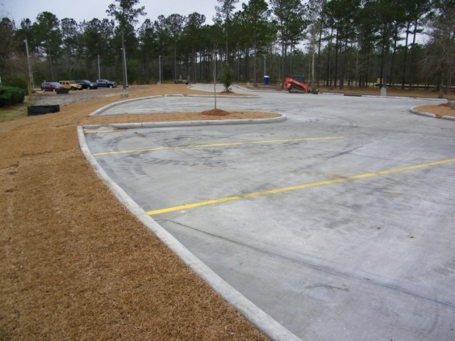

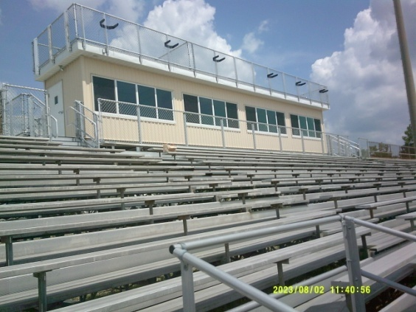

Salmen high School
2023

St. Tammany Parish Coroner’s Office
Parking lot 2022

Evaluation Criteria 9.1.5/9.1.16
Points 10

ADEQUATE STAFF, CONSULTANTS, FACILITIES, EQUIPMENT

PERSONNEL
Indicate the number of personnel by discipline in your firm. (List each person only once by primary function.)

6 | Total Personnel

 | Licensed Architects |  | Intern Architects/Engineers |  | Specification Writers
X | Construction Inspectors/Field Administrator | X | Draftsmen/CADD Operators | X | Designer/Technician
 | Interior Designers |  | Landscape Architects |  | Licensed Civil Engineers
X | Licensed Electrical Engineers | X | Licensed Mechanical Engineers |  | Environmental Engineers
X | Administrative Support |  | Licensed Arborist
 | Other:

PROPOSER’S WORKLOAD
Please comment on your ability to provide services for small projects with your typical workload.

Evaluation Criteria 9.1.7
Points 10

PLAN FOR PERFORMING WORK

Please address the aspect of being responsive to meeting the need to complete design prior to and construction efforts during the very short time frame for summer break and your ability to prioritize the design bid schedule and importance of the construction administration activities to support this effort.

Evaluation Criteria 9.1.9
Points 10

ABILITY TO WORK WITH STPSB STAFF AND OTHER PUBLIC AGENCIES

Please indicate if you have worked with:

YES
St. Tammany Parish School Board Staff
Louisiana State Fire Marshal
Parish of St. Tammany Government
Louisiana Department of Environmental Quality
Louisiana Department of Health and Hospitals
Louisiana Department of Transportation
Corps of Engineers (Wetlands)
Town of Abita Springs
City of Covington
Village of Folsom City of Slidell
Town of Madisonville
City of Mandeville
Town of Pearl River
City of Slidell

Evaluation Criteria 9.1.11
Points 10

PROPOSER’S KNOWLEDGE OF LOCAL CONDITIONS/CONSTRAINTS
List example projects located in St. Tammany Parish which are under contract/were completed within the past three (3) years for which the Applicant firm is responsible for providing services.Use Continuation Sheets as needed.

Project Name | Project Location | Construction Cost/Value | Current Status

Evaluation Criteria 9.1.11
Points 10

Continuation Sheet

Project Name | Project Location | Construction Cost | Current Status

Evaluation Criteria 9.1.18/9.1.19
Points 10
QUALITY CONTROL AND KEEPING PROJECTS WITHIN BUDGET
Please provide information and examples of your firm’s method for quality control, estimating cost of a scope of work and evidence of your cost estimates being within established budgets and minimal change orders.

Evaluation Criteria 9.1.24
Points 15

LOCATION, PROXIMITY TO ST. TAMMANY PARISH
Indicate your office’s proximity to St. Tammany Parish. Indicate if any staff as well as any of the key personnel that are to be assigned to the proposed projects live in/in close proximity to St. Tammany Parish.

Points Associated  With a “Yes” Response* | Questions | Yes or No | Final Points
5 | Applicant Firm: Is Main Office located in St. Tammany Parish, LA?
3 | Applicant Firm: If not located within St. Tammany Parish, LA, is office performing work for this project located in St. Tammany Parish or within 30 miles of the St. Tammany Parish line?
1 | Applicant Firm: If not located within St. Tammany Parish, LA, is office that is performing work for this project located over 30 miles from the St. Tammany Parish line?
5 | Applicant Firm: Is person that will be primarily handling this project during design and construction administration, a resident of or property owner in St. Tammany Parish, LA?
5 | Applicant Firm: Are 50% or more of employees associated with the office performing work for this project, residents of St. Tammany Parish, LA?
3 | If not, 25%-50% of employees residents of St. Tammany Parish?
1 | If not, 5%-25% of employees residents of St. Tammany Parish?
15 | Total Points Possible

*A “Yes” Response = full number of points indicated for the question; A “No” Response = 0 points for the question.

Evaluation Criteria 9.1.25
Points 5

NUMBER AND SIZE OF CONTRACTS WITH STPSB WITHIN PAST 5 YEARS
List the St. Tammany Parish School Board Small Projects (less than $1,500,000.00) received within five (5) years of the year of this RFQ.

Evaluation Criteria 9.1.26
Points 10

OVERVIEW/SUMMARY

Please provide asummary of yourfirm’s experience with and ability to accommodate small projects and anything else you want the committee to know relative to your interest/response to this RFQ.

Evaluation Criteria 9.1.6/9.1.23
MANDATORY

I certify that I am an architect or engineer and a principal (principal is defined as a licensed architect or engineer who has the right and authority to exercise control over the project; who shares in profits, losses, and responsibility for incurred liabilities), with the firm applying for this project, that the foregoing information is accurate and complete to the best of my knowledge, and that I have read the information contained in the Request for Qualifications Package.
Signature of Principal: |  |  |  | Date:
Typed Name and Title of Principal:
Louisiana License Number:

PLACE STAMP/SEAL HERE

Attach the following information:

CURRENT LICENSE
Attach a copy of the document that your firm receives from the licensing board indicating your firm’s current license to practice in the State of Louisiana.

LIABILITY AND PROFESSIONAL INSURANCE
Indicate your ability to provide all insurance required by the Professional Services Agreement. Attach a copy of your current insurance coverages from your insurance company. If your current coverages are less than those required, provide a certified letter from your insurance company verifying that you can meet the coverages required.

AFFIDAVIT
The following page contains an Affidavit which must be signed, notarized, and submitted as a part of this qualification statement.

Evaluation Criteria 9.1.6/9.1.23
MANDATORY

AFFIDAVIT

STATE OF LOUISIANA

PARISH OF ______________________

BEFORE ME, the undersigned authority, personally came and appeared
of (hereinafter referred to as “affiant”), who after being by me duly sworn, deposed and said that affiant has read this affidavit and does hereby agree under oath to comply with the applicable provisions of law set forth herein and affiant further states that Affiant or affiant’s firm is seeking to be selected by the St. Tammany Parish School Board to provide services to be rendered in connection with a contract for construction, alteration or demolition of a public building or project or in connection with providing services in a particular field or specialty for work to be performed on behalf of the St. Tammany Parish School Board and neither he or she or his or her firm has paid any individual or firm to solicit the contract on his or her or its behalf nor has he or she or his or her firm paid a Board member or employee or a Committee member to secure a contract.

Signature of Affiant

Sworn to and subscribed before me this Day of , 2024.

NOTARY PUBLIC

