
554 Old Spanish Trail
Slidell, LA 70458
Phone: 985-649-5832
Fax: 985-641-5950
dammonengineering.com
info@dammonengineering.com

June 4, 2015

Scott Morrison
Slidell Refrigeration
1543 US-190
Slidell, LA 70460
Office :(985) 643-1991
FAX : (985) 643-3169
scott@slidellrefrigeration.com

RE: Christwood Kitchen Renovation
Covington, Louisiana

Dear Mr. Morrison,

It was a pleasure to speak with you to discuss plans for renovations to the kitchen at Christwood in Covington. Dammon Engineering, Inc. is pleased to propose our Engineering services to design the Mechanical portion of this renovation.

We propose a fee of 7.5% of the construction cost for the Mechanical portion of the work.

We look forward to working with you on this project. Please indicate your acceptance of the above by signing below. If you have any questions, or require any further information, please feel free to call.

Sincerely,
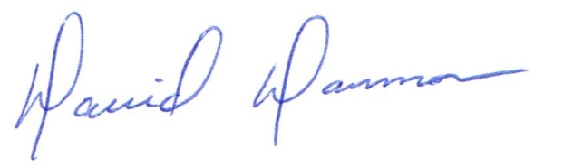

David Dammon, VP

Accepted: ____________________________ Date:__________________ Scott Morrison

