

554 Old Spanish Trail
Slidell, LA 70458
Phone: 985-649-5832
www.dammonengineering.com
info@dammonengineering.com

9/7/2018

Mr. Ravi Bates, PT, CIDN
STAR Physical Therapy New Orleans
340 Falconer Dr.
Covington, LA 70433

Re: 4021 Behrman Place, New Orleans, River Commons Shopping Center, Suite M-1 – Renovation of existing suite for Physical Therapy and MD Clinic

Mr. Bates,

It was a pleasure to meet and talk with you about your plan to renovate Suite M-1 at the subject location. Dammon Engineering, Inc. is pleased to propose our Engineering services to provide you with engineering plans to renovate Suite M-1.
We propose a fee of $750.00 per engineering discipline to re-design HVAC, Electrical and Plumbing for a total of $2,250.00. Our fee does include reasonable modifications to the drawings should the need arise.
Our fee does not include the cost of designing sprinkler or fire alarm systems, soils analysis, survey, drainage studies, wetlands determination, or other engineering studies that may be required by government agencies nor does it include the cost of plan review or permits by the City of New Orleans. These items, if provided by Dammon Engineering, will be billed at a "cost plus" fee.
By signing below you acknowledge that you are duly authorized to enter into and execute contracts/agreements on behalf of “STAR Physical Therapy New Orleans” This contract is predicated on the signed agreement with “Synergy Wellness Solutions”.
We look forward to working with you on this project. Please indicate your acceptance of the above fee by signing below. If you have any questions, or require any further information, please feel free to call.
Sincerely,

If you have any questions, please contact me.

Thank You,

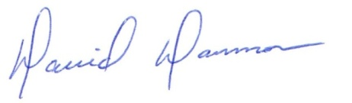
David Dammon __________________________________
President Ravi Bates, PT, CIDN

